Chapter  14 | Forecasting

Discussion Questions

- a. There is no apparent trend in the data. The naïve forecast method, exponential smoothing or the simple moving average would be appropriate for estimating the average.
  - The primary external factors that can be forecasted three days in advance and can appreciably affect air quality are wind velocity and temperature inversions.
  - Weather conditions cannot be forecast two summers in advance. Medium-term causal factors affecting air quality are population, regulations and policies affecting wood burning, mass transit, use of sand and salt on roads, relocation of the airport, and scheduling of major tourism events such as parades, car races, and stock shows.
  - In the area of technological forecasting, qualitative methods of forecasting are best. One such approach is the Delphi method, whereby the consensus of a panel of experts is sought. Here we would survey experts in the fields of electric-powered vehicles, coal-fired combustion for electric utilities, and development of alternatives to sand and salt on roads. We hope to determine whether to expect any technological breakthroughs sufficient to affect air quality within the next 10 years.

- What’s Happening? Our objective in writing this discussion question is to ensure students recognize the difference between sales and demand. Demand forecasting techniques require demand data. Michael is making the common mistake of using sales data as the basis for demand forecasts. Sales are generally equal to the lesser of demand or inventory. Say that inventory matches average demand at a particular location and is 100 newspapers. However, for the current edition, demand is less than average, say 90. Michael enters sales (which happens to be equal to demand in this period) into the forecasting system, resulting in an inventory reduction at that location for the next edition. Now suppose that demand for the next edition is 110. But because inventory has been reduced to 90, only 90 newspapers will be sold. Michael would then enter sales (which happens to be equal to inventory, not demand) into the forecasting system. This approach ratchets downward and tends to starve the distribution system. Because the publication is not reliably available, some customers eventually stop looking for What’s Happening? and demand truly declines. It is important that data used for demand forecasting are demand data, not sales data.

PROBLEMS

- Printer rentals
  - The forecast for week 11 is 29 rentals.

 |  | Forecast for Following
Week Forecast Calculated | ^{D}t | Week ()
5 |  | = 27.2 or 27
6 |  | = 28.2 or 28
7 |  | = 29.8 or 30
8 |  | = 30.4 or 30
9 |  | = 30.4 or 30
10 |  | = 29.0 or 29
  - The Mean Absolute Deviation is 4 rentals.
Week | Actual | Forecast | Absolute Error
6 | 28 | 27 | 1
7 | 32 | 28 | 4
8 | 35 | 30 | 5
9 | 26 | 30 | 4
10 | 24 | 30 | 6
 |  | TOTAL | 20
 |  | MAD | 20/5 = 4

- Dalworth Company
  - Three-month simple moving average

Month | Actual Sales | Three-Month Simple | Absolute | Absolute | Squared
 | (Thousands) | Moving Average | Error | % Error | Error
 |  | Forecast
Jan. | 20
Feb. | 24
Mar. | 27
Apr. | 31
May | 37 | (24+27+31)/3 = 27.33 | 9.67 | 26.14 | 93.51
June | 47 | (27+31+37)/3 = 31.67 | 15.33 | 32.62 | 235.01
July | 53 | (31+37+47)/3 = 38.33 | 14.67 | 27.68 | 215.21
Aug. | 62 | (37+47+53)/3 = 45.67 | 16.33 | 26.34 | 266.67
Sept. | 54 | (47+53+62)/3 = 54.00 | 0.00 | 0.00 | 0.00
Oct. | 36 | (53+62+54)/3 = 56.33 | 20.33 | 56.47 | 413.31
Nov. | 32 | (62+54+36)/3 = 50.67 | 18.67 | 58.34 | 348.57
Dec. | 29 | (54+36+32)/3 = 40.67 | 11.67 | 40.24 | 136.19
Total |  |  | 106.67 | 267.83 | 1,708.47
Average |  |  | 13.33 | 33.48 | 213.56
Such results also can be obtained from the Time Series Forecasting Solver of OM Explorer:
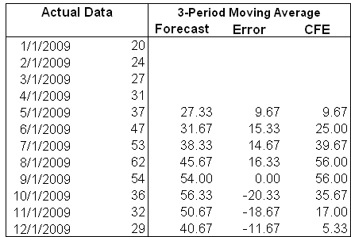

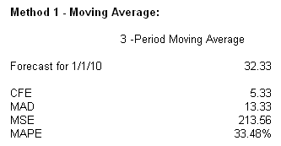

  - Four-month simple moving average

Month |  | Actual Sales | Four-Month Simple |  |  | Absolute | Absolute | Squared
 |  | (Thousands) | Moving Average |  |  | Error | % Error | Error
 |  |  | Forecast
Jan. | 20
Feb. | 24
Mar. | 27
Apr. |  | 31
May |  | 37 | (20+24+27+31)/4 = 25.5 |  |  | 11.50 | 31.08 | 132.25
June |  | 47 | (24+27+31+37)/4 = 29.75 |  |  | 17.25 | 36.70 | 297.56
July |  | 53 | (27+31+37+47)/4 = 35.5 |  |  | 17.50 | 33.02 | 306.25
Aug. |  | 62 | (31+37+47+53)/4 = 42.00 |  |  | 20.00 | 32.26 | 400.00
Sept. |  | 54 | (37+47+53+62)/4 = 49.75 |  |  | 4.25 | 7.87 | 18.06
Oct. |  | 36 | (47+53+62+54)/4 = 54.00 |  |  | 18.00 | 50.00 | 324.00
Nov. |  | 32 | (53+62+54+36)/4 = 51.25 |  |  | 19.25 | 60.16 | 370.56
Dec. |  | 29 | (62+54+36+32)/4 = 46.00 |  |  | 17.00 | 58.62 | 289.00
Total |  |  |  |  |  | 124.75 | 309.71 | 2,137.68
Average |  |  |  |  |  | 15.59 | 38.71 | 267.21
Similarly, using Time Series Forecasting Solver of OM Explorer, we get:
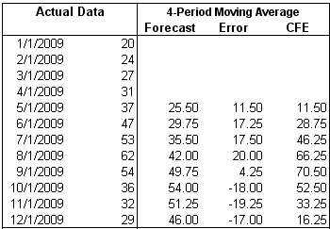

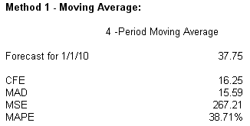

c.−e. Comparison of performance

Question | Measure | 3-Month | 4-Month | Recommendation
 |  | SMA | SMA
c. | MAD | 13.33 | 15.59 | 3-month SMA
d. | MAPE | 33.48 | 38.71 | 3-month SMA
e. | MSE | 213.56 | 267.21 | 3-month SMA

- Karl’s Copiers

Week Forecast Calculated | Calculation of Forecast for Next Week’s Demand
1 | 0.20(24) + 0.80(24) | = 24
2 | 0.20(32) + 0.80(24) | = 25.6 or 26
3 | 0.20(36) + 0.80(25.6) | = 27.68 or 28
4 | 0.20(23) + 0.80(27.68) | = 26.744 or 27
5 | 0.20(25) + 0.80(26.744) | = 26.3952 or 26
Forecasts in each row are for the next week’s demand. For example, the calculations done in Week 1 (after the actual demand for Week 1 is known) of 24 units is actually the forecast for Week 2. It happens to be the same as the forecast made for Week 1’s demand, because the default initial forecast is set equal to the first week’s demand.
The forecast for the week 6 is 26 service calls.
Similarly, using Time Series Forecasting Solver of OM Explorer, we get:
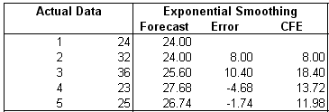
The forecasts are for the weeks listed in the row (not for the next week’s demand).

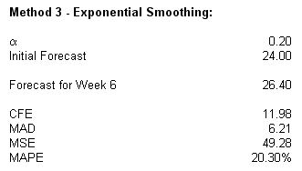

- Dalworth Company (continued)
  - Three-month weighted moving average (weights of 3/6, 2/6, and 1/6)

Month | Actual Sales | Three-Month Weighted | Absolute | Absolute % | Squared
 | (000s) | Moving Average Forecast | Error | Error | Error
Jan. | 20
Feb. | 24
Mar. | 27
Apr. | 31 | [(327)+(224)+(l 20)]/6 = 24.83 | 6.17 | 19.90 | 38.07
May | 37 | [(331)+(227)+(l 24)]/6 = 28.50 | 8.50 | 22.97 | 72.25
June | 47 | [(337)+(231)+(l 27)]/6 = 33.33 | 13.67 | 29.09 | 186.87
July | 53 | [(347)+237)+(l 31)]/6 = 41.00 | 12.00 | 22.64 | 144.00
Aug. | 62 | [(353)+(247)+(l 37)]/6 = 48.33 | 13.67 | 22.05 | 186.87
Sept. | 54 | [(362)+(253)+(l 47)]/6 = 56.50 | 2.50 | 4.63 | 6.25
Oct. | 36 | [(354)+(262)+(l 53)]/6 = 56.50 | 20.50 | 56.94 | 420.25
Nov. | 32 | [(336)+(254)+(l62)]/6 = 46.33 | 14.33 | 44.78 | 205.35
Dec. | 29 | [(332)+(236)+(l 54)]/6 = 37.00 | 8.00 | 27.59 | 64.00
Total |  |  | 99.34 | 250.59 | 1,323.91
Average |  |  | 11.04 | 27.84 | 147.09
The results from Time Series Forecasting Solver of OM Explorer give the same results:
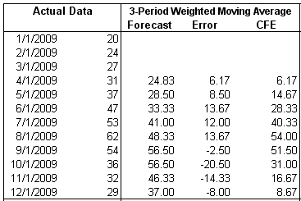

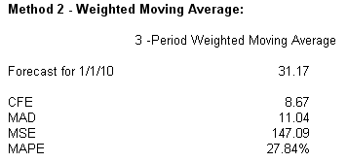
  - Exponential smoothing (α = 0.6)

Month | Dt | Ft | Ft+1 = Ft + α(Dt − Ft) | Absolute | Absolute | Squared
(t) | (millions) |  | (Forecast for Next Month) | Error | % Error | Error
Jan. | 20 | 22.00 | 20.80
Feb. | 24 | 20.80 | 22.72
Mar. | 27 | 22.72 | 25.29
Apr. | 31 | 25.29 | 28.72 | 5.71 | 18.41 | 32.60
May | 37 | 28.72 | 33.69 | 8.28 | 22.38 | 68.56
June | 47 | 33.69 | 41.67 | 13.31 | 28.32 | 177.16
July | 53 | 41.67 | 48.47 | 11.33 | 21.38 | 128.37
Aug. | 62 | 48.47 | 56.59 | 13.53 | 21.82 | 183.06
Sept. | 54 | 56.59 | 55.04 | 2.59 | 4.80 | 6.71
Oct. | 36 | 55.04 | 43.62 | 19.04 | 52.88 | 362.52
Nov. | 32 | 43.62 | 36.64 | 11.61 | 36.28 | 134.79
Dec. | 29 | 36.64 | 32.06 | 7.65 | 26.38 | 58.52
Total |  |  |  | 93.05 | 232.65 | 1,152.29
Average |  |  |  | 10.34 | 25.85 | 128.03
c.−e. Comparison of performance

Question | Measure | 3-Month | Exponential | Recommendation
 |  | WMA | Smoothing
c. | MAD | 11.04 | 10.34 | Exponential smoothing
d. | MAPE | 27.84 | 25.85 | Exponential smoothing
e. | MSE | 147.09 | 128.03 | Exponential smoothing
Exponential smoothing is the better performer on all three criteria.
- Convenience Store
The worksheet calculations from the Time Series Forecasting Solver of OM Explorer for both Exponential Smoothing and Trend Projection with Regression follow:
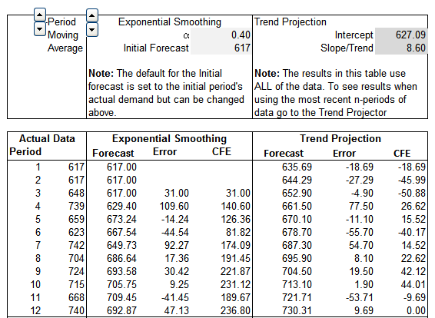

The results from the Time Series Forecasting Solver of OM Explorer for Trend Projection with Regression:
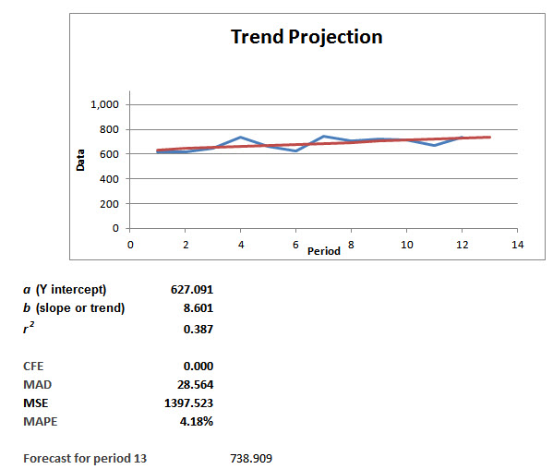
Thus sales are trending up, by 8.60 cans (the slope/trend) per week.
Given a regression equation of Y=627.091+8.601X as provided by the Time Series Forecasting Solver of OM Explorer for Trend Projection with Regression, these results are supported by Excel calculations as follows on the next page:

Trend Projection with Regression
Week (t) | Sales | Forecast | Error | Absolute Error | Squared Error | Absolute Percent Error
1 | 617 | 635.7 | -18.7 | 18.69 | 349.37 | 3.03
2 | 617 | 644.3 | -27.3 | 27.29 | 744.90 | 4.42
3 | 648 | 652.9 | -4.9 | 4.89 | 23.95 | 0.76
4 | 739 | 661.5 | 77.5 | 77.50 | 6006.93 | 10.49
5 | 659 | 670.1 | -11.1 | 11.10 | 123.14 | 1.68
6 | 623 | 678.7 | -55.7 | 55.70 | 3102.31 | 8.94
7 | 742 | 687.3 | 54.7 | 54.70 | 2992.11 | 7.37
8 | 704 | 695.9 | 8.1 | 8.10 | 65.59 | 1.15
9 | 724 | 704.5 | 19.5 | 19.50 | 380.15 | 2.69
10 | 715 | 713.1 | 1.9 | 1.90 | 3.59 | 0.27
11 | 668 | 721.7 | -53.7 | 53.71 | 2884.27 | 8.04
12 | 740 | 730.3 | 9.7 | 9.69 | 93.96 | 1.31
 | Forecast | 738.9
 | CFE |  | 0.0
 | MAD |  |  | 28.56
 | MSE |  |  |  | 1397.52
 | MAPE |  |  |  |  | 4.18

The results from the Time Series Forecasting Solver of OM Explorer for Exponential Smoothing:

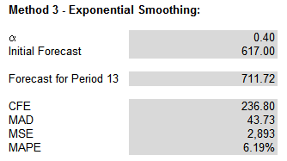

These results are supported by Excel calculations as follows:

Exponential Smoothing
Week (t) | Sales | Forecast | Error | Absolute Error | Squared Error | Absolute Percent Error
1 | 617 | 617.0 | 0.0 | 0.00 | 0.00 | 0.00
2 | 617 | 617.0 | 0.0 | 0.00 | 0.00 | 0.00
3 | 648 | 617.0 | 31.0 | 31.00 | 961.00 | 4.78
4 | 739 | 629.4 | 109.6 | 109.60 | 12012.16 | 14.83
5 | 659 | 673.2 | -14.2 | 14.24 | 202.78 | 2.16
6 | 623 | 667.5 | -44.5 | 44.54 | 1984.17 | 7.15
7 | 742 | 649.7 | 92.3 | 92.27 | 8514.42 | 12.44
8 | 704 | 686.6 | 17.4 | 17.36 | 301.51 | 2.47
9 | 724 | 693.6 | 30.4 | 30.42 | 925.28 | 4.20
10 | 715 | 705.7 | 9.3 | 9.25 | 85.58 | 1.29
11 | 668 | 709.4 | -41.4 | 41.45 | 1718.05 | 6.20
12 | 740 | 692.9 | 47.1 | 47.13 | 2221.27 | 6.37
 | Forecast | 711.7
 | CFE |  | 236.80
 | MAD |  |  | 43.73
 | MSE |  |  |  | 2892.62
 | MAPE |  |  |  |  | 6.19

Method Comparisons:
Trend Exponential
Projection Smoothing
MAD 28.56 43.73
MAPE 4.18 6.19

The Trend Projection with Regression method is superior for both MAD and MAPE. Thus, it appears that a modest trend does exist. Trend component provided through regression analysis = 8.60 cans per week.

- Community Federal
The results from the Time Series Forecasting Solver of OM Explorer for Trend Projection with Regression are :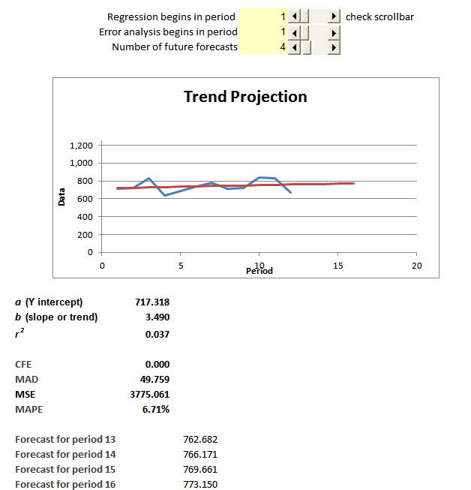

With r² so low, the upward trend is negligible.

- Heartville General Hospital
- Exponential smoothing,

Year | Demand | Exponential Smoothing | Absolute | Absolute % | Square
 |  |  | Deviation | Deviation | Error
1 | 45 | 45
2 | 50 | 45 + .6(45 – 45) = 45
3 | 52 | 45 + .6(50 – 45) = 48 | 4.00 | 7.69 | 16.00
4 | 56 | 48 + .6(52 – 48) = 50.40 | 5.60 | 10.00 | 31.36
5 | 58 | 50.40 + .6(56 – 50.4) = 53.76 | 4.24 | 7.31 | 17.98
 |  | Totals | 13.84 | 25.00 | 65.34
 |  | Averages | 4.61 | 8.33 | 21.78
The same forecast (45) is shown for both years 1 and 2, because the default setting makes the initial forecast for the first period equal to its actual year 2 (for year 3) remains at 45.
- Exponential smoothing, α = 0.9

Year | Demand | Exponential Smoothing | Absolute | Absolute % | Squared
 |  |  | Deviation | Deviation | Error
1 | 45 | 45
2 | 50 | 45 + .9(45 – 45) = 45
3 | 52 | 45 + .9(50 – 45) = 49.50 | 2.50 | 4.81 | 6.25
4 | 56 | 49.50 + .9(52 – 49.5) = 51.75 | 4.25 | 7.59 | 18.06
5 | 58 | 51.75 + .9(56 – 51.75) = 55.58 | 2.43 | 4.19 | 5.90
 |  | Totals | 9.18 | 16.59 | 30.21
 |  | Averages | 3.06 | 5.53% | 10.06

iii. Trend Projection with Regression: model obtained from the Time Series Forecasting Solver of OM Explorer for Trend Projection with Regression:

Year | Demand | Trend Projection | Absolute | Absolute % | Squared
 |  |  | Deviation | Deviation | Error
1 | 45 | 42.6 + 3.21 = 45.8
2 | 50 | 42.6 + 3.22 = 49.0
3 | 52 | 42.6 + 3.23 = 52.2 | 0.20 | 0.38 | 0.04
4 | 56 | 42.6 + 3.24 = 55.4 | 0.60 | 1.07 | 0.36
5 | 58 | 42.6 + 3.25 = 58.6 | 0.60 | 1.03 | 0.36
 |  | Totals | 1.40 | 2.48 | 0.76
 |  | Averages | 0.47 | 0.83% | 0.25

These Excel computations are confirmed by the Trend Projection with Regression Solver of OM Explorer:
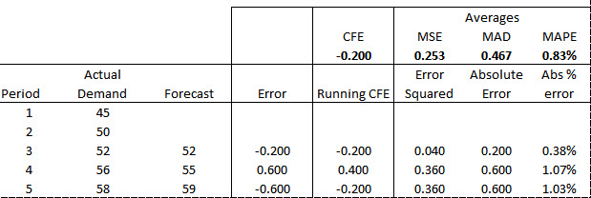
- Two-year moving average

Year | Demand | 2-Year Moving | Absolute | Absolute % | Square
 |  | Average | Deviation | Deviation | Error
1 | 45
2 | 50
3 | 52 | (45 + 50)/2 = 47.5 | 4.50 | 8.65 | 20.25
4 | 56 | (50 + 52)/2 = 51.0 | 5.00 | 8.93 | 25.00
5 | 58 | (52 + 56)/2 = 54.0 | 4.00 | 6.90 | 16.00
 |  | Total | 13.50 | 24.48 | 61.25
 |  | Average | 4.50 | 8.16% | 20.42

- Two-year weighted moving average

Year | Demand | 2-Year Weighted | Absolute | Absolute % | Squared
 |  | Moving Average | Deviation | Deviation | Error
1 | 45
2 | 50
3 | 52 | (45(0.4) + 50(0.6)) = 48.0 | 4.00 | 7.69 | 16.00
4 | 56 | (50(0.4) + 52(0.6)) = 51.2 | 4.80 | 8.57 | 23.04
5 | 58 | (52(0.4) + 56(0.6)) = 54.4 | 3.60 | 6.21 | 12.96
 |  | Totals | 12.40 | 22.47 | 52.00
 |  | Averages | 4.13 | 7.49% | 17.33

vi-viii Comparison of the forecasting methodologies

Forecast | MAD | MAPE | MSE
Methodology
Exponential smoothing α = .6 | 4.61 | 8.33% | 21.78
Exponential smoothing α = .9 | 3.06 | 5.53% | 10.06
Trend Projection with Regression | 0.47 | 0.83% | 0.25
Two-year moving average | 4.50 | 8.16% | 20.42
Two-year weighted moving average | 4.13 | 7.49% | 17.33

The Trend Projection with Regression model methodology works best in this case for all performance criteria.

- Calculator sales
The Trend Projection with Regression Solver of OM Explorer gives the following results:

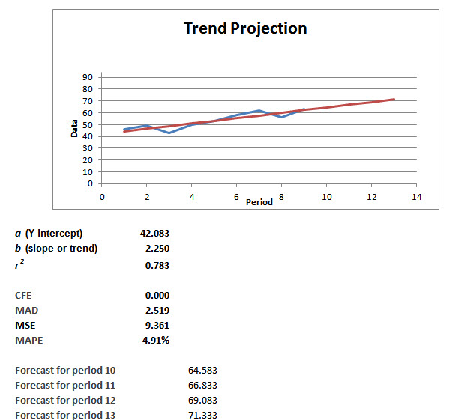

Detailed analysis from the TPWorksheet is::
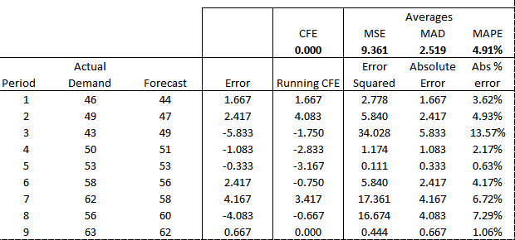

Trend Projection with Regression: model obtained from the Time Series Forecasting Solver of OM Explorer for Trend Projection with Regression. These results are supported by Excel calculations as follows:

Trend Projection with Regression
Week (t) | Sales | Forecast | Error | Absolute Error | Squared Error | Absolute Percent Error
1 | 46 | 44.3 | 1.7 | 1.67 | 2.78 | 3.62
2 | 49 | 46.6 | 2.4 | 2.42 | 5.84 | 4.93
3 | 43 | 48.8 | -5.8 | 5.83 | 34.02 | 13.57
4 | 50 | 51.1 | -1.1 | 1.08 | 1.17 | 2.17
5 | 53 | 53.3 | -0.3 | 0.33 | 0.11 | 0.63
6 | 58 | 55.6 | 2.4 | 2.42 | 5.84 | 4.17
7 | 62 | 57.8 | 4.2 | 4.17 | 17.36 | 6.72
8 | 56 | 60.1 | -4.1 | 4.08 | 16.67 | 7.29
9 | 63 | 62.3 | 0.7 | 0.67 | 0.44 | 1.06
10 | Forecast | 64.6
11 | Forecast | 66.8
12 | Forecast | 69.1
13 | Forecast | 71.3
 | Total |  | 0.0 | 22.7 | 84.3 | 44.2
 | CFE |  | 0.0
 | MAD |  |  | 2.52
 | MSE |  |  |  | 9.36
 | MAPE |  |  |  |  | 4.91
 | Std Dev |  |  |  | 3.25

In the above table, σ is “Std Dev” which is calculated as
The r² was calculated as 0.783 by the Trend Projection with Regression Solver of OM Explorer.
- Krispee Crunchies
The Trend Projection with Regression Solver of OM Explorer gives the following results:
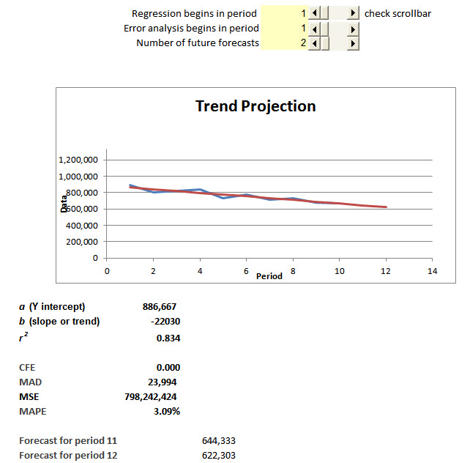

Detailed analysis from the TPWorksheet is:
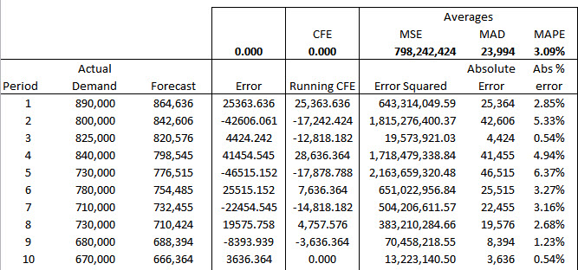
If current conditions remain in place, the r² of better than 80% provide some measure of confidence that the downward trend (estimated at 22,030 boxes per month) will continue.

- Forrest’s boxes of chocolates
  - One possible estimated forecast for Year 4:

Quarter | Forecast
1 | 3,700
2 | 2,700
3 | 1,900
4 | 6,500
 | 14,800
  - Multiplicative seasonal method

 |  |  |  |  |  |  | Average
 |  | Seasonal |  | Seasonal |  | Seasonal | Seasonal
Quarter | Year 1 | Factor | Year 2 | Factor | Year 3 | Factor | Factor
1 | 3,000 | 1.20 | 3,300 | 1.1 | 3502 | 1.03 | 1.11
2 | 1,700 | 0.68 | 2,100 | 0.7 | 2448 | 0.72 | 0.70
3 | 900 | 0.36 | 1,500 | 0.5 | 1768 | 0.52 | 0.46
4 | 4,400 | 1.76 | 5,100 | 1.7 | 5882 | 1.73 | 1.73
Totals | 10,000 |  | 12,000 |  | 13,600
Averages | 2,500 |  | 3,000 |  | 3,400

Forecast for year 4, 14,800. Average = 3,700.

Quarter | Average | Factor | Forecast
1 | 3,700 | 1.11 | 4,107
2 | 3,700 | 0.70 | 2,590
3 | 3,700 | 0.46 | 1,702
4 | 3,700 | 1.73 | 6,401
 |  |  | 14,800
This technique forecasts that the third-quarter sales will decrease compared to sales for the third quarter of the third year. Betcha thought it would increase. Mamma always said: “Life is full of surprises!”
Just to make sure, we find confirmation of our calculations using the Seasonal
Forecasting Solver of OM Explorer:

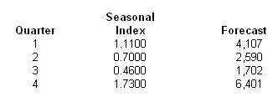

- Snyder’s Garden Center

 |  | Seasonal |  | Seasonal | Average
Quarter | Year 1 | Factor | Year 2 | Factor | Seasonal Factor
1 | 40 | 0.179 | 60 | 0.218 | 0.199
2 | 350 | 1.573 | 440 | 1.600 | 1.587
3 | 290 | 1.303 | 320 | 1.164 | 1.234
4 | 210 | 0.944 | 280 | 1.018 | 0.981
Total | 890 |  | 1,100
Average | 222.50 |  | 275.00

Average quarterly sales in year 3 are expected to be 287.50 (1,150/4). Using the average seasonal factors, the forecasts for year 3 are:

Quarter |  | Forecast
1 | 0.199(287.50) | 57
2 | 1.587(287.50) | 456
3 | 1.234(287.50) | 355
4 | 0.981(287.50) | 282

With the Seasonal Forecasting Solver of OM Explorer, we get the same results

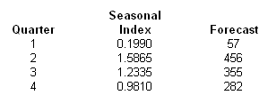

- Utility company
Quarter | Year 1 | Year 2 | Year 3 | Year 4
1 | 103.5 | 94.7 | 118.6 | 109.3
2 | 126.1 | 116.0 | 141.2 | 131.6
3 | 144.5 | 137.1 | 159.0 | 149.5
4 | 166.1 | 152.5 | 178.2 | 169.0
Totals | 540.2 | 500.3 | 597.0 | 559.4
Averages | 135.05 | 125.075 | 149.25 | 139.85

Quarter | Year 1 | Year 2 | Year 3 | Year 4 | Average
 |  |  |  |  | Seasonal Index
1 | 0.7664 | 0.7571 | 0.7946 | 0.7816 | 0.7749
2 | 0.9337 | 0.9274 | 0.9410 | 0.9410 | 0.9371
3 | 1.0700 | 1.0961 | 1.0653 | 1.0690 | 1.0751
4 | 1.2299 | 1.2193 | 1.1940 | 1.2084 | 1.2129
Totals | 4.0 | 4.0 | 4.0 | 4.0 | 4.0
Forecast for Year 5
Quarter | Average Demand | Adjusted
 | per Quarter | Demand
1 | 150 | 116.235 | = | 116
2 | 150 | 140.565 | = | 141
3 | 150 | 161.265 | = | 161
4 | 150 | 181.935 | = | 182
 | 600 | 600
Turning to the Seasonal Forecasting Solver of OM Explorer, we get the same results:
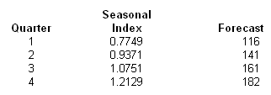

- Garcia’s Garage
- The results, using the Regression Analysis Solver of OM Explorer, are:

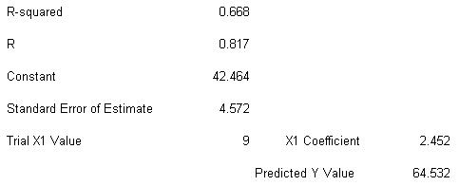

The regression equation is Y = 42.464 + 2.452X
- Forecasts
Y (Sep) = 42.464 + 2.452 (9) = 64.532 or 65
Y (Oct) = 42.464 + 2.452 (10) = 66.984 or 67
Y (Nov) = 42.464 + 2.452 (11) = 71.888 or 72

- Hydrocarbon Processing Factory
Using the Regression Analysis Solver of OM Explorer, we get:
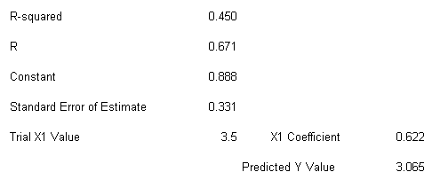
- Relationship to forecast Y from X
Y = 0.888 + 0.622 X
- Strength of relationship between Y and X is moderate as indicated by
R² = 0.450
R = 0.671
Standard Error of Estimate = 0.331

- Ohio Swiss Milk
The results from the Regression Analysis Solver are:
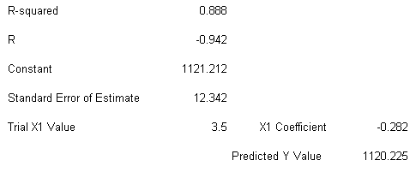
- Y = 1,121.212. − 0.282 X
- R² = 0.888
R = −0.942 indicates a fairly strong negative relationship. Increases in costs explain 89% of the decreases in gallons sold
- Y = 1,121.212 − 0.282 (325) = 1,029.562
Because these numbers are in terms of thousands of gallons, the cost per gallon is $1.03 at this production level.

advanced PROBLEMS

- Franklin Tooling

- Naïve (1-Period Moving Average) Forecasting results

Demand for Component 135.AG | 1-Period Moving Average (Naïve) Forecast
Demand for Component 135.AG | Forecast | Error | ABS (Error) | Square (Error) | Percent (Error)
137
136 | 137.00
143 | 136.00
136 | 143.00
141 | 136.00 | 5.00 | 5.00 | 25.00 | 3.55
128 | 141.00 | -13.00 | 13.00 | 169.00 | 10.16
149 | 128.00 | 21.00 | 21.00 | 441.00 | 14.09
136 | 149.00 | -13.00 | 13.00 | 169.00 | 9.56
134 | 136.00 | -2.00 | 2.00 | 4.00 | 1.49
142 | 134.00 | 8.00 | 8.00 | 64.00 | 5.63
125 | 142.00 | -17.00 | 17.00 | 289.00 | 13.60
134 | 125.00 | 9.00 | 9.00 | 81.00 | 6.72
118 | 134.00 | -16.00 | 16.00 | 256.00 | 13.56
131 | 118.00 | 13.00 | 13.00 | 169.00 | 9.92
132 | 131.00 | 1.00 | 1.00 | 1.00 | 0.76
124 | 132.00 | -8.00 | 8.00 | 64.00 | 6.45
121 | 124.00 | -3.00 | 3.00 | 9.00 | 2.48
127 | 121.00 | 6.00 | 6.00 | 36.00 | 4.72
118 | 127.00 | -9.00 | 9.00 | 81.00 | 7.63
120 | 118.00 | 2.00 | 2.00 | 4.00 | 1.67
115 | 120.00 | -5.00 | 5.00 | 25.00 | 4.35
106 | 115.00 | -9.00 | 9.00 | 81.00 | 8.49
120 | 106.00 | 14.00 | 14.00 | 196.00 | 11.67
113 | 120.00 | -7.00 | 7.00 | 49.00 | 6.19
121 | 113.00 | 8.00 | 8.00 | 64.00 | 6.61
119 | 121.00 | -2.00 | 2.00 | 4.00 | 1.68
Forecast | 119.00
CFE |  | -17.00
MAD |  |  | 8.68
MSE |  |  |  | 103.68
MAPE |  |  |  |  | 6.86

- 3-Period Moving Average

Demand for Component 135.AG | 3-Period Moving Average Forecast
Demand for Component 135.AG | Forecast | Error | ABS (Error) | Square (Error) | Percent (Error)
137
136
143
136 | 138.67
141 | 138.33 | 2.67 | 2.67 | 7.11 | 1.89
128 | 140.00 | -12.00 | 12.00 | 144.00 | 9.38
149 | 135.00 | 14.00 | 14.00 | 196.00 | 9.40
136 | 139.33 | -3.33 | 3.33 | 11.11 | 2.45
134 | 137.67 | -3.67 | 3.67 | 13.44 | 2.74
142 | 139.67 | 2.33 | 2.33 | 5.44 | 1.64
125 | 137.33 | -12.33 | 12.33 | 152.11 | 9.87
134 | 133.67 | 0.33 | 0.33 | 0.11 | 0.25
118 | 133.67 | -15.67 | 15.67 | 245.44 | 13.28
131 | 125.67 | 5.33 | 5.33 | 28.44 | 4.07
132 | 127.67 | 4.33 | 4.33 | 18.78 | 3.28
124 | 127.00 | -3.00 | 3.00 | 9.00 | 2.42
121 | 129.00 | -8.00 | 8.00 | 64.00 | 6.61
127 | 125.67 | 1.33 | 1.33 | 1.78 | 1.05
118 | 124.00 | -6.00 | 6.00 | 36.00 | 5.08
120 | 122.00 | -2.00 | 2.00 | 4.00 | 1.67
115 | 121.67 | -6.67 | 6.67 | 44.44 | 5.80
106 | 117.67 | -11.67 | 11.67 | 136.11 | 11.01
120 | 113.67 | 6.33 | 6.33 | 40.11 | 5.28
113 | 113.67 | -0.67 | 0.67 | 0.44 | 0.59
121 | 113.00 | 8.00 | 8.00 | 64.00 | 6.61
119 | 118.00 | 1.00 | 1.00 | 1.00 | 0.84
Forecast | 117.67
CFE |  | -39.33
MAD |  |  | 5.94
MSE |  |  |  | 55.59
MAPE |  |  |  |  | 4.78

- Exponential Smoothing, with α=.28

Demand for Component 135.AG | Exponential Smoothing Forecast
Demand for Component 135.AG | Forecast | Error | ABS (Error) | Square (Error) | Percent (Error)
137 | 137.00
136 | 137.00
143 | 136.72
136 | 138.48
141 | 137.78 | 3.22 | 3.22 | 10.34 | 2.28
128 | 138.68 | -10.68 | 10.68 | 114.17 | 8.35
149 | 135.69 | 13.31 | 13.31 | 177.07 | 8.93
136 | 139.42 | -3.42 | 3.42 | 11.69 | 2.51
134 | 138.46 | -4.46 | 4.46 | 19.91 | 3.33
142 | 137.21 | 4.79 | 4.79 | 22.92 | 3.37
125 | 138.55 | -13.55 | 13.55 | 183.68 | 10.84
134 | 134.76 | -0.76 | 0.76 | 0.57 | 0.57
118 | 134.55 | -16.55 | 16.55 | 273.76 | 14.02
131 | 129.91 | 1.09 | 1.09 | 1.18 | 0.83
132 | 130.22 | 1.78 | 1.78 | 3.18 | 1.35
124 | 130.72 | -6.72 | 6.72 | 45.11 | 5.42
121 | 128.84 | -7.84 | 7.84 | 61.40 | 6.48
127 | 126.64 | 0.36 | 0.36 | 0.13 | 0.28
118 | 126.74 | -8.74 | 8.74 | 76.42 | 7.41
120 | 124.29 | -4.29 | 4.29 | 18.44 | 3.58
115 | 123.09 | -8.09 | 8.09 | 65.48 | 7.04
106 | 120.83 | -14.83 | 14.83 | 219.82 | 13.99
120 | 116.67 | 3.33 | 3.33 | 11.06 | 2.77
113 | 117.61 | -4.61 | 4.61 | 21.21 | 4.08
121 | 116.32 | 4.68 | 4.68 | 21.94 | 3.87
119 | 117.63 | 1.37 | 1.37 | 1.88 | 1.15
Forecast | 118.01
CFE |  | -70.62
MAD |  |  | 6.29
MSE |  |  |  | 61.88
MAPE |  |  |  |  | 5.11

- Trend Projection with Regression: model Y=143.1613-1.1289X obtained from the Time Series Forecasting Solver of OM Explorer for Trend Projection with Regression

Demand for Component 135.AG | Trend Projection with Regression
Demand for Component 135.AG | Forecast | Error | ABS (Error) | Square (Error) | Percent (Error)
137 | 142.03
136 | 140.90
143 | 139.77
136 | 138.64
141 | 137.52 | 3.48 | 3.48 | 12.12 | 2.47
128 | 136.39 | -8.39 | 8.39 | 70.39 | 6.55
149 | 135.26 | 13.74 | 13.74 | 188.76 | 9.22
136 | 134.13 | 1.87 | 1.87 | 3.49 | 1.37
134 | 133.00 | 1.00 | 0.99 | 1.00 | 0.74
142 | 131.87 | 10.13 | 10.13 | 102.53 | 7.13  Please note that MAD for the Trend model is 5.23, which is higher than any of the combination forecasts.
125 | 130.74 | -5.74 | 5.74 | 32.97 | 4.59
134 | 129.62 | 4.38 | 4.38 | 19.22 | 3.27
118 | 128.49 | -10.49 | 10.49 | 109.92 | 8.89
131 | 127.36 | 3.64 | 3.64 | 13.26 | 2.78
132 | 126.23 | 5.77 | 5.77 | 33.30 | 4.37
124 | 125.10 | -1.10 | 1.10 | 1.21 | 0.89
121 | 123.97 | -2.97 | 2.97 | 8.83 | 2.45
127 | 122.84 | 4.16 | 4.16 | 17.28 | 3.27
118 | 121.71 | -3.71 | 3.71 | 13.77 | 3.14
120 | 120.59 | -0.59 | 0.59 | 0.34 | 0.49
115 | 119.46 | -4.46 | 4.46 | 19.86 | 3.88
106 | 118.33 | -12.33 | 12.33 | 151.97 | 11.63
120 | 117.20 | 2.80 | 2.80 | 7.85 | 2.33
113 | 116.07 | -3.07 | 3.07 | 9.40 | 2.72
121 | 114.94 | 6.06 | 6.06 | 36.71 | 5.01
119 | 113.81 | 5.19 | 5.19 | 26.91 | 4.36
Forecast | 112.68
CFE |  | 9.36
MAD |  |  | 5.23
MSE |  |  |  | 40.06
MAPE |  |  |  |  | 4.16

These results are confirmed by the output from the Time Series Forecasting Solver of OM Explorer:

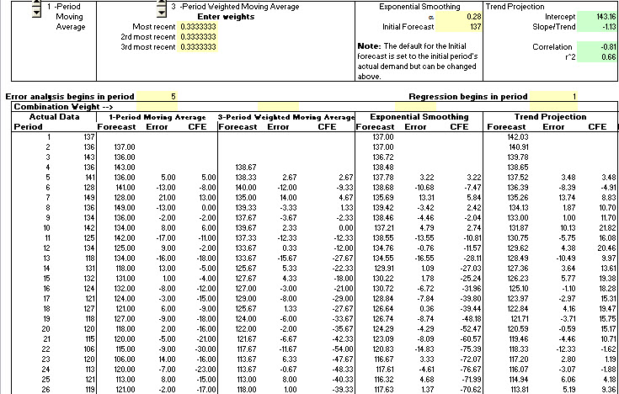

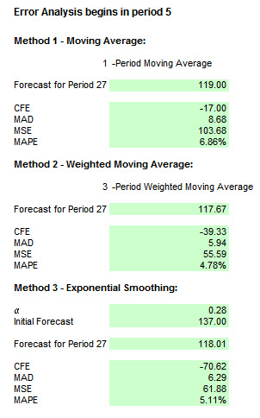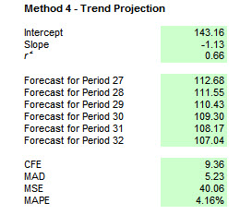

a.-d. As seen in the summary table, the Trend Projection with Regression method provides superior results across all performance criteria.The reason that it does not have a CFE of 0.0 is that the regression begins with period 1, but the error analysis begins in period 5.
 |  |  |  |  | CFE | MAD | MSE | MAPE
1-Period Moving Average (Naïve) Forecast |  |  |  |  | -17.00 | 8.68 | 103.68 | 6.86%
3-Period Moving Average Forecast |  |  |  |  | -39.33 | 5.94 | 55.59 | 4.78%
Exponential Smoothing Forecast |  |  |  |  | -70.62 | 6.29 | 61.88 | 5.11%
Trend Projection with Regression |  |  |  |  | 9.36 | 5.23 | 40.06 | 4.16%

- Combination Forecast for Problem 16
In ranked order, the best methods for Franklin Tool, based on MAD, are Trend Projection with Regression (MAD=5.23), 3-period Moving Average (MAD=5.94), Exponential Smoothing (MAD=6.29), and Naïve (MAD=8.68).

Combination Forecast giving equal weight to all four methods:

Forecasts
Demand | Trend | MA | EA |  | Naive | Comb of all 4 | Error | Absolute Error | Demand | Absolute Percent Error
137 | 142.03
136 | 140.91 |  |  |  | 137.00
143 | 139.78 |  |  |  | 136.00
136 | 138.65 | 138.67 |  |  | 143.00
141 | 137.52 | 138.33 | 137.78 |  | 136.00 | 137.41 | 3.59 | 3.59 | 12.89 | 2.55
128 | 136.39 | 140.00 | 138.68 |  | 141.00 | 139.02 | -11.02 | 11.02 | 121.41 | 8.61
149 | 135.26 | 135.00 | 135.69 |  | 128.00 | 133.49 | 15.51 | 15.51 | 240.61 | 10.41
136 | 134.13 | 139.33 | 139.42 |  | 149.00 | 140.47 | -4.47 | 4.47 | 19.99 | 3.29
134 | 133.00 | 137.67 | 138.46 |  | 136.00 | 136.28 | -2.28 | 2.28 | 5.21 | 1.70
142 | 131.87 | 139.67 | 137.21 |  | 134.00 | 135.69 | 6.31 | 6.31 | 39.84 | 4.44
125 | 130.75 | 137.33 | 138.55 |  | 142.00 | 137.16 | -12.16 | 12.16 | 147.81 | 9.73
134 | 129.62 | 133.67 | 134.76 |  | 125.00 | 130.76 | 3.24 | 3.24 | 10.50 | 2.42
118 | 128.49 | 133.67 | 134.55 |  | 134.00 | 132.67 | -14.67 | 14.67 | 215.35 | 12.44
131 | 127.36 | 125.67 | 129.91 |  | 118.00 | 125.23 | 5.77 | 5.77 | 33.24 | 4.40
132 | 126.23 | 127.67 | 130.22 |  | 131.00 | 128.78 | 3.22 | 3.22 | 10.38 | 2.44
124 | 125.10 | 127.00 | 130.72 |  | 132.00 | 128.70 | -4.70 | 4.70 | 22.13 | 3.79
121 | 123.97 | 129.00 | 128.84 |  | 124.00 | 126.45 | -5.45 | 5.45 | 29.72 | 4.51
127 | 122.84 | 125.67 | 126.64 |  | 121.00 | 124.04 | 2.96 | 2.96 | 8.77 | 2.33
118 | 121.71 | 124.00 | 126.74 |  | 127.00 | 124.86 | -6.86 | 6.86 | 47.11 | 5.82
120 | 120.59 | 122.00 | 124.29 |  | 118.00 | 121.22 | -1.22 | 1.22 | 1.49 | 1.02
115 | 119.46 | 121.67 | 123.09 |  | 120.00 | 121.05 | -6.05 | 6.05 | 36.65 | 5.26
106 | 118.33 | 117.67 | 120.83 |  | 115.00 | 117.96 | -11.96 | 11.96 | 142.92 | 11.28
120 | 117.20 | 113.67 | 116.67 |  | 106.00 | 113.38 | 6.62 | 6.62 | 43.76 | 5.51
113 | 116.07 | 113.67 | 117.61 |  | 120.00 | 116.84 | -3.84 | 3.84 | 14.71 | 3.39
121 | 114.94 | 113.00 | 116.32 |  | 113.00 | 114.31 | 6.69 | 6.69 | 44.70 | 5.53
119 | 113.81 | 118.00 | 117.63 |  | 121.00 | 117.61 | 1.39 | 1.39 | 1.93 | 1.17
Forecast |  |  |  |  |  | 115.35
CFE |  |  |  |  |  |  | -29.40
MAD |  |  |  |  |  |  |  | 6.36
MSE |  |  |  |  |  |  |  |  | 56.87
MAPE |  |  |  |  |  |  |  |  |  | 5.09  e these the best 3 that you used?

These results are confirmed by the output from the Time Series Forecasting Solver of OM Explorer:

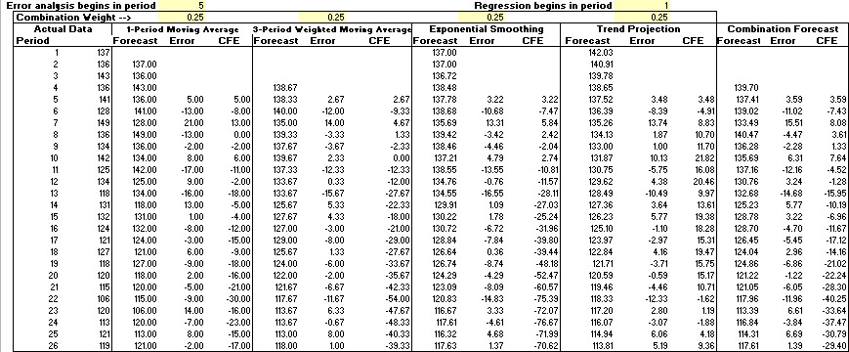

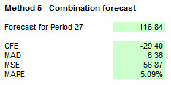

Combination Forecast giving equal weight to the best three methods (Trend Projection with Regression, 3-period Moving Average, and Exponential Smoothing):

 | Forecasts
Demand | Trend | MA | EA | Comb of best 3 | Error | Absolute Error | Squared Error | Absolute Percent Error
137 | 142.03 |  | 137.00
136 | 140.91 |  | 137.00
143 | 139.78 |  | 136.72
136 | 138.65 | 138.67 | 138.48 | 138.60
141 | 137.52 | 138.33 | 137.78 | 137.88 | 3.12 | 3.12 | 9.74 | 2.21
128 | 136.39 | 140.00 | 138.68 | 138.36 | -10.36 | 10.36 | 107.29 | 8.09
149 | 135.26 | 135.00 | 135.69 | 135.32 | 13.68 | 13.68 | 187.20 | 9.18
136 | 134.13 | 139.33 | 139.42 | 137.63 | -1.63 | 1.63 | 2.65 | 1.20
134 | 133.00 | 137.67 | 138.46 | 136.38 | -2.38 | 2.38 | 5.65 | 1.77
142 | 131.87 | 139.67 | 137.21 | 136.25 | 5.75 | 5.75 | 33.05 | 4.05
125 | 130.75 | 137.33 | 138.55 | 135.54 | -10.54 | 10.54 | 111.17 | 8.44
134 | 129.62 | 133.67 | 134.76 | 132.68 | 1.32 | 1.32 | 1.74 | 0.98
118 | 128.49 | 133.67 | 134.55 | 132.23 | -14.23 | 14.23 | 202.59 | 12.06
131 | 127.36 | 125.67 | 129.91 | 127.65 | 3.35 | 3.35 | 11.25 | 2.56
132 | 126.23 | 127.67 | 130.22 | 128.04 | 3.96 | 3.96 | 15.70 | 3.00
124 | 125.10 | 127.00 | 130.72 | 127.61 | -3.61 | 3.61 | 13.00 | 2.91
121 | 123.97 | 129.00 | 128.84 | 127.27 | -6.27 | 6.27 | 39.30 | 5.18
127 | 122.84 | 125.67 | 126.64 | 125.05 | 1.95 | 1.95 | 3.80 | 1.54
118 | 121.71 | 124.00 | 126.74 | 124.15 | -6.15 | 6.15 | 37.85 | 5.21
120 | 120.59 | 122.00 | 124.29 | 122.29 | -2.29 | 2.29 | 5.26 | 1.91
115 | 119.46 | 121.67 | 123.09 | 121.40 | -6.40 | 6.40 | 41.02 | 5.57
106 | 118.33 | 117.67 | 120.83 | 118.94 | -12.94 | 12.94 | 167.44 | 12.21
120 | 117.20 | 113.67 | 116.67 | 115.85 | 4.15 | 4.15 | 17.25 | 3.46
113 | 116.07 | 113.67 | 117.61 | 115.78 | -2.78 | 2.78 | 7.73 | 2.46
121 | 114.94 | 113.00 | 116.32 | 114.75 | 6.25 | 6.25 | 39.03 | 5.16
119 | 113.81 | 118.00 | 117.63 | 116.48 | 2.52 | 2.52 | 6.35 | 2.12
Forecast |  |  |  | 116.12
CFE |  |  |  |  | -33.53
MAD |  |  |  |  |  | 5.71
MSE |  |  |  |  |  |  | 48.46
MAPE |  |  |  |  |  |  |  | 4.60

These results are confirmed by the output from the Time Series Forecasting Solver of OM Explorer:

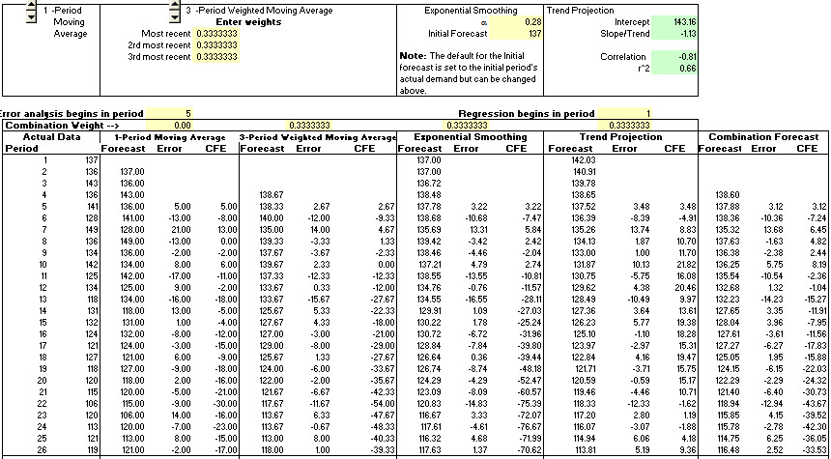

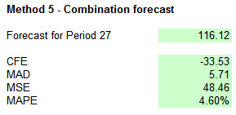

Combination Forecast giving equal weight to the best two methods (Trend Projection with Regression and 3-period Moving Average):

 | Forecasts
Demand | Trend | MA | Comb of best 2 | Error | Absolute Error | Squared Error | Absolute Percent Error
137 | 142.03
136 | 140.91
143 | 139.78
136 | 138.65 | 138.67 | 138.66
141 | 137.52 | 138.33 | 137.93 | 3.07 | 3.07 | 9.45 | 2.18
128 | 136.39 | 140.00 | 138.19 | -10.19 | 10.19 | 103.93 | 7.96
149 | 135.26 | 135.00 | 135.13 | 13.87 | 13.87 | 192.37 | 9.31
136 | 134.13 | 139.33 | 136.73 | -0.73 | 0.73 | 0.54 | 0.54
134 | 133.00 | 137.67 | 135.33 | -1.33 | 1.33 | 1.78 | 1.00
142 | 131.87 | 139.67 | 135.77 | 6.23 | 6.23 | 38.81 | 4.39
125 | 130.75 | 137.33 | 134.04 | -9.04 | 9.04 | 81.71 | 7.23
134 | 129.62 | 133.67 | 131.64 | 2.36 | 2.36 | 5.56 | 1.76
118 | 128.49 | 133.67 | 131.08 | -13.08 | 13.08 | 171.01 | 11.08
131 | 127.36 | 125.67 | 126.51 | 4.49 | 4.49 | 20.14 | 3.43
132 | 126.23 | 127.67 | 126.95 | 5.05 | 5.05 | 25.52 | 3.83
124 | 125.10 | 127.00 | 126.05 | -2.05 | 2.05 | 4.20 | 1.65
121 | 123.97 | 129.00 | 126.49 | -5.49 | 5.49 | 30.10 | 4.53
127 | 122.84 | 125.67 | 124.25 | 2.75 | 2.75 | 7.54 | 2.16
118 | 121.71 | 124.00 | 122.86 | -4.86 | 4.86 | 23.59 | 4.12
120 | 120.59 | 122.00 | 121.29 | -1.29 | 1.29 | 1.67 | 1.08
115 | 119.46 | 121.67 | 120.56 | -5.56 | 5.56 | 30.93 | 4.84
106 | 118.33 | 117.67 | 118.00 | -12.00 | 12.00 | 143.93 | 11.32
120 | 117.20 | 113.67 | 115.43 | 4.57 | 4.57 | 20.86 | 3.81
113 | 116.07 | 113.67 | 114.87 | -1.87 | 1.87 | 3.49 | 1.65
121 | 114.94 | 113.00 | 113.97 | 7.03 | 7.03 | 49.42 | 5.81
119 | 113.81 | 118.00 | 115.91 | 3.09 | 3.09 | 9.57 | 2.60
Forecast |  |  | 115.17
CFE |  |  |  | -14.98
MAD |  |  |  |  | 5.45
MSE |  |  |  |  |  | 44.37
MAPE |  |  |  |  |  |  | 4.38

These results are confirmed by the output from the Time Series Forecasting Solver of OM Explorer:

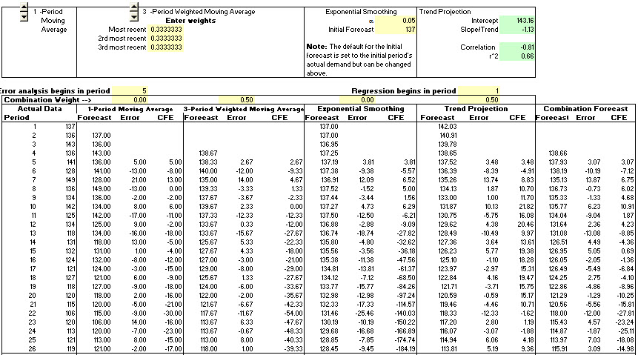

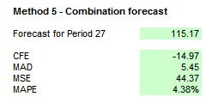

Of the three Combination Methods, the “best-two” forecast provides superior results. These forecasts are better than the Naïve, Moving Average and Exponential Smoothing methods. However, the Trend Projection with Regression method still provides the best overall result. Combination forecasts are better when they bring in something new, such as judgmental forecasts based on contextual knowledge or salesforce polling information.

18. Large Public Library
Using the Time Series Forecasting Solver of OM Explorer, we get the following results by varying the number of periods (n) in the Simple Moving Average method:
n | Forecast for  January, Year 4 | MAD | CFE
1 | 2,451 | 282 | 604
2 | 2,299 | 267 | –68
3 | 2,221 | 257 | –291
4 | 2,127 | 242 | –524
5 | 2,037 | 242 | –846
10 | 2,189 | 216 | –445
In general, as n increases, MAD decreases and CFE (bias) increases. The 10-month average seems to be a good combination of relatively low MAD and low CFE.

- Large Public Library (continued, using 1,847 as initial average)
Using the Time Series Forecasting Solver, we get the following results by varying α in the exponential smoothing model:
α | Forecast for  January, Year 4 | MAD | CFE
0.10 | 2,193 | 265 | 3,458
0.20 | 2,178 | 256 | 1,654
0.30 | 2,186 | 256 | 1,131
0.50 | 2,259 | 258 | 823
0.65 | 2,325 | 255 | 736
0.70 | 2,346 | 256 | 713
0.80 | 2,385 | 262 | 673
1.00 | 2,451 | 282 | 604
As α increases, CFE (bias) generally decreases and MAD generally increases. When α = 0.65 there seems to be a good combination of low bias and low MAD.

- Large Public Library (continued)
Using the Time Series Forecasting Solver of OM Explorer, we get the following results
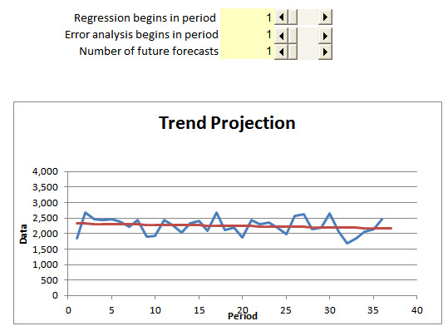

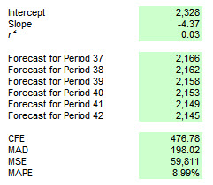
Trend Projection seems to provide the best forecast because of its low CFE and MAD results, relative to those of the simple moving average or the exponential smoothing methods.
21. Cannister Inc.

- Multiplicative Seasonal Method

Year | 1 | 2 | 3 | 4 | 5
Jan | 742 | 741 | 896 | 951 | 1,030
Feb | 697 | 700 | 793 | 861 | 1,032
Mar | 776 | 774 | 885 | 938 | 1,126
Apr | 898 | 932 | 1,055 | 1,109 | 1,285
May | 1,030 | 1,099 | 1,204 | 1,274 | 1,468
Jun | 1,107 | 1,223 | 1,326 | 1,422 | 1,637
Jul | 1,165 | 1,290 | 1,303 | 1,486 | 1,611
Aug | 1,216 | 1,349 | 1,436 | 1,555 | 1,608
Sep | 1,208 | 1,341 | 1,473 | 1,604 | 1,528
Oct | 1,131 | 1,296 | 1,453 | 1,600 | 1,420
Nov | 971 | 1,066 | 1,170 | 1,403 | 1,119
Dec | 783 | 901 | 1,023 | 1,209 | 1,013
Total | 11,724 | 12,712 | 14,017 | 15,412 | 15,877
Averages | 977 | 1,059.333 | 1,168.083 | 1,284.333 | 1,323.083

Year | 1 | 2 | 3 | 4 | 5 | Average  Seasonal Index
Jan | 0.759 | 0.699 | 0.767 | 0.740 | 0.778 | 0.749
Feb | 0.713 | 0.661 | 0.679 | 0.670 | 0.780 | 0.701
Mar | 0.794 | 0.731 | 0.758 | 0.730 | 0.851 | 0.773
Apr | 0.919 | 0.880 | 0.903 | 0.863 | 0.971 | 0.907
May | 1.054 | 1.037 | 1.031 | 0.992 | 1.110 | 1.045
Jun | 1.133 | 1.154 | 1.135 | 1.107 | 1.237 | 1.153
Jul | 1.192 | 1.218 | 1.116 | 1.157 | 1.218 | 1.180
Aug | 1.245 | 1.273 | 1.229 | 1.211 | 1.215 | 1.235
Sep | 1.236 | 1.266 | 1.261 | 1.249 | 1.155 | 1.233
Oct | 1.158 | 1.223 | 1.244 | 1.246 | 1.073 | 1.189
Nov | 0.994 | 1.006 | 1.002 | 1.092 | 0.846 | 0.988
Dec | 0.801 | 0.851 | 0.876 | 0.941 | 0.766 | 0.847
- Simple Linear Regression Model to forecast annual sales
obtained from the Time Series Forecasting Solver of OM Explorer for Trend Projection with Regression
c. Forecast for Year 6 (or ) is:
- Monthly Seasonal Forecast for Year 6
(17,250/12)*Average Seasonal Index
Jan | 1,076.7 |  | Jul | 1,696.4
Feb | 1,007.3 |  | Aug | 1,774.9
Mar | 1,110.9 |  | Sep | 1,773.1
Apr | 1,304.4 |  | Oct | 1,708.9
May | 1,501.9 |  | Nov | 1,420.2
Jun | 1,658.1 |  | Dec | 1,217.5

- Midwest Computer Company
  - The results of the Trend Projection with Regression Solver of OM Explorer are

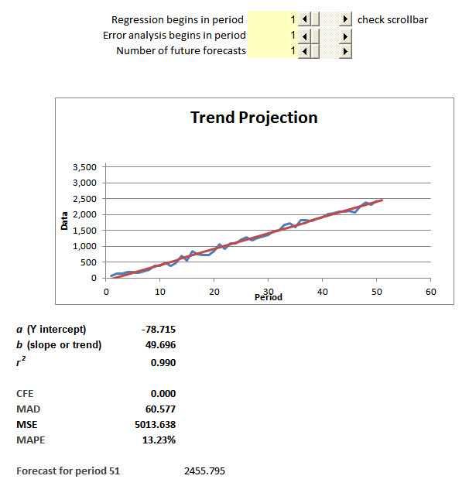
The solver provides a CFE (bias) of 0.00 with a MAD of 60.577 and a correlation coefficient of 0.990. The forecast for week 51 using this method is 2,456.
  - The linear regression model is
Y = -28.693 + 4.9815 X or Sales =-28.693 + 4.9815 (number of leases)
from the Trend Analysis/Time Series Analysis module in POM for Windows.

The statistical results and graph are as follows:

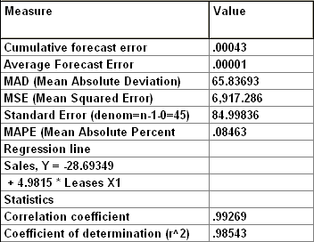

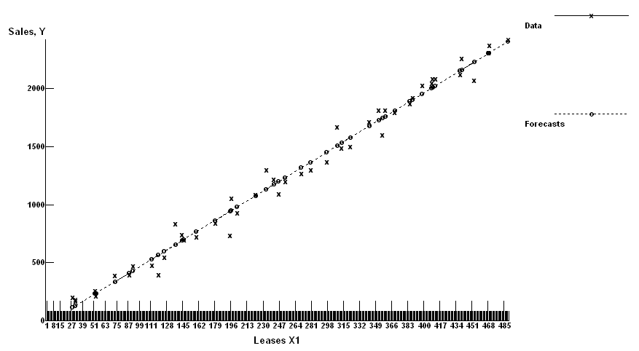
The forecast for month 51 (when X = 496 from month 48) is -28.693 + 4.9815 (496) = 2,442.
  - While both methods provide extremely high coefficients of determination, the Trend Projection with Regression Solver has a slightly lower MAD of only 60.577. Therefore, it is slightly more likely to provide better forecasts, based on past experience.

- P&Q Supermarkets
Numerous methods could be used.
Moving Average
Moving Average
Number of Periods | MAD | CFE | Forecast
2 | 7.09 | 5.00 | 39.50
3 | 6.87 | 13.67 | 41.33
4 | 6.21 | 12.75 | 41.50
5 | 4.52 | 1.00 | 44.80
6 | 4.80 | 7.00 | 44.17
7 | 4.94 | 7.43 | 43.43
12 | 5.15 | 3.08 | 43.08
Exponential smoothing
Use α for the lowest MAD.
 | MAD | CFE | Forecast
 | 5.34 | 47.62 | 42.53
 | 7.52 | 5.00 | 38
Use α = 1.00 (equivalent of naïve model) for the lowest bias.
Trend Projction with Regression
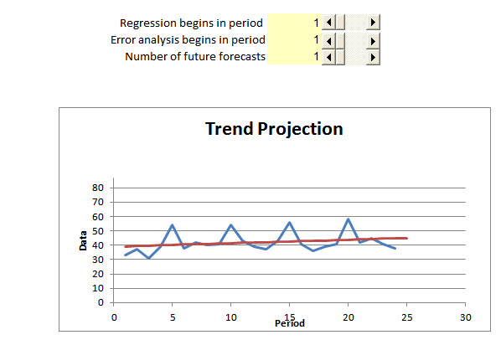
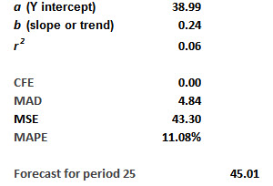

Combination
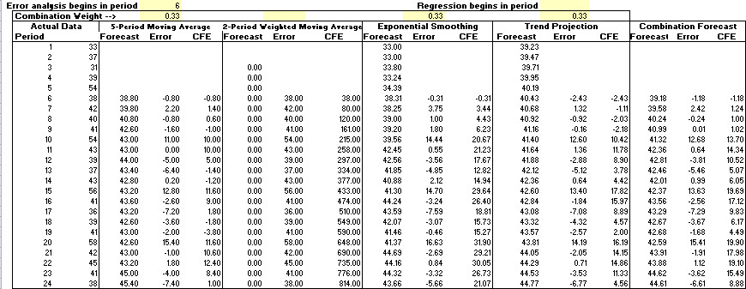

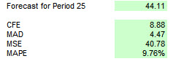
The Combination method gives slightly better forecasts. However, the graphic plot of the data reveals a spike every fifth period in a cycle. None of the methods tried so far reasonably accounts for the fifth-period spike. One way to deal with this cyclical data is to use the multiplicative seasonal method with five periods in a cycle. Unfortunately, OM Explorer’s Seasonal Forecasting Solver does not allow for a situation where there are 5 periods in a cycle. Therefore if you must do some manual calculations or write your own Excel spreadsheet. Here we do the manual calculations, beginning with the seasonal indexes.

 |  | Seasonal |  | Seasonal |  | Seasonal |  | Seasonal | Average
Period | Cycle 1 | Index | Cycle 2 | Index | Cycle 3 | Index | Cycle 4 | Index | Index
1 | 33 | 0.8508 | 38 | 0.8837 | 43 | 0.9862 | 41 | 0.9535 | 0.9186
2 | 37 | 0.9536 | 42 | 0.9767 | 39 | 0.8945 | 36 | 0.8372 | 0.9155
3 | 31 | 0.7990 | 40 | 0.9302 | 37 | 0.8486 | 39 | 0..9070 | 0.8712
4 | 39 | 1.0052 | 41 | 0.9535 | 43 | 0.9862 | 41 | 0.9535 | 0.9746
5 | 54 | 1.3918 | 54 | 1.2558 | 56 | 1.2844 | 58 | 1.3488 | 1.3202
 | 194 |  | 215 |  | 218 |  | 215

One way to estimate the total demand for cycle 5 is to use OM Explorer’s Trend Projection routine in the Time Series Solver. Here we get the following results:

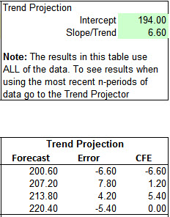

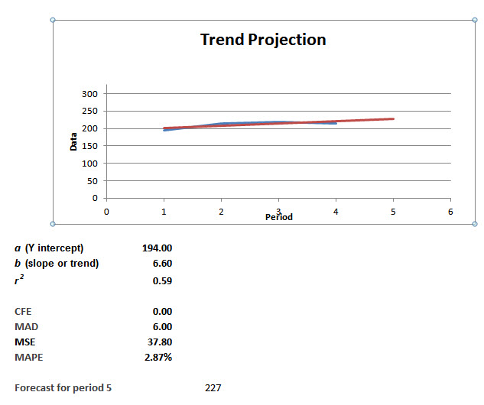

Thus the average demand per period for the 5th cycle is forecast to be 227 / 5 = 45.4. Applying the seasonal indexes, we get:

 | Actual | Seasonal | Forecast
Period | Cycle 5 | Index | Cycle 5
21 | 42 | 0.9186 | 42
22 | 45 | 0.9155 | 42
23 | 41 | 0.8712 | 39
24 | 38 | 0.9746 | 44
25 | ?? | 1.3202 | 60
 |  |  | 227
To calculate the errors for the multiplicative seasonal method, at least for the first four periods of the 5th cycle, we use the Error Analysis module of POM for Windows, with the following results:

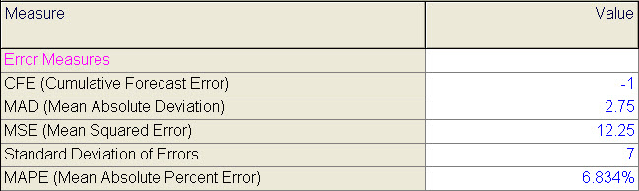

At least over this limited sample, the multiplicative seasonal method performs better than the Combination method because it accounts for the peak in the last period of each cycle.

24. Air visibility
  - Below is the analysis using the Time Series Forecasting Solver of OM Explorer.

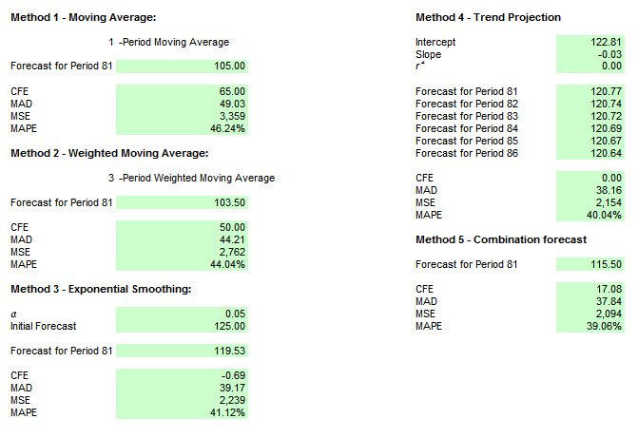
The Trend Projection and Combination models give the best results, but they offer virtually no predictive ability. Note that the r² value of the regression is 0.00 and the slope is only - 0.03. MAPE is quite high at around 40 %.
Given the need for a forecast, an estimate of around 117 (above the combination forecast and below the trend projection forecast) seems reasonable.
  - There is no reason to support expectations for air quality in the third year to be any different from that of the first two years. It will average about 120.5 unless public policy affects transportation, population growth, or utilities burning natural gas rather than coal. That might make a detectable difference in air quality. However, the effects of public policy are not recorded in the database, so qualitative forecasting methods are needed.

- Flatlands Public Power District
The historical data show both trend and seasonal components. We will use the multiplicative seasonal method to forecast demand for the next year, then look for a low-demand period of two weeks during which the Comstock plant can be serviced. Weeks 7 and 8 look like the best two-week period to schedule maintenance.
 | Demand | Seasonal | Demand | Seasonal | Demand | Seasonal | Demand | Seasonal | Demand | Seasonal
Week | Year 1 | Index | Year 2 | Index | Year 3 | Index | Year 4 | Index | Year 5 | Index
1 | 2,050 | 0.1017 | 2,000 | 0.0959 | 1,950 | 0.0922 | 2,100 | 0.1010 | 2,275 | 0.1064
2 | 1,925 | 0.0955 | 2,075 | 0.0995 | 1,800 | 0.0851 | 2,400 | 0.1154 | 2,300 | 0.1076
3 | 1,825 | 0.0906 | 2,225 | 0.1067 | 2,150 | 0.1017 | 1,975 | 0.0950 | 2,150 | 0.1006
4 | 1,525 | 0.0757 | 1,800 | 0.0863 | 1,725 | 0.0816 | 1,675 | 0.0805 | 1,525 | 0.0713
5 | 1,050 | 0.0521 | 1,175 | 0.0564 | 1,575 | 0.0745 | 1,350 | 0.0649 | 1,350 | 0.0632
6 | 1,300 | 0.0645 | 1,050 | 0.0504 | 1,275 | 0.0603 | 1,525 | 0.0733 | 1,475 | 0.0690
7 | 1,200 | 0.0596 | 1,250 | 0.0600 | 1,325 | 0.0626 | 1,500 | 0.0721 | 1,475 | 0.0690
8 | 1,175 | 0.0583 | 1,025 | 0.0492 | 1,100 | 0.0520 | 1,150 | 0.0553 | 1,175 | 0.0550
9 | 1,350 | 0.0670 | 1,300 | 0.0624 | 1,500 | 0.0709 | 1,350 | 0.0649 | 1,375 | 0.0643
10 | 1,525 | 0.0757 | 1,425 | 0.0683 | 1,550 | 0.0733 | 1,225 | 0.0589 | 1,400 | 0.0655
11 | 1,725 | 0.0856 | 1,625 | 0.0779 | 1,375 | 0.0650 | 1,225 | 0.0589 | 1,425 | 0.0667
12 | 1,575 | 0.0782 | 1,950 | 0.0935 | 1,825 | 0.0863 | 1,475 | 0.0709 | 1,550 | 0.0725
13 | 1,925 | 0.0955 | 1,950 | 0.0935 | 2,000 | 0.0946 | 1,850 | 0.0889 | 1,900 | 0.0889
Total | 20,150 |  | 20,850 |  | 21,150 |  | 20,800 |  | 21,375

Using regression to forecast the demand for Year 6, we get :
. When , .
Using this annual demand forecast, we calculate the weekly breakdown as :

Week | Demand Year 6 | Average Seasonal Index
1 | 2,147 | 0.0995
2 | 2,172 | 0.1006
3 | 2,135 | 0.0989
4 | 1,707 | 0.0791
5 | 1,343 | 0.0622
6 | 1,371 | 0.0635
7 | 1,396 | 0.0647
8 | 1,164 | 0.0539
9 | 1,422 | 0.0659
10 | 1,475 | 0.0683
11 | 1,529 | 0.0708
12 | 1,733 | 0.0803
13 | 1,992 | 0.0923
Total | 21,585
- Using the Trend Projection with Regression Solver, we get the following results.
  - The following output makes a forecast of 4,729 units for December of Year 4.
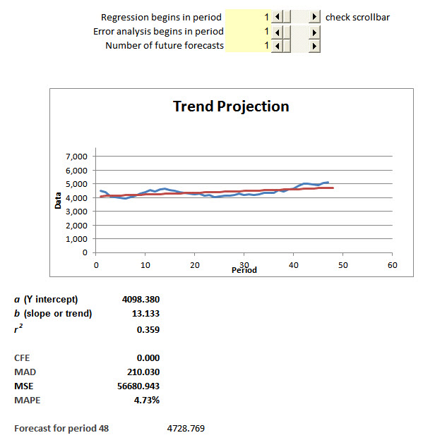
  - The forecast is 4,791 for period 49, up by 63 units. This is quite a jump, and the error measures have also decreased. For example, MAD drops from 210 to 207. These results are somewhat surprising, although the actual demand was quite a bit higher than forecast. Regression can be quite adaptive.
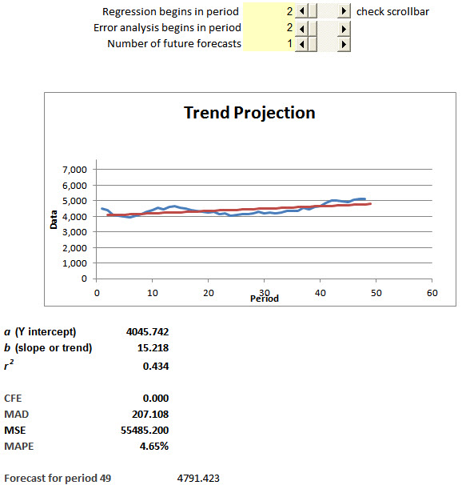

  - Starting again, but with regression beginning with period 25, the forecast for December of Year 4 is 5,114 units, as opposed to the 4,729 units forecast when the regression began with period 1. Error terms are also lower, with MAD down from 210 to 91.
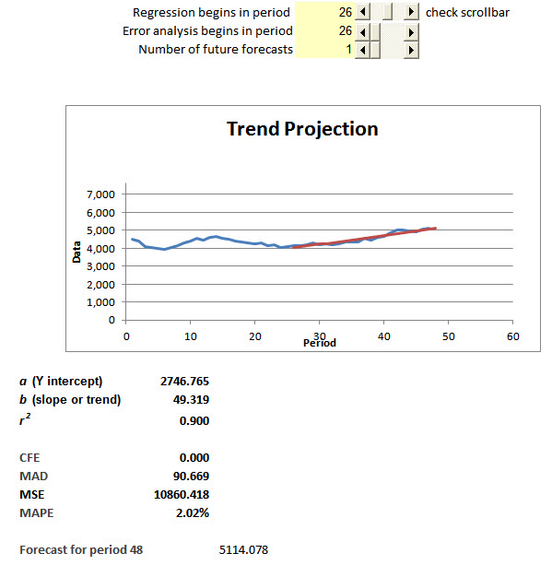
When the demand for period 48 is input as 5,100 while starting regression with period 25, the forecast is 5,152 and MAD decreases to 88, the lowest value found. The most reasonable forecast for period 49 is 5,152.
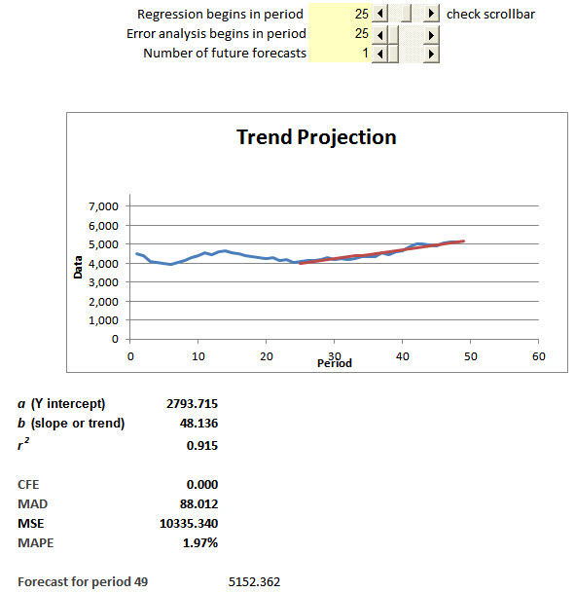
- The results from the Least Square Linear Regression module of POM for Windows are:
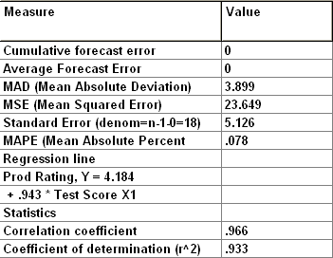

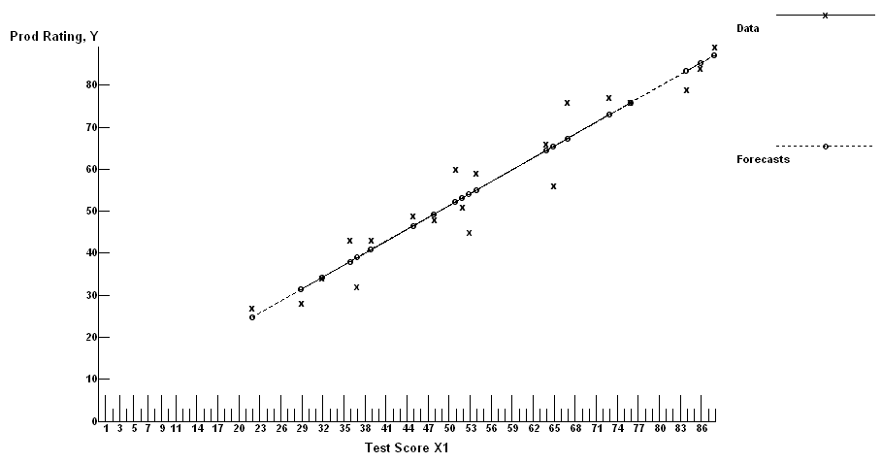
  - From the output, the relationship is
Rating = 4.184 + 0.943 (Score)
  - Score = 80
Rating = 4.184 + 0.943 (80) = 79.624
There is a very strong positive relationship. Increases in scores explain 93% of increases in ratings.

- Materials handing
The results from the POM for Windows’ least squares-linear regression module are:
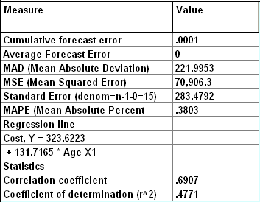
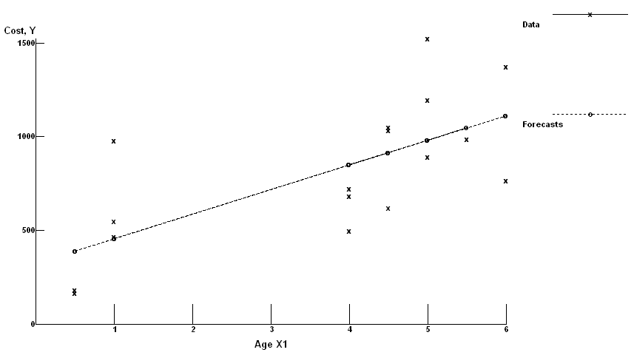
- From the output shown, the relationship is
Cost = 323.6223 + 131.7165 (Age)
- Annual Cost to maintain a three-year old tractor
y = 323.6223 + 131.7165 (3) = $718.77
Annual Cost to maintain a fleet of 20 three-year-old tractors
= (20) ($718.77) = $14,375.44

CASE: YANKEE FORK AND HOE COMPANY

    - Synopsis
Yankee Fork and Hoe is a company that produces garden tools for a mature, price-sensitive market in which customers also want on-time delivery. Recently customers have been complaining about late shipments. The president has hired a consultant to look into the problem. The consultant traces the production planning process and its reliance on accurate forecasts. The consultant must make a recommendation to management.

    - Purpose
This case provides the basis for a discussion of the need for accurate forecasts in an industry where low-cost production is critical. It also contains sufficient data to enable the student to generate forecasts for each month of the following year. Specifically, the case can be used to:
      - Discuss the effects of poor forecasts on capacities and schedules.
      - Discuss the choice of the proper data to use for forecasts.
      - Quantitatively analyze forecasting data and provide forecasts for the following year.

    - Analysis
Yankee Fork and Hoe is experiencing two major problems with the current forecasting system. First, the production department is unaware of how marketing arrives at its forecasts. Production views the forecasts as the result of an overinflated estimate of actual customer demand. However, the forecasting technique in use by the marketing department is based on actual shipments rather than on actual demand. Second, marketing, in its desire to reflect production capacity, is compounding the problems experienced by Yankee Fork and Hoe by trying to rectify past problems. Although marketing adjusts for shortages in the actual shipment data, it is still reflecting past problems and not future demand. If Yankee would move to a system that utilizes past demand to forecast future demand, production would be able to schedule bow rake production more effectively. In addition, production must be aware of how the forecasts are made and what information is being provided so that arbitrary adjustments are no longer needed.
A forecasting system based on actual demands requires careful analysis of Exhibit TN. 1. It is apparent that the bow rake experiences seasonal demand. It is also obvious that there is an upward trend in the annual demand. A forecasting system that recognizes both of these factors is desirable. To arrive at the average monthly demand for year 5, the average increase in the average monthly demands was determined to be 2,589 units. Therefore the average monthly demand for year five is 45,928 + 2,589 = 48,517. This value is then multiplied by the average seasonal factors (see Exhibit TN.2) to arrive at the forecast shown in Exhibit TN.1. Exhibits TN.3 and TN.4 show graphs of the series.

    - Recommendations
The recommendations to management could include the following:
      - Improve the lines of communication between marketing and production regarding the preparation of forecasts. This will eliminate arbitrary adjustments to the forecasts.
      - Use actual demand data rather than shipment data.
      - Use models that somehow handle seasonality, such as the seasonal forecast method, the weighted moving average (with significant weights placed on time periods lagged by one year), or regression with a trend variable and also dummy variables for the seasons.
      - Consider a combination forecasting approach or possibly focus forecasting, rather than using a single model.

    - Teaching Suggestions: As an Experiential Exercise
This case makes for an excellent team-based experiential exercise, spread over two days. Presumably the basic concepts and techniques of forecasting have already been covered. The exercise might take 45 minutes on the first day and 30 minutes on the second day.
Day 1
Introduce the exercise after the basic concepts and techniques of forecasting have been covered. Students should have read the case beforehand, and each team should bring at least one laptop to class. To get things started, briefly open up and demonstrate three solvers:
    - Regression Analysis (describe how you should use it with one independent variable for the trend, and dummy variables for some of the major seasons)
    - Seasonal Forecasting
    - Time-Series Forecasting (which represents four basic models and countless options in their use)
Have the team members discuss among themselves which forecasting methods might be best, and begin to experiment with some of the models to see how they perform. Have them do their analysis only using data from the first three years, and reserving the fourth year as a holdout sample. They should totally block out that information, as it will provide the “acid test” for their assignment due on the second day. After they get into the project and determine their general approach, give them the assignment for the next day.
Day 2
Between the first day and the second session, each team is to develop combination forecasts for the holdout sample (year 4). They must commit to their combination forecasting procedure (such as which methods to include in the combination and their weights) before they evaluate its results for the holdout sample. They are to prepare a short report on their results.
On the first page of their report, they should describe the approach taken and indicate why they are confident in their forecasts. On the subsequent page(s) they should show a spreadsheet of actual demand, forecasts (from two or more individual methods and then the combination), period-by-period forecast error terms, and summary error measures
(CFE, MAD, MAPE, and MSE). They can manually compute the errors, or develop formulas to make the calculations (perhaps borrowing some of the formulas used in the Time Series Forecasting Solver’s “worksheet”). If students use dynamic models, they must “bootstrap” one period at time. If judgment is used as one forecasting technique, the team must control what information the “judgment expert” is given (such as time series model information to date). Actually, a judgment forecasting approach is unlikely to be effective because students have no “contextual knowledge.” It might be convenient to have the teams not only submit hard copy, but also e-mail or post their results to the instructor before class. If done this way, have the elements in the report combined into one electronic file (such as using the Edit/Paste Special/Picture option to insert spreadsheets and graphs into a Word document.
Based on experience to date, a team typically reports CFE values of plus/minus 20,000 for CFE, 6,000 for MAD, 22% for MAPE, and 85,000,000 for MSE. In all cases to date, the combination forecast did better than any individual forecasting method.

    - Teaching Suggestions: Out-of-Class Exercise
This case should be made an overnight assignment because the students need to develop forecasts for year 5. A computer program can be used to get the forecasts; however, it is not mandatory. The forecasts contained in Exhibit TN.1 were done manually using the multiplicative seasonal method described in the text.
This case is based on an actual company that supplies garden tools to companies such as Sears and Scott’s & Sons. The initial discussion should focus on the competitive priorities for Yankee Fork and Hoe (low costs and on-time delivery) and how operations can support these priorities. The need for accurate forecasts in that sort of competitive environment should be emphasized.
The instructor should raise the question, “How would you revise the forecasting system in use at Yankee Fork and Hoe?” This discussion will lead to the issue of which data (shipments or actual demands) to use and how the marketing and production departments can coordinate on the development of the forecasts.
Finally, the students can be asked to present their forecasts (perhaps on blank transparencies provided with the assignment). Discuss how each student’s forecast was developed and explore the reasons for the differences between the students’ forecasts. The forecast provided in Exhibit TN. I can be used as a benchmark.

    - Board Plan
Board 1
Competitive Priorities | Management Support
Low costs | Efficient internal schedules
On-time delivery | Proper inventory levels
 | Good supplier contracts

Board 2
Current Forecasting System | Proposed Forecasting System
Based on shipments | Based on actual demands
One month’s lead on promotions | Several month’s lead on promotions
Marketing passed to production | Coordinated between marketing and production
Second-guessing marketing | Take the forecasts as given

EXHIBIT TN.1 |  |  | Actual Bow Rake Demands and Forecast
Actual Demands
Month | Year 1 | Year 2 |  | Year 3 | Year 4 | Forecast
1 | 55,220 | 39,875 |  | 32,180 | 62,377 | 70,203
2 | 57,350 | 64,128 |  | 38,600 | 66,501 | 72,911
3 | 15,445 | 47,653 |  | 25,020 | 31,404 | 19,636
4 | 27,776 | 43,050 |  | 51,300 | 36,504 | 35,312
5 | 21,408 | 39,359 |  | 31,790 | 16,888 | 27,217
6 | 17,118 | 10,317 |  | 32,100 | 18,909 | 21,763
7 | 18,028 | 45,194 |  | 59,832 | 35,500 | 22,920
8 | 19,883 | 46,530 |  | 30,740 | 51,250 | 25,278
9 | 15,796 | 22,105 |  | 47,800 | 34,443 | 20,082
10 | 53,665 | 41,350 |  | 73,890 | 68,088 | 68,226
11 | 83,269 | 46,024 |  | 60,202 | 68,175 | 105,862
12 | 72,991 | 41,856 |  | 55,200 | 61,100 | 92,796
Averages | 38,162 | 40,620 |  | 44,805 | 45,928 | 48,517

EXHIBIT TN.2 |  |  | Seasonal Factors
Month | Year 1 | Year 2 |  | Year 3 | Year 4 | Average
1 | 1.447 | 0.982 |  | 0.718 | 1.358 | 1.126
2 | 1.503 | 1.579 |  | 0.862 | 1.448 | 1.348
3 | 0.405 | 1.173 |  | 0.558 | 0.684 | 0.705
4 | 0.728 | 1.060 |  | 1.145 | 0.795 | 0.932
5 | 0.561 | 0.969 |  | 0.710 | 0.368 | 0.652
6 | 0.449 | 0.254 |  | 0.694 | 0.412 | 0.452
7 | 0.472 | 1.113 |  | 1.335 | 0.773 | 0.923
8 | 0.521 | 1.145 |  | 0.686 | 1.116 | 0.867
9 | 0.414 | 0.544 |  | 1.067 | 0.750 | 0.694
10 | 1.406 | 1.018 |  | 1.649 | 1.482 | 1.389
11 | 2.182 | 1.133 |  | 1.344 | 1.484 | 1.536
12 | 1.913 | 1.030 |  | 1.232 | 1.330 | 1.376

EXHIBIT TN.3 | Monthly Demands

EXHIBIT TN.4 | Four-Year Plot
Experiential Learning EXERCISE One
Forecasting with Holdout Sample

The history file suggests that sales are quite forecastable. The most important demand pattern is the trend, although there is some hint of cycles (Period 1-46 vs. 46-95). The following graph from the Trend Projection with Regression Solver of OM Explorer shows that there is a steady upward trend in the last half of the series. Including periods before that time results in worse error measures. While some students may do their analysis for the whole time series, we chose to limit it to the second half of the time series beginning with period 46.

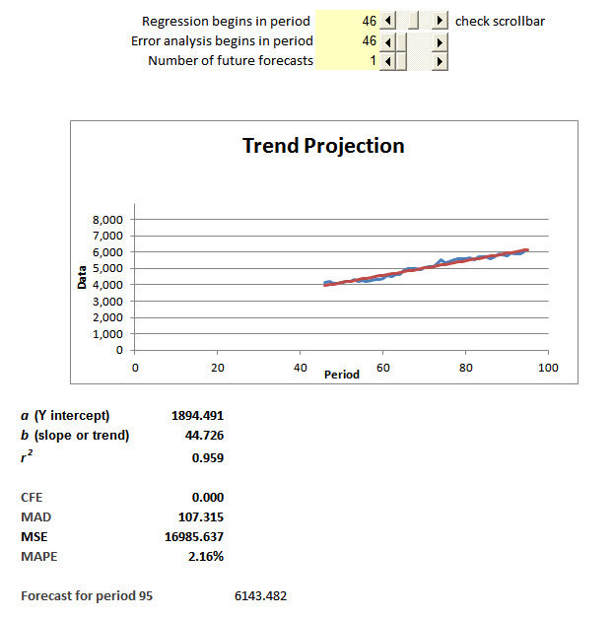
There is no contextual knowledge about this product, and so judgmental forecasts should not be given much importance, unless the forecasters believe another down cycle is beginning or believe one model has been performing particularly well in recent months.

- Results on History File
After searching through the various models in the Time Series Forecasting Solver, four models (including the combination model) are of interest when the error analysis begins in period 46. No moving average model is better than the naïve model, so they are not included.

Model | CFE | MAD | Forecast for November, Year 9
Naïve (Moving Average with n = 1) | 1,707 | 90 | 5987
Weighted Moving Average (0.4, 0.3) | 2,361 | 89 | 5957
Exponential Smoothing (α= 0.9) | 1,888 | 87 | 5979
Trend Projection with Regression | 0 | 107 | 6143
Combination | 1,177 | 74 | 6043

The detailed analysis behind these statistics is as follows:

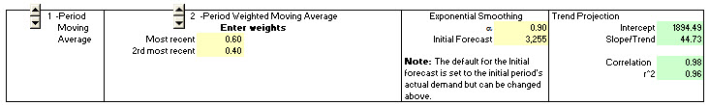

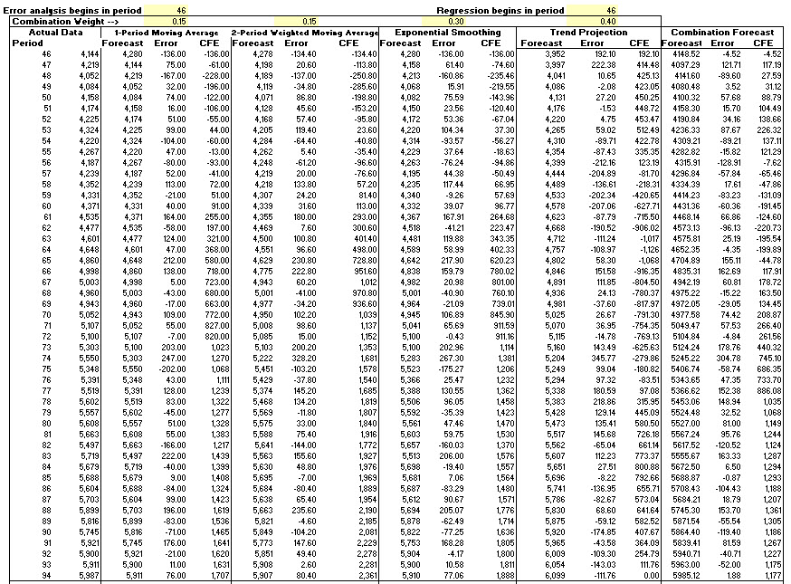

The Trend Projection with Regression model has the best fit with the past data in terms of CFE, with the Combination forecast coming in second best. The Combination forecast is best when MAD is the error term. The real test, however, is how well the models predict future demand. We assess that with the 6 periods in the holdout sample. Our forecasts will be based on the Combination forecast, although students may make other forecasts, including those with judgmental adjustments.

Results on Holdout Sample

In class, the computer shows the forecasts for each of the models one month at a time. At this point, the students must make their forecast. Once their forecasts are entered, the instructor announces the actual demand. The actual demands for the holdout sample are:

Month and | Actual
Year | Demand
Nov, 8 | 6074
Dec, 8 | 6045
Jan, 9 | 6488
Feb, 9 | 6235
Mar, 9 | 6440
Apr, 9 | 6508

Next the computer calculates the forecast errors for each model and for their forecast. It also makes forecasts for each model for the next period, at which time the students must make their forecast for the second period in the holdout sample. The process continues on until the last period in the holdout sample is reached, which is period 100 (April, Year 9).

Shown below are the screens of the Holdout Sample spreadsheet for Periods 95 and 96 (November and December of Year 8). Following it is a table which summarizes the forecasts and errors for all 6 months in the holdout sample.

Screen at Start of Period 95

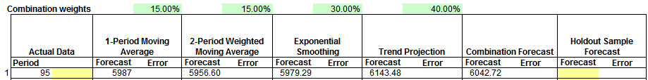

Screen at End of Period 95

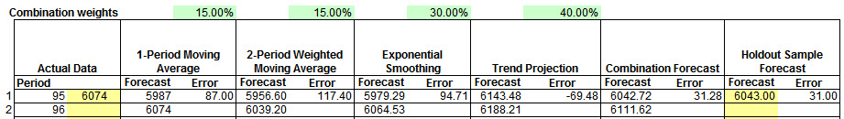

Screen at End of Period 96

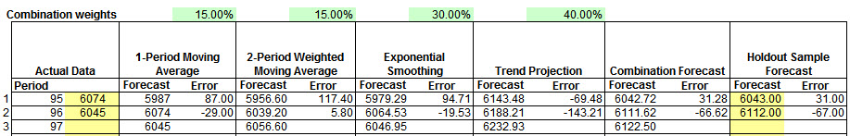

Screen at End of Period 100

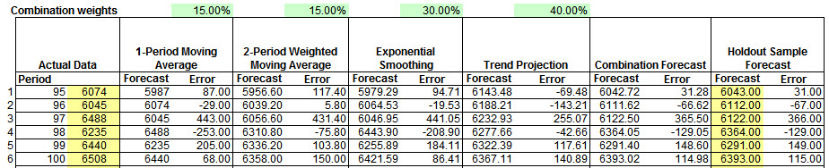

The following Excel table records the actual demands and forecast for all 6 months in the holdout sample.

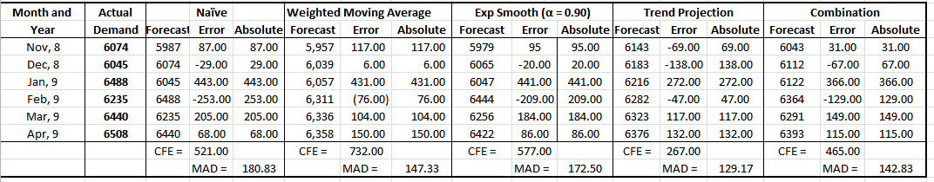

The results may surprise some students, because the Combination forecast had the lowest MAD for the history file, but was outperformed by Trend Projection with Regression in the Holdout sample. The Trend Projection with Regression had both the lowest CFE and MAD error terms with the holdout sample. The Combination Forecast comes in the next best, with the Exponential smoothing and Naive models not doing as well. In retrospect, the data has a strong trend, which explains why the naïve model performs better than any moving average model, and the best exponential model has such a high α value.
hese conclusions may have to be rewritten after Howard sends back to repaied solver for the Holdout sheet.

Comparing Results of History File vs. Holdout File
The following table addresses the real reason for doing a holdout sample. We want to see if the error measures found for the history file give an overly optimistic picture of how well the forecasting techniques will do on data that was not considered when the models were developed.

Forecasting | CFE |  | MAD
Technique | History File | Holdout Sample | History File | Holdout Sample
Naive | 1,707 | 521 | 90 | 181
Weighted Moving Average | 2,361 | 732 | 89 | 147
Exponential Smoothing | 1,888 | 577 | 87 | 172
Trend Progression | 0 | 267 | 107 | 129
Combination | 1,177 | 465 | 74 | 143

These results show surprisingly that the techniques generally do better on the holdout sample than the history file with respect to CFE. Unfortunately, it is a different story with respect to MAD. MAD errors are roughly double those experienced with the history file. Developing models using demand data on which their performance is evaluated may indeed overstate the accuracy of the models in forecasting future demand, as opposed to explaining past demand.

This exercise covers considerable territory. Among other things, it
- gets students familiar with the various forecasting techniques,
- requires them to create their own Excel spreadsheets to evaluate errors across models, and
- cautions them against the possibility of over fitting the history file.

Experiential Learning EXERCISE TWO
Forecasting East Coast Crude Oil Imports

Complete data set including 5-period holdout sample (April 01, 2011 – April 29, 2011)

Quarter 2 2010 |  | Quarter 3 2010 |  | Quarter 4 2010 |  | Quarter 1 2011 |  | Quarter 2 2011
Time Period | Data | Time Period | Data | Time Period | Data | Time Period | Data | Time Period | Data
Apr 02, 2010 | 1160 | Jul 02, 2010 | 1116 | Oct 01, 2010 | 1073 | Dec 31, 2010 | 994 | Apr 01, 2011 | 771
Apr 09, 2010 | 779 | Jul 09, 2010 | 1328 | Oct 08, 2010 | 857 | Jan 07, 2011 | 1307 | Apr 08, 2011 | 709
Apr 16, 2010 | 1134 | Jul 16, 2010 | 1183 | Oct 15, 2010 | 1197 | Jan 14, 2011 | 997 | Apr 15, 2011 | 562
Apr 23, 2010 | 1275 | Jul 23, 2010 | 1219 | Oct 22, 2010 | 718 | Jan 21, 2011 | 1082 | Apr 22, 2011 | 1154
Apr 30, 2010 | 1355 | Jul 30, 2010 | 1132 | Oct 29, 2010 | 817 | Jan 28, 2011 | 887 | Apr 29, 2011 | 998
May 07, 2010 | 1513 | Aug 06, 2010 | 1094 | Nov 05, 2010 | 946 | Feb 04, 2011 | 1067
May 14, 2010 | 1394 | Aug 13, 2010 | 1040 | Nov 12, 2010 | 725 | Feb 11, 2011 | 890
May 21, 2010 | 1097 | Aug 20, 2010 | 1053 | Nov 19, 2010 | 748 | Feb 18, 2011 | 865
May 28, 2010 | 1206 | Aug 27, 2010 | 1232 | Nov 26, 2010 | 1031 | Feb 25, 2011 | 858
Jun 04, 2010 | 1264 | Sep 03, 2010 | 1073 | Dec 03, 2010 | 1061 | Mar 04, 2011 | 814
Jun 11, 2010 | 1153 | Sep 10, 2010 | 1329 | Dec 10, 2010 | 1074 | Mar 11, 2011 | 871
Jun 18, 2010 | 1424 | Sep 17, 2010 | 1096 | Dec 17, 2010 | 941 | Mar 18, 2011 | 1255
Jun 25, 2010 | 1274 | Sep 24, 2010 | 1125 | Dec 24, 2010 | 994 | Mar 25, 2011 | 980

The Data Set: | Weekly East Coast Crude Oil Imports (in Thousand Barrels per Day)
Source: | The US Energy Information Administration
Excel File Name: | psw09.xls
Available from Web Page: | http://www.eia.gov/oil_gas/petroleum/data_publications/weekly_petroleum_status_report/wpsr.html
Source Web Site: | Energy Information Administration
For Help, Contact: | infoctr@eia.gov
 | (202) 586-8800

a. Use the Time Series Forecasting Solver of OM Explorer to develop initial forecasts for the history file..
The time series plot shows the week-to-week variation in oil imports. A slight downward trend but no obvious seasonality is evident.
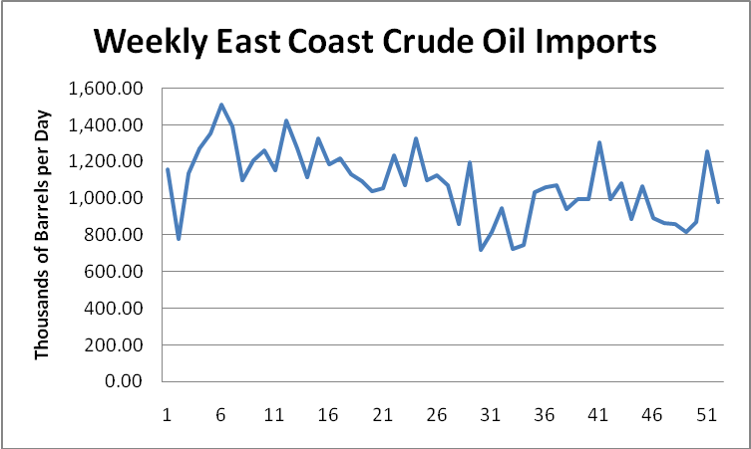
The Time Series Forecasting Solver of OM Explorer provides calculation worksheets and results for the each of the models suggested for this exercise.
Naïve Forecast Worksheet
Actual Data |  | 1-Period Moving Average
Period |  | Forecast | Error | CFE
1 | 1,160
2 | 779 | 1,160
3 | 1,134 | 779
4 | 1,275 | 1,134
5 | 1,355 | 1,275 | 80.00 | 80.00
6 | 1,513 | 1,355 | 158.00 | 238.00
7 | 1,394 | 1,513 | -119.00 | 119.00
8 | 1,097 | 1,394 | -297.00 | -178.00
9 | 1,206 | 1,097 | 109.00 | -69.00
10 | 1,264 | 1,206 | 58.00 | -11.00
11 | 1,153 | 1,264 | -111.00 | -122.00
12 | 1,424 | 1,153 | 271.00 | 149.00
13 | 1,274 | 1,424 | -150.00 | -1.00
14 | 1,116 | 1,274 | -158.00 | -159.00
15 | 1,328 | 1,116 | 212.00 | 53.00
16 | 1,183 | 1,328 | -145.00 | -92.00
17 | 1,219 | 1,183 | 36.00 | -56.00
18 | 1,132 | 1,219 | -87.00 | -143.00
19 | 1,094 | 1,132 | -38.00 | -181.00
20 | 1,040 | 1,094 | -54.00 | -235.00
21 | 1,053 | 1,040 | 13.00 | -222.00
22 | 1,232 | 1,053 | 179.00 | -43.00
23 | 1,073 | 1,232 | -159.00 | -202.00
24 | 1,329 | 1,073 | 256.00 | 54.00
25 | 1,096 | 1,329 | -233.00 | -179.00
26 | 1,125 | 1,096 | 29.00 | -150.00
27 | 1,073 | 1,125 | -52.00 | -202.00
28 | 857 | 1,073 | -216.00 | -418.00
29 | 1,197 | 857 | 340.00 | -78.00
30 | 718 | 1,197 | -479.00 | -557.00
31 | 817 | 718 | 99.00 | -458.00
32 | 946 | 817 | 129.00 | -329.00
33 | 725 | 946 | -221.00 | -550.00
34 | 748 | 725 | 23.00 | -527.00
35 | 1,031 | 748 | 283.00 | -244.00
36 | 1,061 | 1,031 | 30.00 | -214.00
37 | 1,074 | 1,061 | 13.00 | -201.00
38 | 941 | 1,074 | -133.00 | -334.00
39 | 994 | 941 | 53.00 | -281.00
40 | 994 | 994 | 0.00 | -281.00
41 | 1,307 | 994 | 313.00 | 32.00
42 | 997 | 1,307 | -310.00 | -278.00
43 | 1,082 | 997 | 85.00 | -193.00
44 | 887 | 1,082 | -195.00 | -388.00
45 | 1,067 | 887 | 180.00 | -208.00
46 | 890 | 1,067 | -177.00 | -385.00
47 | 865 | 890 | -25.00 | -410.00
48 | 858 | 865 | -7.00 | -417.00
49 | 814 | 858 | -44.00 | -461.00
50 | 871 | 814 | 57.00 | -404.00
51 | 1,255 | 871 | 384.00 | -20.00
52 | 980 | 1,255 | -275.00 | -295.00
To minimize MAPE, a three-point moving average is a good choice. Additionally, a three-point WMA with weights of .4,.3,.3 works well. It should be noted that in this case, the best weights for the WMA procedure are close to being equivalent. Thus, the WMA procedure provides results almost identical to the simpler moving average procedure.
Moving Average (3-point) and Weighted Moving Average (3-point weights = .4, .3, .3) Forecast Worksheets
Actual Data |  | 3-Period Moving Average |  |  | 3-Period Weighted Moving Average
Period | Data | Forecast | Error | CFE | Forecast | Error | CFE
1 | 1,160
2 | 779
3 | 1,134
4 | 1,275 | 1,024 | 250.67 | 250.67 | 1,035 | 239.70 | 239.70
5 | 1,355 | 1,063 | 292.33 | 543.00 | 1,084 | 271.10 | 510.80
6 | 1,513 | 1,255 | 258.33 | 801.33 | 1,265 | 248.30 | 759.10
7 | 1,394 | 1,381 | 13.00 | 814.33 | 1,394 | -0.20 | 758.90
8 | 1,097 | 1,421 | -323.67 | 490.67 | 1,418 | -321.00 | 437.90
9 | 1,206 | 1,335 | -128.67 | 362.00 | 1,311 | -104.90 | 333.00
10 | 1,264 | 1,232 | 31.67 | 393.67 | 1,230 | 34.30 | 367.30
11 | 1,153 | 1,189 | -36.00 | 357.67 | 1,197 | -43.50 | 323.80
12 | 1,424 | 1,208 | 216.33 | 574.00 | 1,202 | 221.80 | 545.60
13 | 1,274 | 1,280 | -6.33 | 567.67 | 1,295 | -20.70 | 524.90
14 | 1,116 | 1,284 | -167.67 | 400.00 | 1,283 | -166.70 | 358.20
15 | 1,328 | 1,271 | 56.67 | 456.67 | 1,256 | 72.20 | 430.40
16 | 1,183 | 1,239 | -56.33 | 400.33 | 1,248 | -65.20 | 365.20
17 | 1,219 | 1,209 | 10.00 | 410.33 | 1,206 | 12.60 | 377.80
18 | 1,132 | 1,243 | -111.33 | 299.00 | 1,241 | -108.90 | 268.90
19 | 1,094 | 1,178 | -84.00 | 215.00 | 1,173 | -79.40 | 189.50
20 | 1,040 | 1,148 | -108.33 | 106.67 | 1,143 | -102.90 | 86.60
21 | 1,053 | 1,089 | -35.67 | 71.00 | 1,084 | -30.80 | 55.80
22 | 1,232 | 1,062 | 169.67 | 240.67 | 1,061 | 170.60 | 226.40
23 | 1,073 | 1,108 | -35.33 | 205.33 | 1,121 | -47.70 | 178.70
24 | 1,329 | 1,119 | 209.67 | 415.00 | 1,115 | 214.30 | 393.00
25 | 1,096 | 1,211 | -115.33 | 299.67 | 1,223 | -127.10 | 265.90
26 | 1,125 | 1,166 | -41.00 | 258.67 | 1,159 | -34.00 | 231.90
27 | 1,073 | 1,183 | -110.33 | 148.33 | 1,178 | -104.50 | 127.40
28 | 857 | 1,098 | -241.00 | -92.67 | 1,096 | -238.50 | -111.10
29 | 1,197 | 1,018 | 178.67 | 86.00 | 1,002 | 194.80 | 83.70
30 | 718 | 1,042 | -324.33 | -238.33 | 1,058 | -339.80 | -256.10
31 | 817 | 924.00 | -107.00 | -345.33 | 903.40 | -86.40 | -342.50
32 | 946 | 910.67 | 35.33 | -310.00 | 901.30 | 44.70 | -297.80
33 | 725 | 827.00 | -102.00 | -412.00 | 838.90 | -113.90 | -411.70
34 | 748 | 829.33 | -81.33 | -493.33 | 818.90 | -70.90 | -482.60
35 | 1,031 | 806.33 | 224.67 | -268.67 | 800.50 | 230.50 | -252.10
36 | 1,061 | 834.67 | 226.33 | -42.33 | 854.30 | 206.70 | -45.40
37 | 1,074 | 946.67 | 127.33 | 85.00 | 958.10 | 115.90 | 70.50
38 | 941 | 1,055 | -114.33 | -29.33 | 1,057 | -116.20 | -45.70
39 | 994 | 1,025 | -31.33 | -60.67 | 1,017 | -22.90 | -68.60
40 | 994 | 1,003 | -9.00 | -69.67 | 1,002 | -8.10 | -76.70
41 | 1,307 | 976.33 | 330.67 | 261.00 | 978.10 | 328.90 | 252.20
42 | 997 | 1,098 | -101.33 | 159.67 | 1,119 | -122.20 | 130.00
43 | 1,082 | 1,099 | -17.33 | 142.33 | 1,089 | -7.10 | 122.90
44 | 887 | 1,129 | -241.67 | -99.33 | 1,124 | -237.00 | -114.10
45 | 1,067 | 988.67 | 78.33 | -21.00 | 978.50 | 88.50 | -25.60
46 | 890 | 1,012 | -122.00 | -143.00 | 1,018 | -127.50 | -153.10
47 | 865 | 948.00 | -83.00 | -226.00 | 942.20 | -77.20 | -230.30
48 | 858 | 940.67 | -82.67 | -308.67 | 933.10 | -75.10 | -305.40
49 | 814 | 871.00 | -57.00 | -365.67 | 869.70 | -55.70 | -361.10
50 | 871 | 845.67 | 25.33 | -340.33 | 842.50 | 28.50 | -332.60
51 | 1,255 | 847.67 | 407.33 | 67.00 | 850.00 | 405.00 | 72.40
52 | 980 | 980.00 | 0.00 | 67.00 | 1,008 | -27.50 | 44.90

Since the data appear to be moving in a downward direction, students may expect that Trend Projection with Regression should provide some good results.
Trend Projection with Regression Forecast Worksheet
Actual Data |  | Trend Projection
Period |  | Forecast | Error | CFE
1 | 1,160 | 1,250 | -90.45 | -90.45
2 | 779 | 1,244 | -464.72 | -555.16
3 | 1,134 | 1,237 | -102.98 | -658.15
4 | 1,275 | 1,230 | 44.75 | -613.40
5 | 1,355 | 1,224 | 131.48 | -481.92
6 | 1,513 | 1,217 | 296.21 | -185.71
7 | 1,394 | 1,210 | 183.94 | -1.76
8 | 1,097 | 1,203 | -106.33 | -108.09
9 | 1,206 | 1,197 | 9.41 | -98.68
10 | 1,264 | 1,190 | 74.14 | -24.54
11 | 1,153 | 1,183 | -30.13 | -54.67
12 | 1,424 | 1,176 | 247.60 | 192.93
13 | 1,274 | 1,170 | 104.33 | 297.26
14 | 1,116 | 1,163 | -46.93 | 250.33
15 | 1,328 | 1,156 | 171.80 | 422.12
16 | 1,183 | 1,149 | 33.53 | 455.65
17 | 1,219 | 1,143 | 76.26 | 531.91
18 | 1,132 | 1,136 | -4.01 | 527.90
19 | 1,094 | 1,129 | -35.28 | 492.63
20 | 1,040 | 1,123 | -82.54 | 410.08
21 | 1,053 | 1,116 | -62.81 | 347.27
22 | 1,232 | 1,109 | 122.92 | 470.19
23 | 1,073 | 1,102 | -29.35 | 440.84
24 | 1,329 | 1,096 | 233.38 | 674.22
25 | 1,096 | 1,089 | 7.11 | 681.34
26 | 1,125 | 1,082 | 42.85 | 724.18
27 | 1,073 | 1,075 | -2.42 | 721.76
28 | 857 | 1,069 | -211.69 | 510.07
29 | 1,197 | 1,062 | 135.04 | 645.11
30 | 718 | 1,055 | -337.23 | 307.88
31 | 817 | 1,048 | -231.50 | 76.39
32 | 946 | 1,042 | -95.76 | -19.38
33 | 725 | 1,035 | -310.03 | -329.41
34 | 748 | 1,028 | -280.30 | -609.71
35 | 1,031 | 1,022 | 9.43 | -600.28
36 | 1,061 | 1,015 | 46.16 | -554.12
37 | 1,074 | 1,008 | 65.89 | -488.22
38 | 941 | 1,001 | -60.37 | -548.60
39 | 994 | 994.64 | -0.64 | -549.24
40 | 994 | 987.91 | 6.09 | -543.15
41 | 1,307 | 981.18 | 325.82 | -217.33
42 | 997 | 974.45 | 22.55 | -194.77
43 | 1,082 | 967.72 | 114.28 | -80.49
44 | 887 | 960.98 | -73.98 | -154.47
45 | 1,067 | 954.25 | 112.75 | -41.72
46 | 890 | 947.52 | -57.52 | -99.24
47 | 865 | 940.79 | -75.79 | -175.03
48 | 858 | 934.06 | -76.06 | -251.09
49 | 814 | 927.33 | -113.33 | -364.42
50 | 871 | 920.59 | -49.59 | -414.01
51 | 1,255 | 913.86 | 341.14 | -72.87
52 | 980 | 907.13 | 72.87 | 0.00
Results screen for each method used indicate that:
Naïve forecasting method has the highest MAD,MSE and MAPE.
MA and WMA perform similarly in terms of MAPE

Method 1 - Moving Average (Naïve):
1 | -Period Moving Average
Forecast for Period 53 | 980.00
CFE | -295.00
MAD | 147.40
MSE | 34,238
MAPE | 14.02%

Method 2 - Moving Average:
3 | -Period Moving Average
Forecast for Period 53 | 1,035
CFE | -183.67
MAD | 124.31
MSE | 25,643
MAPE | 11.72%

Method 3 - Weighted Moving Average:
3 | -Period Weighted Moving Average
Forecast for Period 53 | 1,030
CFE | -194.80
MAD | 124.42
MSE | 25,404
MAPE | 11.75%

Method 4 – Trend Projection (using all of the data)
Intercept | 1257
Slope | -6.73
r² | 0.28
Forecast for Period 53 | 900.40
Forecast for Period 54 | 893.67
Forecast for Period 55 | 886.93
Forecast for Period 56 | 880.20
Forecast for Period 57 | 873.47
Forecast for Period 58 | 866.74
CFE | 613.40
MAD | 111.68
MSE | 22,210
MAPE | 10.85%
Moving Average and Weighted Moving Average provide very similar results. Trend Projection using Regression provide better results.
It is interesting to note, as seen in the following plots, that the MA and Trend models provide somewhat similar results by forecasting in different ways. The MA and WMA methods attempt to project the past forward while dampen random variation. The Trend Projection method attempts to isolate and project a linear rise or fall in the data series.
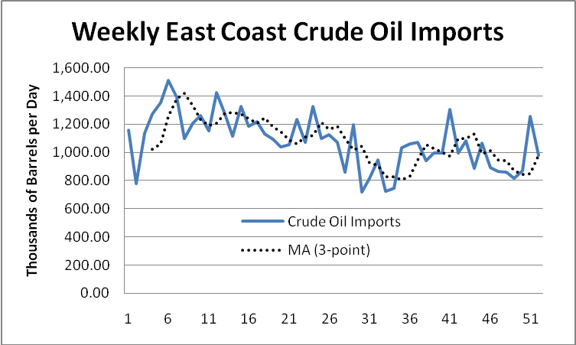
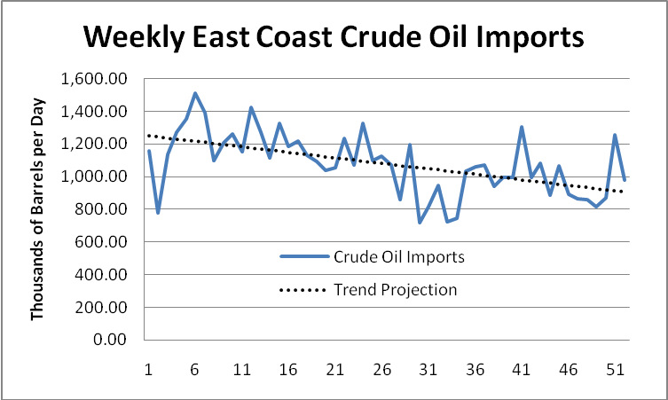
b. Since the performance of the Moving Average, Weighted Moving Average and Trend Projection methods are similar, one may decide to weigh these three methods equally to develop a combination forecast. The logic would be to improve the overall forecast by combining the benefits of each technique. An example Excel spreadsheet follows. Note that the calculation of CFE, MAD, MSE and MAPE are included.

Combination Forecast (MA,WMA, and Trend equally weighted)
Week (t) | Crude Oil Imports | Forecast | Error | Absolute Error | Squared Error | Absolute Percent Error
1 | 1,160.00 | 1,250.45 | -90.45 | 90.45 | 8,180.66 | 7.80
2 | 779.00 | 1,243.72 | -464.72 | 464.72 | 215,960.30 | 59.66
3 | 1,134.00 | 1,236.98 | -102.98 | 102.98 | 10,605.62 | 9.08
4 | 1,275.00 | 1,096.63 | 178.37 | 178.37 | 31,816.43 | 13.99
5 | 1,355.00 | 1,123.36 | 231.64 | 231.64 | 53,656.04 | 17.10
6 | 1,513.00 | 1,245.39 | 267.61 | 267.61 | 71,617.77 | 17.69
7 | 1,394.00 | 1,328.42 | 65.58 | 65.58 | 4,300.88 | 4.70
8 | 1,097.00 | 1,347.33 | -250.33 | 250.33 | 62,665.39 | 22.82
9 | 1,206.00 | 1,280.72 | -74.72 | 74.72 | 5,583.08 | 6.20
10 | 1,264.00 | 1,217.30 | 46.70 | 46.70 | 2,181.05 | 3.69
11 | 1,153.00 | 1,189.54 | -36.54 | 36.54 | 1,335.41 | 3.17
12 | 1,424.00 | 1,195.42 | 228.58 | 228.58 | 52,248.07 | 16.05
13 | 1,274.00 | 1,248.23 | 25.77 | 25.77 | 663.92 | 2.02
14 | 1,116.00 | 1,243.10 | -127.10 | 127.10 | 16,154.53 | 11.39
15 | 1,328.00 | 1,227.78 | 100.22 | 100.22 | 10,044.29 | 7.55
16 | 1,183.00 | 1,212.33 | -29.33 | 29.33 | 860.54 | 2.48
17 | 1,219.00 | 1,186.05 | 32.95 | 32.95 | 1,085.93 | 2.70
18 | 1,132.00 | 1,206.75 | -74.75 | 74.75 | 5,587.13 | 6.60
19 | 1,094.00 | 1,160.23 | -66.23 | 66.23 | 4,385.81 | 6.05
20 | 1,040.00 | 1,137.93 | -97.93 | 97.93 | 9,589.49 | 9.42
21 | 1,053.00 | 1,096.09 | -43.09 | 43.09 | 1,857.02 | 4.09
22 | 1,232.00 | 1,077.60 | 154.40 | 154.40 | 23,837.87 | 12.53
23 | 1,073.00 | 1,110.46 | -37.46 | 37.46 | 1,403.32 | 3.49
24 | 1,329.00 | 1,109.88 | 219.12 | 219.12 | 48,011.96 | 16.49
25 | 1,096.00 | 1,174.44 | -78.44 | 78.44 | 6,152.80 | 7.16
26 | 1,125.00 | 1,135.72 | -10.72 | 10.72 | 114.88 | 0.95
27 | 1,073.00 | 1,145.42 | -72.42 | 72.42 | 5,244.46 | 6.75
28 | 857.00 | 1,087.40 | -230.40 | 230.40 | 53,082.76 | 26.88
29 | 1,197.00 | 1,027.50 | 169.50 | 169.50 | 28,731.10 | 14.16
30 | 718.00 | 1,051.79 | -333.79 | 333.79 | 111,413.72 | 46.49
31 | 817.00 | 958.63 | -141.63 | 141.63 | 20,059.60 | 17.34
32 | 946.00 | 951.24 | -5.24 | 5.24 | 27.50 | 0.55
33 | 725.00 | 900.31 | -175.31 | 175.31 | 30,733.87 | 24.18
34 | 748.00 | 892.18 | -144.18 | 144.18 | 20,787.29 | 19.28
35 | 1,031.00 | 876.13 | 154.87 | 154.87 | 23,983.45 | 15.02
36 | 1,061.00 | 901.27 | 159.73 | 159.73 | 25,514.32 | 15.05
37 | 1,074.00 | 970.96 | 103.04 | 103.04 | 10,617.78 | 9.59
38 | 941.00 | 1,037.97 | -96.97 | 96.97 | 9,403.00 | 10.30
39 | 994.00 | 1,012.29 | -18.29 | 18.29 | 334.59 | 1.84
40 | 994.00 | 997.67 | -3.67 | 3.67 | 13.47 | 0.37
41 | 1,307.00 | 978.54 | 328.46 | 328.46 | 107,887.72 | 25.13
42 | 997.00 | 1,063.99 | -66.99 | 66.99 | 4,488.12 | 6.72
43 | 1,082.00 | 1,052.05 | 29.95 | 29.95 | 897.03 | 2.77
44 | 887.00 | 1,071.22 | -184.22 | 184.22 | 33,935.81 | 20.77
45 | 1,067.00 | 973.81 | 93.19 | 93.19 | 8,685.09 | 8.73
46 | 890.00 | 992.34 | -102.34 | 102.34 | 10,473.48 | 11.50
47 | 865.00 | 943.66 | -78.66 | 78.66 | 6,187.84 | 9.09
48 | 858.00 | 935.94 | -77.94 | 77.94 | 6,074.82 | 9.08
49 | 814.00 | 889.34 | -75.34 | 75.34 | 5,676.37 | 9.26
50 | 871.00 | 869.59 | 1.41 | 1.41 | 2.00 | 0.16
51 | 1,255.00 | 870.51 | 384.49 | 384.49 | 147,833.01 | 30.64
52 | 980.00 | 964.88 | 15.12 | 15.12 | 228.72 | 1.54
 |  | 984.88 | 78.31 | 115.55 | 21,992.79 | 10.99

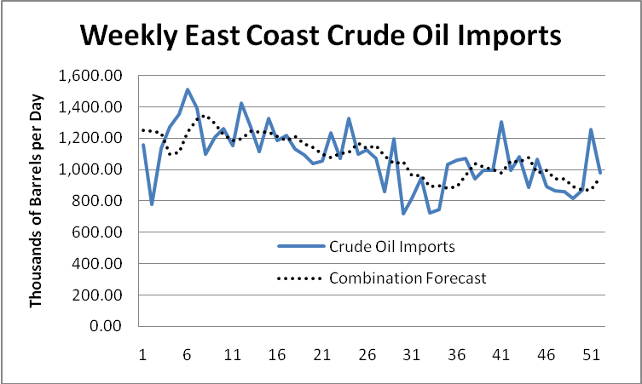

In terms of CFE, the performance of the combination forecast is best. For MAD, MSE and MAPE, the combination forecast is better than the performance of the MA and WMA forecasts and close to the Trend Projection method.

In-Class Exercise

The following spreadsheets and plots provide the forecasts and the performance of the Naive, MA, Trend Projection and Combination Forecasts as new data are added.

1-Period Moving Average (Naïve) Forecast
Week (t) | Crude Oil Imports | Forecast | Error | Absolute Error | Squared Error | Absolute Percent Error
53 | 771.00 | 980.00 | -209.00 | 209.00 | 43,681.00 | 27.11
54 | 709.00 | 771.00 | -62.00 | 62.00 | 3,844.00 | 8.74
55 | 562.00 | 709.00 | -147.00 | 147.00 | 21,609.00 | 26.16
56 | 1,154.00 | 562.00 | 592.00 | 592.00 | 350,464.00 | 51.30
57 | 998.00 | 1,154.00 | -156.00 | 156.00 | 24,336.00 | 15.63
 |  |  | 18.00 | 233.20 | 88,786.80 | 25.79
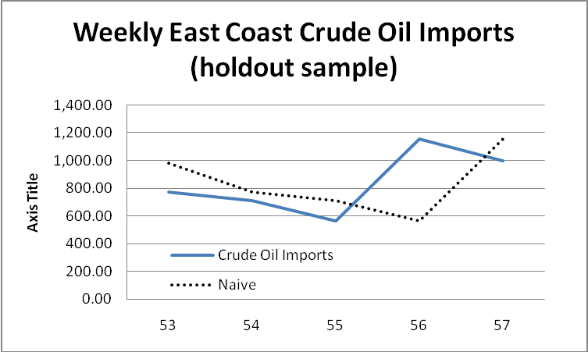

3-Period Moving Average Forecast
Week (t) | Crude Oil Imports | Forecast | Error | Absolute Error | Squared Error | Absolute Percent Error
53 | 771.00 | 1,035.33 | -264.33 | 264.33 | 69,872.11 | 34.28
54 | 709.00 | 1,002.00 | -293.00 | 293.00 | 85,849.00 | 41.33
55 | 562.00 | 820.00 | -258.00 | 258.00 | 66,564.00 | 45.91
56 | 1,154.00 | 680.67 | 473.33 | 473.33 | 224,044.44 | 41.02
57 | 998.00 | 808.33 | 189.67 | 189.67 | 35,973.44 | 19.00
 |  |  | -152.33 | 295.67 | 96,460.60 | 36.31

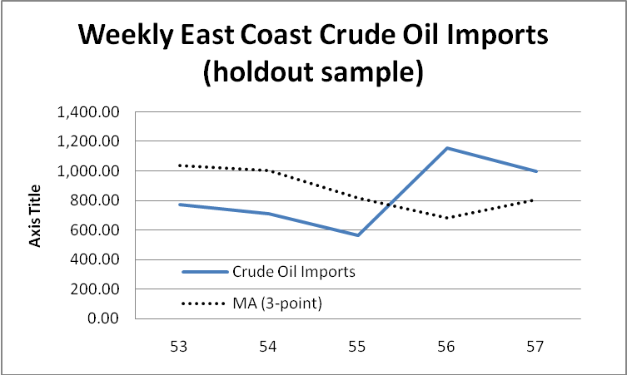

Trend Projection with Regression Forecast
Week (t) | Crude Oil Imports | Forecast | Error | Absolute Error | Squared Error | Absolute Percent Error
53 | 771.00 | 900.40 | -129.40 | 129.40 | 16,743.89 | 16.78
54 | 709.00 | 893.67 | -184.67 | 184.67 | 34,101.70 | 26.05
55 | 562.00 | 886.93 | -324.93 | 324.93 | 105,582.60 | 57.82
56 | 1,154.00 | 880.20 | 273.80 | 273.80 | 74,964.77 | 23.73
57 | 998.00 | 873.47 | 124.53 | 124.53 | 15,507.39 | 12.48
 |  |  | -240.67 | 207.47 | 49,380.07 | 27.37

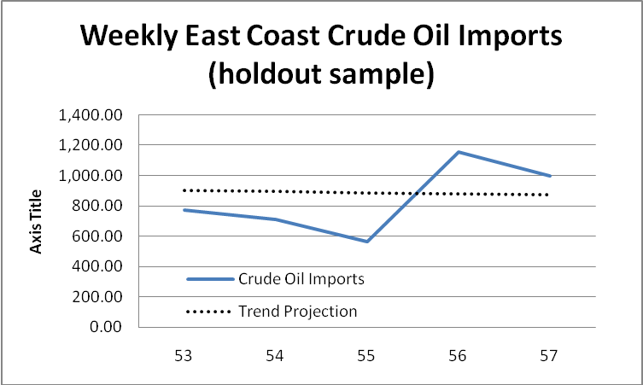

Combination Forecast (MA,WMA, and Trend equally weighted)
Week (t) | Crude Oil Imports | Forecast | Error | Absolute Error | Squared Error | Absolute Percent Error
53 | 771.00 | 988.51 | -217.51 | 217.51 | 47,310.82 | 28.21
54 | 709.00 | 958.19 | -249.19 | 249.19 | 62,095.07 | 35.15
55 | 562.00 | 838.61 | -276.61 | 276.61 | 76,513.97 | 49.22
56 | 1,154.00 | 743.22 | 410.78 | 410.78 | 168,737.55 | 35.60
57 | 998.00 | 841.57 | 156.43 | 156.43 | 24,470.90 | 15.67
 |  |  | -176.10 | 262.10 | 75,825.66 | 32.77
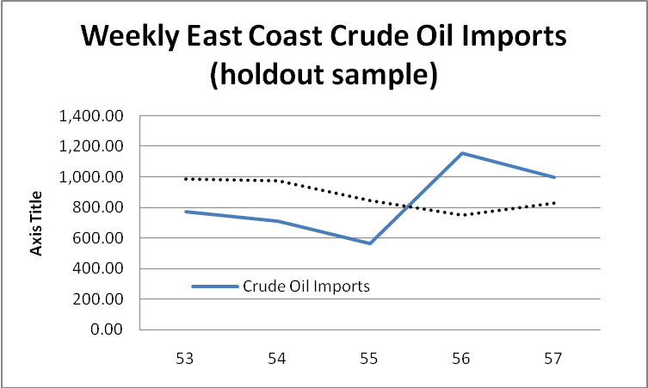

In terms of the overall best-performing methods given the holdout data:
CFE – Naive Method (18.00)
MAD – Trend Projection (207.47)
MSE – Trend Projection (49,380.07)
MAPE – Naïve Method (25.79)

The intercept and slope parameters calculated with the Trend Projection with Regression method were not updated after each holdout data point was provided. Students may be interested in examining the effectiveness of recalibrating the regression equation each period.

Recalibrated regression equations are as follows:

Parameter recalibration provides the following forecast performance for Trend Projection:

Trend Projection with Regression Forecast - updated each holdout period
Week (t) | Crude Oil Imports | Forecast | Error | Absolute Error | Squared Error | Absolute Percent Error
53 | 771.00 | 900.40 | -129.40 | 129.40 | 16,743.89 | 16.78
54 | 709.00 | 883.90 | -174.90 | 174.90 | 30,590.21 | 24.67
55 | 562.00 | 863.94 | -301.94 | 301.94 | 91,168.61 | 53.73
56 | 1,154.00 | 834.63 | 319.37 | 319.37 | 101,999.58 | 27.68
57 | 998.00 | 849.49 | 148.51 | 148.51 | 22,053.98 | 14.88
 |  |  | -138.36 | 214.82 | 52,511.25 | 27.55
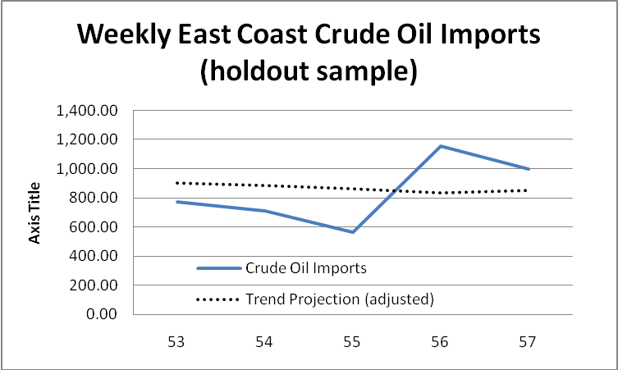

Comparing Results of History File vs. Holdout File
The following table addresses the reason for doing a holdout sample. We want to see if the error measures found for the history file give an overly optimistic picture of how well the forecasting techniques will do on data that was not considered when the models were developed.

Forecasting | CFE |  | MAD
Technique | History File | Holdout Sample | History File | Holdout Sample
Naive | -295.00 | 18.00 | 147.40 | 233.20
Moving Average | -183.67 | -152.33 | 124.31 | 295.67
Trend Progression | 613.40 | -240.67 | 111.68 | 207.47
Combination | 78.31 | -176.10 | 115.55 | 262.10

These results show surprisingly that the techniques generally do better on the holdout sample than the history file with respect to CFE. Unfortunately, it is a different story with regard to MAD. MAD errors are roughly double those experienced with the history file. Developing models using demand data on which their performance is evaluated may indeed overstate the accuracy of the models in forecasting future demand, as opposed to explaining past demand.

Illustrative graded Homework Assignment
Shown below is on way to make graded homework assignments, using Problem 7 as a case in point.

Name ____________________________________________

Graded Homework #6: Time-series Forecasting

Due on Tuesday 11/27 on Blackboard at 1:45 pm and on paper in class.

See Problem 7 in Chapter 14 of your textbook. The problem lists six forecasting methods (i through vi). Using the OM Explorer’s Time Series Forecasting solver, answer the below questions only for methods i, ii, and v.

1. | What is the forecast for the next period using method i? | ___________
2. | What is the forecast for the next period using method ii? | ___________
3 | What is the forecast for the next period using method iii? | ___________
3. | What is the forecast for the next period using method v? | ___________
4 | If MAD is the performance criterion chosen by the administration, which forecasting method should it choose? | ___________
5. | If MSE is the performance criterion chosen by the administration, which forecasting method should it choose? | ___________
6. | If bias is the performance criterion chosen by the administration, which forecasting method should it choose?  Hint: “Bias” is CFE or CFE / n. | ___________

- Submit your answers in Blackboard ASSIGNMENTS at “Time-series Forecasting Submission” by the required time above.

- In addition, submit your paper answer in class as follows:

  - This page with answers entered above.
  - Attach printouts of “Details and Error Analysis” page from POM for Windows for each of the three forecasting methods with your name clearly identified on each.

NOTE: You have to solve the problem three times – once for each method. Recall that you can put your name in the data set “title” field so it appears on the printouts.

Source: This assignment was prepared by Dr. Daniel Steele, University of South Carolina, and illustrates one way to convert homework problems into graded homework assignments. The assessment components in myomlab also offers powerful options.

