Chapter  15 | Operations Planning and Scheduling

Discussion Questions

- Over the past several years, many corporations have experienced reductions in the workforce of sufficient size to receive attention in the media. Restructuring charges reflected in the annual reports to stockholders are often in the order of magnitude of $100,000 per employee. If business is expected to recover within a year, the company would usually be better off to keep these employees on the payroll, perhaps shifting some of them to sales, or loan others for community volunteer work. It is difficult to estimate the monetary value of the following costs associated with layoffs:
q Decreased morale and loyalty of employees not layed off
q Employee stress, mortgage defaults, failed marriages, suicides
q Customers may question the ability to perform, creating a chilling effect on sales
q Suppliers may become suspicious of firm’s financial strength, demand cash
q Loss of experience, skill and knowledge inventories
q Loss of goodwill in community, future cooperation in zoning
q Loss of redevelopment incentives
q Loss of reputation as an employer, future difficulty in hiring a qualified workforce

- Responses will vary depending on which firms are used as examples. Some industries, such as the U.S. auto industry, have a long history and tradition of workforce furlough and recall to match production with demand. Generations of employees are accustomed to this cycle, and fairly smoothly transition between working in the plant during good times and finding other temporary careers when business is slow. Other industries, such as utilities, have a history of stable employment, but are now faced with competition, restructuring, and dealing with employees who hired on for life and now feel betrayed. Stable employment requires stable markets, management loyalty to the workforce, long product lifecycles, financial strength, skilled workforces, and competition that also needs stable workforces.

- Several arguments support these policies. First, the revenue management policies maximize the revenues generated from fixed capacity. Maximizing profits helps the firm succeed and support its workforce. Second, it is the customers themselves who determine the price differentials. The more they gamble (with an increased probability of losing), the more likely they will get a free room.
Arguments against begin with many customers not knowing fully how the “Total Rewards” card program is being used. The ethics of being denied a room, saying that there is no capacity, when the real reason is that the customer is not a big gambler, is debatable. In addition, the process supports an activity that can be addictive to some people and goes beyond entertainment.

- Priority systems affect operations performance and aid management in making operational decisions. They facilitate prioritizing of work in the organization, as all the work to be performed in the organization cannot be done at the same time. The choice of priority system also helps management to focus and consciously decide on the scheduling system that will emphasize the performance criteria it considers to be important. By providing guidance for the numerous routine decisions associated with determining the sequence in which jobs are to be processed, priority systems allow managers to spend more time with strategic issues.

PROBLEMS

- Barberton Municipal Division of Road Maintenance
  - The peak demand is 19,000 hours in quarter 3. As each employee can work 600 hours per quarter (500 on regular time and 100, or 0.20 × 500, on overtime), the level workforce that relies just on overtime, allows no delay, and minimizes undertime is
19,000/600 = 31.67 or 32 employees.
Cost | Calculation | Amount
Regular wages | ($6,000 per quarter)(32)(4 quarters) | $768,000
Overtime wages | (3,000 hr in quarter 3)($18 per hr) | 54,000
Hire costs | ($3,000 per hire)(21 hires) | 63,000
 | TOTAL | $885,000
The 32 workers can produce (32)(500) = 16,000 hours of regular time in any quarter. The 19,000-hour requirement in quarter 3 exceeds this amount by 3000 hours.
The total undertime hours can be calculated as:

Quarter 1 | 32(500) – 6,000 | = | 10,000 | hours
Quarter 2 | 32(500) – 12,000 | = | 4,000
Quarter 4 | 32(500) – 9,000 | = | 7,000
 |  |  | 21,000 | hours
  - The chase strategy:
Quarter | Demand (hr) | Workforce | Hires | Layoffs
1 | 6,000 | 12 | 1
2 | 12,000 | 24 | 12
3 | 19,000 | 38 | 14
4 | 9,000 | 18 | 0 | 20
TOTAL |  | 92 | 27 | 20

Cost | Calculation | Amount
Regular wages | ($6,000 per quarter)(92) | $552,000
Hire costs | ($3,000 per hire)(27 hires) | 81,000
Layoff costs | ($2,000 per layoff)(20 layoffs) | 40,000
 | TOTAL | $673,000
  - Proposed plan
This plan uses a mixed strategy. Although it uses the chase strategy for the first two quarters, it hires on 7 extra workers in Quarter 3, using 3,500 hours of overtime in (the equivalent of 6.2 workers) to fill the gap. The savings in hiring and layoff costs exceeds the extra overtime costs.

Quarter | Demand (hr) | Workforce | Hires | Layoffs | Overtime (hr)
1 | 6,000 | 12 | 1
2 | 12,000 | 24 | 12
3 | 19,000 | 31 | 7 |  | 3,500
4 | 9,000 | 18 | 0 | 13 | 0
TOTAL |  | 85 | 20 | 13 | 3,500

Cost | Calculation | Amount
Regular wages | ($6,000 per quarter)(85) | $510,400
Hire costs | ($3,000 per hire)(20 hires) | 60,000
Layoff costs | ($2,000 per layoff)(13 layoff) | 26,000
Overtime | ($18 per hour)(3,500 hours) | 63,000
 | TOTAL | $659,000

- Bob Carlton’s Golf Camp
- The level strategy:
The peak demand is 6,400 hours in quarter 2. As each employee can work 600 hours per quarter (480 on regular time and 120 on overtime), the level workforce that covers requirements and minimizes undertime is 6,400/600 = 10.67 or 11 employees.
Cost | Calculation | Amount
Regular wages | ($7200 per quarter)(11)(8 quarters) | $633,600
Overtime wages* | (1,120 hr in quarter 2)($20 per hr) | 22,400
 | (960 hr in quarter 6)($20 per hr) | 19,200
Hire costs | ($10,000 per hire)(3 hires) | 30,000
 | TOTAL | $705,200

* The 11 workers can produce (11) (480) = 5,280 hours of regular time in any quarter. The 6,400-hour requirement in quarter 2 exceeds this amount by 1,120 hours. The 6,240-hour requirement in quarter 6 exceeds this amount by 960 hours.
The total undertime hours can be calculated as:
Quarter 1 | 11(480) – 4,200 | 1,080 | hours
Quarter 3 | 11(480) – 3,000 | 2,280
Quarter 4 | 11(480) – 4,800 | 480
Quarter 5 | 11(480) – 4,400 | 880
Quarter 7 | 11(480) – 3,600 | 1,680
Quarter 8 | 11(480) – 4,800 | 480
 |  | 6,880 | hours
- The chase strategy:
Quarter | Demand (hr) | Workforce | Hires | Layoffs
1 | 4,200 | 9 | 1
2 | 6,400 | 14 | 5
3 | 3,000 | 7 |  | 7
4 | 4,800 | 10 | 3
5 | 4,400 | 10
6 | 6,240 | 13 | 3
7 | 3,600 | 8 |  | 5
8 | 4,800 | 10 | 2 | 0
 | TOTAL | 81 | 14 | 12

Cost | Calculation | Amount
Regular wages | ($7,200 per quarter)(81) | $583,200
Hire costs | ($10,000 per hire)(14 hires) | 140,000
Layoff costs | ($4,000 per layoff)(12 layoffs) | 48,000
 | TOTAL | $771,200

- Proposed plan:
This plan begins with just 9 workers for Quarter 1, as with the chase strategy. However, it increases temporarily the workforce to 11 employees in Quarters 2 and 6, making up the shortfall with overtime.

Quarter | Demand (hr) | Workforce | Hires | Layoffs | Overtime (hr)
1 | 4,200 | 9 | 1
2 | 6,400 | 11 | 2 |  | 1,120
3 | 3,000 | 9 |  | 2
4 | 4,800 | 9 |  |  | 480
5 | 4,400 | 9 |  |  | 80
6 | 6,240 | 11 | 2 |  | 960
7 | 3,600 | 9 |  | 2
8 | 4,800 | 9 | 0 | 0 | 480
 | TOTAL | 76 | 5 | 4 | 3,120

Cost | Calculation | Amount
Regular wages | ($7,200 per quarter)(76) | $547,200
Hire costs | ($10,000 per hire)(5 hires) | 50,000
Layoff costs | ($4,000 per layoff)(4 layoffs) | 16,000
Overtime | ($20 per hour)(3,120 hours) | 62,400
 | TOTAL | $675,600

This plan is more like the level strategy, except that only 9 employees are on the workforce each quarter, with another 2 hired temporarily in Quarters 2 and 6. It also uses more overtime than with the level strategy.

- Bob Carlton’s Golf Camp with part-time instructors
- One of many plans that take advantage of flexibility provided by part-time instructors, this plan reduces hiring and layoffs of certified instructors, reduces overtime, and reduces total costs.
 | Demand | Certified | Cert | Cert | PT | PT | PT | Overtime
Qtr | (hr) | Workforce | Hires | Layoffs | Work Hours | Hires | Layoffs | (hr)
1 | 4,200 | 9 | 1
2 | 6,400 | 10 | 1 |  | 720 | 3 |  | 880
3 | 3,000 | 8 |  | 2 |  |  | 3
4 | 4,800 | 8 |  |  | 720 | 3 |  | 240
5 | 4,400 | 8 |  |  | 560
6 | 6,240 | 10 | 2 |  | 720 |  |  | 720
7 | 3,600 | 8 |  | 2 |  |  | 3
8 | 4,800 | 8 |  |  | 720 | 3 |  | 240
 | TOTAL | 69 | 4 | 4 | 3,440 | 9 | 6 | 2,080

Cost | Calculation | Amount
Regular wages | ($7,200 per quarter)(69) | $496,800
Cert. hire costs | ($10,000 per hire)(4 hires) | 40,000
Cert. layoff costs | ($4,000 per hire)(4 layoffs) | 16,000
PT. hire costs | ($2,000 per hire)(9 hires) | 18,000
PT. labor costs | ($12/hr) (3,440 hrs) | 41,280
Overtime | ($20 per hour)(2,080 hours) | 41,600
 | TOTAL | $653,680

- Donald Fertilizer Company
- For Parts (a) and (b), we need to find the level production rate that is high enough to avoid any backorders or backlogs. A good place to start is with the average quarterly demand level, or 340,000/4 = 85,000 gallons per quarter. That pace may or may not be sufficient, but let’s check it out. If we run short, then we must increase the output rate until we reach a level that does not result in a shortage for any of the four quarters. This particular production level is evaluated in the following table, showing that it just gets by with no extra anticipation inventory at the end of the Quarter 4.

 | Production Rate | Demand (gallons) | Anticipation Inventory
Quarter | (gallons) in Quarter | in Quarter | (gallons) at Quarter’s End
1 | 85,000 | 80,000 | 5,000
2 | 85,000 | 50,000 | 40,000
3 | 85,000 | 80,000 | 45,000
4 | 85,000 | 130,000 | 0

- The anticipation inventory is shown in the above table. The anticipation inventory for a quarter is the beginning inventory of the prior period (0 at the start of quarter 1), plus production, minus demand. For Quarter 1, it is 5,000 gallons (or 0 + 85,000 – 80,000).
- In part (a), the average demand rate fortunately can also be our average production rate. That solution is not always sufficient, as demonstrated here for another demand pattern where the peak occurs early in the year. Shown below is what would happen if we used 85,000 as the level production rate with the new demand forecasts. The column for anticipation inventory shows backorders in Quarters 2 and 3, which are not allowed.

 | Production Rate | Demand (gallons) | Anticipation Inventory
Quarter | (gallons) in Quarter | in Quarter | (gallons) at Quarter’s End
1 | 85,000 | 80,000 | 5,000
2 | 85,000 | 130,000 | −40,000
3 | 85,000 | 50,000 | −5,000
4 | 85,000 | 80,000 | 0

So we will have to set the production rate higher to meet demand, which has the peak in Quarter 2. Using trial-and-error with increasingly larger production rates (say 90,000, 100,000, and finally 105,000), we discover that the 105,000 level production rate will meet the demand for each quarter. The table below shows a large buildup of anticipation inventory at the end of the year, which will carry over into the next year. If next year’s demand is about the same as this year’s, we will be able to cut back on our level production rate next year. Probably a better solution is to consider a mixed strategy.

 | Production Rate | Demand (gallons) | Anticipation Inventory
Quarter | (gallons) in Quarter | in Quarter | (gallons) at Quarter’s End
1 | 105,000 | 80,000 | 25,000
2 | 105,000 | 130,000 | 0
3 | 105,000 | 50,000 | 55,000
4 | 105,000 | 80,000 | 80,000

- Kerby Corporation
  - Level Strategy Production Plan – using Excel Spreadsheet
Level Strategy
Month | Demand | Number of Employees | Total Production | Beginning Inventory | Ending Inventory | Hires | Layoffs
- |  | 140 |  |  | -
1 | 500 | 163 | 1,630 | - | 1,130 | 23 | -
2 | 800 | 163 | 1,630 | 1,130 | 1,960 | - | -
3 | 1,000 | 163 | 1,630 | 1,960 | 2,590 | - | -
4 | 1,400 | 163 | 1,630 | 2,590 | 2,820 | - | -
5 | 2,000 | 163 | 1,630 | 2,820 | 2,450 | - | -
6 | 3,000 | 163 | 1,630 | 2,450 | 1,080 | - | -
7 | 2,700 | 163 | 1,630 | 1,080 | 10 | - | -
8 | 1,500 | 163 | 1,630 | 10 | 140 | - | -
9 | 1,400 | 163 | 1,630 | 140 | 370 | - | -
10 | 1,500 | 163 | 1,630 | 370 | 500 | - | -
11 | 2,000 | 163 | 1,630 | 500 | 130 | - | -
12 | 1,200 | 163 | 1,630 | 130 | 560 | - | -
Sum |  | 1,956 |  |  | 13,740 | 23 | -
Level Strategy |  | Wages |  | $2,000/month/employee |  | $3,912,000
 |  | Hire costs |  | $2,000/hire |  | $46,000
 |  | Layoff costs |  | $500/layoff |  | $0
 |  | Inventory costs |  | $32/unit/month |  | $439,680
 |  | Total Cost |  |  |  | $4,397,680

b. Chase Strategy Production Plan – using Excel Spreadsheet
Chase Strategy
Month | Demand | Number of Employees | Total Production | Beginning Inventory | Ending Inventory | Hires | Layoffs
- |  | 140 |  |  | -
1 | 500 | 50 | 500 | - | - | - | 90
2 | 800 | 80 | 800 | - | - | 30 | -
3 | 1,000 | 100 | 1,000 | - | - | 20 | -
4 | 1,400 | 140 | 1,400 | - | - | 40 | -
5 | 2,000 | 200 | 2,000 | - | - | 60 | -
6 | 3,000 | 300 | 3,000 | - | - | 100 | -
7 | 2,700 | 270 | 2,700 | - | - | - | 30
8 | 1,500 | 150 | 1,500 | - | - | - | 120
9 | 1,400 | 140 | 1,400 | - | - | - | 10
10 | 1,500 | 150 | 1,500 | - | - | 10 | -
11 | 2,000 | 200 | 2,000 | - | - | 50 | -
12 | 1,200 | 120 | 1,200 | - | - | - | 80
Sum |  | 1,900 |  |  | - | 310 | 330
Chase Strategy |  | Wages |  | $2,000/month/employee |  | $3,800,000
 |  | Hire costs |  | $2,000/hire |  | $620,000
 |  | Layoff costs |  | $500/layoff |  | $165,000
 |  | Inventory costs |  | $32/unit/month |  | $0
 |  | Total Cost |  |  |  | $4,585,000

c. Mixed Strategy Production Plan – using Excel Spreadsheet
Mixed Strategy
Month | Demand | Number of Employees | Total Production | Beginning Inventory | Ending Inventory | Hires | Layoffs
0 |  | 140 |  |  | 0
1 | 500 | 163 | 1,630 | 0 | 1,130 | 23 | 0
2 | 800 | 163 | 1,630 | 1,130 | 1,960 | 0 | 0
3 | 1,000 | 163 | 1,630 | 1,960 | 2,590 | 0 | 0
4 | 1,400 | 163 | 1,630 | 2,590 | 2,820 | 0 | 0
5 | 2,000 | 163 | 1,630 | 2,820 | 2,450 | 0 | 0
6 | 3,000 | 163 | 1,630 | 2,450 | 1,080 | 0 | 0
7 | 2,700 | 163 | 1,630 | 1,080 | 10 | 0 | 0
8 | 1,500 | 150 | 1,500 | 10 | 10 | 0 | 13
9 | 1,400 | 140 | 1,400 | 10 | 10 | 0 | 10
10 | 1,500 | 150 | 1,500 | 10 | 10 | 10 | 0
11 | 2,000 | 200 | 2,000 | 10 | 10 | 50 | 0
12 | 1,200 | 120 | 1,200 | 10 | 10 | 0 | 80
Sum |  | 1,901 |  |  | 12,090 | 83 | 103
Mixed Strategy |  | Wages |  | $2,000/month/employee |  | $3,802,000
 |  | Hire costs |  | $2,000/hire |  | $166,000
 |  | Layoff costs |  | $500/layoff |  | $51,500
 |  | Inventory costs |  | $32/unit/month |  | $386,880
 |  | Total Cost |  |  |  | $4,406,380

d. Cost Comparisons – Total cost is minimized by the Level Strategy
 |  | Level | Chase | Mixed
Wages |  | $3,912,000 | $3,800,000 | $3,802,000
Hire costs |  | $46,000 | $620,000 | $166,000
Layoff costs |  | $0 | $165,000 | $51,500
Inventory costs |  | $439,680 | $0 | $386,880
Total Cost |  | $4,397,680 | $4,585,000 | $4,406,380

- Tax Prep Advisers Inc.
- Level strategy
The most overtime we can use is 25% of regular-time capacity (W), so we have
1.25W = 20 employees (maximum need in any period)
W = 20/1.25 = 16 employees
This staff size minimizes the resulting amount of undertime, although is it still considerable because anticipation inventory is not an option for this service provider. As there are already 10 employees, Tax Prep Advisers should hire 6 more. Plan 1 shows the resulting hires and overtime.
Plan 1: Level Strategy
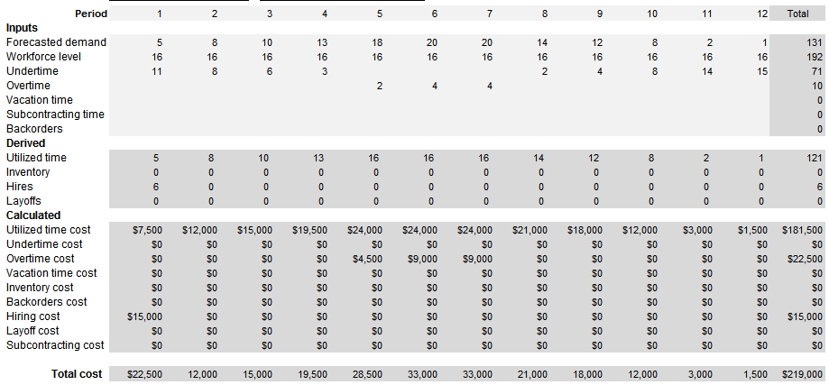

- Chase strategy
This strategy simply involves adjusting the workforce as needed to meet demand. Plan 2 shows the effect of changing the staff level with hires and layoffs.

 | 1 | 2 | 3 | 4 | 5 | 6 | 7 | 8 | 9 | 10 | 11 | 12 | Total
Requirement | 5 | 8 | 10 | 13 | 18 | 20 | 20 | 14 | 12 | 8 | 2 | 1 | 131
Staff level | 5 | 8 | 10 | 13 | 18 | 20 | 20 | 14 | 12 | 8 | 2 | 1 | 131
Hires | — | 3 | 2 | 3 | 5 | 2 | — | — | — | — | — | — | 15
Layoffs | 5 | — | — | — | — | — | — | 6 | 2 | 4 | 6 | 1 | 24
Overtime | — | — | — | — | — | — | — | — | — | — | — | — | 0

Output from OM Explorer confirms these calculations:

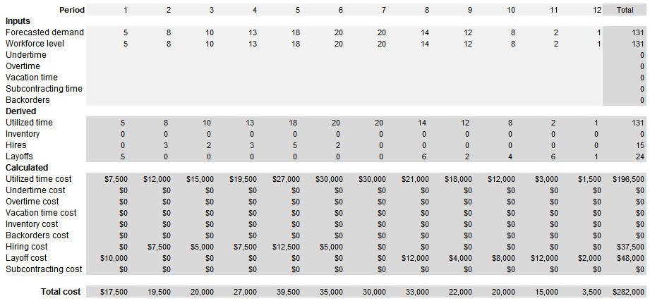

- Mixed Strategy: The Level strategy had a lower cost (because undertime has no cost) than the chase strategy (because of the frequent hiring and layoff costs). In addition, anticipation inventory is not allowed. These observations suggest a strategy of chasing the increasing demand until the peak is reached (rather than hiring them all in period 1), and then keep the workforce level at that level for the rest of the year. The plan is shown below.
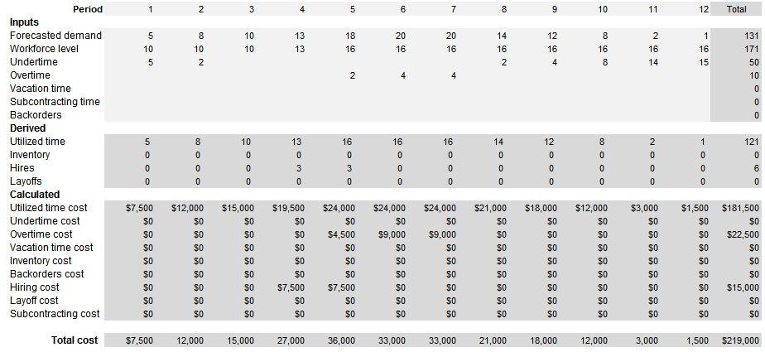
Plan 3 has the same cost as Plan 1. Management may find it better on qualitative basis, because it calls for less undertime (although still sizeable). Much depends on whether management can attract a workforce that seeks part-time jobs.

- Cost comparisons for the staffing plans

Cost | Plan 1: Level Strategy | Plan 2: Chase Strategy | Plan 3: Mixed Strategy
Utilized RT @ $1500 | 121 wrk-mo. = $181,500 | 131 worker-mo. = $196,500 | 121 worker-mo. = $181,500
OT @ $2,250 | 10 worker-mo. = $ 22,500 | 0 worker-mo. = $ 0 | 10 worker-mo. = $ 22,500
Hire @ $2,500 | 6 workers = $ 15,000 | 15 workers = $ 37,500 | 6 workers = $ 15,000
Layoff @ $2,000 | 0 workers = $ 0 | 24 workers = $ 48,000 | 0 workers = $ 0
 | Total $219,000 | $282,000 | $219,000

- Climate Control Inc.
  - If overtime is authorized only in months in which regular time production and current inventory levels are not adequate to meet the current month’s demand, not enough overtime capacity will be available. Overtime is first required in month 6. If management waits until this point to use overtime, shortages will occur.
Month | Demand | Number of Employees | Regular Production Capacity | Beginning Inventory | Ending Inventory | Overtime Required | Overtime Available
- |  | 9 |  |  | 24,000
1 | 25,000 | 9 | 18,000 | 24,000 | 17,000 | - | -
2 | 16,000 | 9 | 18,000 | 17,000 | 19,000 | - | -
3 | 15,000 | 9 | 18,000 | 19,000 | 22,000 | - | -
4 | 19,000 | 9 | 18,000 | 22,000 | 21,000 | - | -
5 | 32,000 | 9 | 18,000 | 21,000 | 7,000 | - | -
6 | 29,000 | 9 | 18,000 | 7,000 | (400) | 4,000 | 3,600
7 | 27,000 | 9 | 18,000 | (400) | (5,800) | 9,400 | 3,600
8 | 22,000 | 9 | 18,000 | (5,800) | (6,200) | 9,800 | 3,600
9 | 14,000 | 9 | 18,000 | (6,200) | - | 2,200 | 2,200
10 | 15,000 | 9 | 18,000 | - | 3,000 | - | -
11 | 20,000 | 9 | 18,000 | 3,000 | 1,000 | - | -
12 | 6,000 | 9 | 18,000 | 1,000 | 13,000 | - | -
Sum |  | 108 |  |  | 90,600 | 25,400 | 13,000

  - The ability to backorder up to 5,000 suits from month to month instead of using overtime is also an inadequate strategy. In month 6, backorders of 4000 units must be backordered. Starting in month 7 and beyond, well over the 5,000 unit limit would have to be backordered each month to keep up with demand.
Month | Demand | Number of Employees | Regular Production Capacity | Beginning Inventory | Ending Inventory | Units of Backorders Required
- |  | 9 |  |  | 24,000
1 | 25,000 | 9 | 18,000 | 24,000 | 17,000 | -
2 | 16,000 | 9 | 18,000 | 17,000 | 19,000 | -
3 | 15,000 | 9 | 18,000 | 19,000 | 22,000 | -
4 | 19,000 | 9 | 18,000 | 22,000 | 21,000 | -
5 | 32,000 | 9 | 18,000 | 21,000 | 7,000 | -
6 | 29,000 | 9 | 18,000 | 7,000 | (4,000) | 4,000
7 | 27,000 | 9 | 18,000 | (4,000) | (13,000) | 13,000
8 | 22,000 | 9 | 18,000 | (13,000) | (17,000) | 17,000
9 | 14,000 | 9 | 18,000 | (17,000) | (13,000) | 13,000
10 | 15,000 | 9 | 18,000 | (13,000) | (10,000) | 10,000
11 | 20,000 | 9 | 18,000 | (10,000) | (12,000) | 12,000

- The preemptive use of overtime in months 1-4 will adequately address the shortage issue as long as a small amount of overtime is authorized in month 8.
Month | Demand | Number of Employees | Regular Production Capacity | Beginning Inventory | Ending Inventory | Overtime Required | Overtime Used
- |  | 9 |  |  | 24,000
1 | 25,000 | 9 | 18,000 | 24,000 | 20,600 | 3,600 | 3,600
2 | 16,000 | 9 | 18,000 | 20,600 | 26,200 | 3,600 | 3,600
3 | 15,000 | 9 | 18,000 | 26,200 | 32,800 | 3,600 | 3,600
4 | 19,000 | 9 | 18,000 | 32,800 | 35,400 | 3,600 | 3,600
5 | 32,000 | 9 | 18,000 | 35,400 | 21,400 | - | -
6 | 29,000 | 9 | 18,000 | 21,400 | 10,400 | - | -
7 | 27,000 | 9 | 18,000 | 10,400 | 1,400 | - | -
8 | 22,000 | 9 | 18,000 | 1,400 | - | 2,600 | 2,600
9 | 14,000 | 9 | 18,000 | - | 4,000 | - | -
10 | 15,000 | 9 | 18,000 | 4,000 | 7,000 | - | -
11 | 20,000 | 9 | 18,000 | 7,000 | 5,000 | - | -
12 | 6,000 | 9 | 18,000 | 5,000 | 17,000 | - | -
Sum |  | 108 |  |  | 181,200 | 2,600 | 17,000

- Gretchen’s Kitchen
  - Each hamburger requires 4 minutes, each pint of chili requires 3 minutes, each drink/shake requires 2 minutes, and each bag of French fries requires 2 minutes. Because the average customer buys 2.1 hamburgers, 0.2 pint of chili, 1 drink, and 1 bag of French fries, the average time required per customer is:
2.1(4) + 0.2(3) + 1.0(2) + 1.0(2) = 13 minutes
The service requirements, given in hours, are:
 | Month
 | J | F | M | A | M | J | J | A | S | O | N | D | Total
Cust. | 3,200 | 2,600 | 3,300 | 3,900 | 3,600 | 4,200 | 4,800 | 4,200 | 3,800 | 3,600 | 3,500 | 3,000 | 43,700
Hrs.* | 693.3 | 563.3 | 715 | 845 | 780 | 910 | 1,040.0 | 910.0 | 823.3 | 780.0 | 758.3 | 650.0 | 9468.2

* In any month, the hours of requirements are the estimated number of customers times 13 minutes divided by 60 minutes.
  - Three strategies
Level strategy with overtime and undertime:
The maximum requirement in any month is 1,040 hours. The maximum number of hours an employee can work is 96 hours: 80 on regular time and 16 on overtime. Consequently, to avoid lost demand we need 1,040/96 = 10.83 or 11 employees. This gives us a monthly capacity of 11(80) = 880 hours on regular time. With this workforce we would need the following overtime: 30 hours in June, 160 hours in July, and 30 hours in August, for a total of 220 hours.
Total cost = Regular-time wages + Overtime wages + Hire costs
= 11($400)(12 months) + 220($7.50) + 1($250)
= $54,700
Modified chase strategy with a base workforce of 10:
With 10 employees the regular-time capacity is 800 hours per month. Hiring and laying off to avoid overtime and undertime results in the following plan:

 | Month
 | J | F | M | A | M | J | J | A | S | O | N | D
Requirements | 693.3 | 563.3 | 715.0 | 845.0 | 780.0 | 910.0 | 1,040.0 | 910.0 | 823.3 | 780.0 | 758.3 | 650.0
Workforce | 10 | 10 | 10 | 11 | 10 | 12 | 13 | 12 | 11 | 10 | 10 | 10
Capacity | 800 | 800 | 800 | 880 | 800 | 960 | 1,040 | 960 | 880 | 800 | 800 | 800
Hires | - | - | - | 1 | - | 2 | 1 | - | - | - | - | -
Layoffs | - | - | - | - | 1 | - | - | 1 | 1 | 1 | - | -

Total cost = Wages + Hire costs + Layoff costs
= (129 employee-months)($400) + 4($250) + 4($50)
= $52,800
Chase strategy:
With this plan, hiring and laying off is used to match the requirements without the need for overtime.
 | Month
 | J | F | M | A | M | J | J | A | S | O | N | D
Requirements | 693.3 | 563.3 | 715 | 845 | 780 | 910 | 1,040.0 | 910.0 | 823.3 | 780.0 | 758.3 | 650.0
Workforce | 9 | 8 | 9 | 11 | 10 | 12 | 13 | 12 | 11 | 10 | 10 | 9
Capacity | 720 | 640 | 720 | 880 | 800 | 960 | 1,040 | 960 | 880 | 800 | 800 | 720
Hires | — | — | 1 | 2 | — | 2 | 1 | — | — | — | — | —
Layoffs | 1 | 1 | — | — | 1 | — | — | 1 | 1 | 1 | — | 1
Total cost = Wages + Hire costs + Layoff costs
= (124 employee-months)($400) + 6(250) + 7($50)
= $51,450
The best plan is the chase strategy.
  - If the cost of hiring were only $50, the total costs of the plans would be:
Level strategy: $54,500
Modified chase strategy with base workforce: $52,000
Chase strategy: $50,250
The strategy would not change in this case. The best is still a pure chase strategy. However, the manager should consider employee morale. Hiring and laying off employees may cause a reduction in productivity. Eventually, it may be difficult to find employees willing to work if they think they may be laid off after a few months.
- King Kool Company
- Level strategy with overtime, undertime, and vacations:.
The following plan calls for a level workforce of 142 employees, because when combined with 28 employee-month equivalents (or 0.20 x 142 = 28.4) of overtime in June avoids any backorders. The total cost is $2,706,000. The plan’s biggest advantage is a stable workforce. However, inventory is not allowed with the level strategy. The workforce must be increased, and yet undertime and overtime costs are high. Paid vacations amount to 65 employee-month periods (or 0.5 x 130) for the current employees, and are used during the slack season. If demand holds up in the following year, paid vacations would increase to 71 periods for all 142 employees.

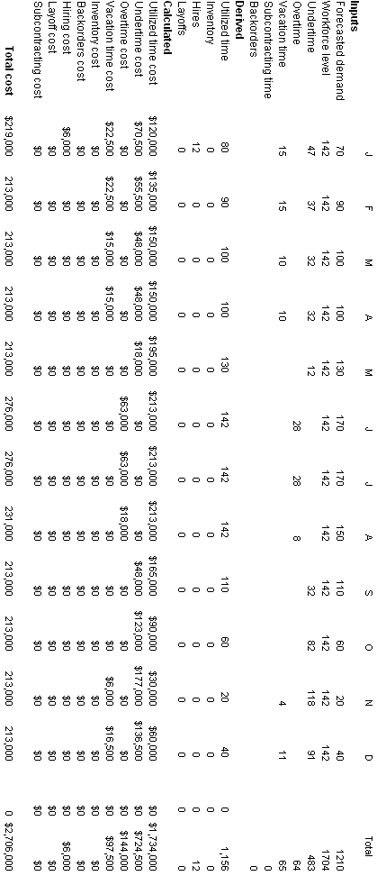

- Chase strategy with vacations:
The following plan costs less at $2,285,000. However, the workforce fluctuates widely, which creates a considerable amount of hiring and layoffs. Students may not agree on how many periods to provide for paid vacations. Accounting students will argue that vacation time is accrued; that so long as an employee is on the workforce at the end of the previous year, he/she gets vacation the following year; i.e at least all 80 in January, if not all 130 current employees who’ve already earned it.
Here we provide overtime during November and December, and base the amount on the workforce size at the end of October, or 60 x 0.5 = 30. If it is based on the number employed in November, only 40 vacations periods are needed, which reduces the cost to $2,265,000. One does wonder if this plan does justice to the workers who have been with the company for years.

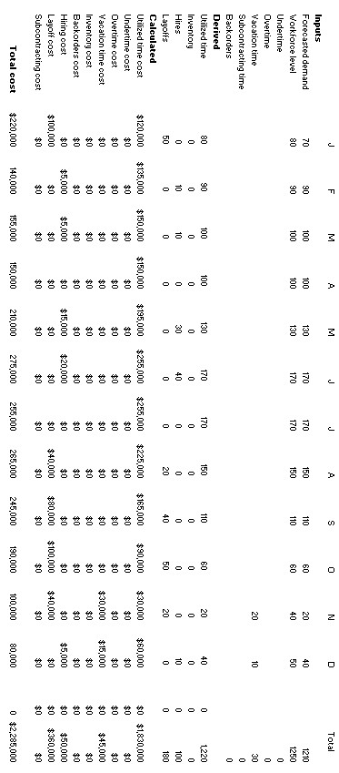

- Mixed strategy with inventory, overtime, backorders and vacations:
The cost of the following plan costs drops to $2,239,000. The workforce is smaller and more stable, and only 50 vacation periods are needed (or 100 x 0.5). If 59 vacation periods are provided, given the 118-person workforce in September, the cost would not really change. The 9 extra vacation periods would be offset by a 9-period decrease in undertime (if it is provided in October-December). In balance, this plan seems to be the best of the three plans presented.

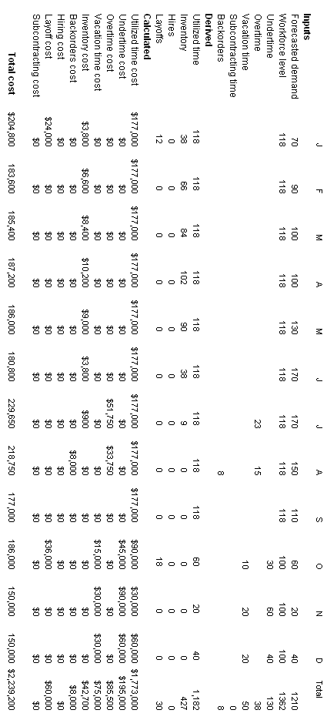

- Breakeven Analysis
The fixed cost for the regular time only is the sum of the hire and layoff costs, whereas the fixed cost of the overtime option is $0. Setting the total cost of the regular time only option to the total cost of the overtime option, and solving for w, we get:
5,000 + 500w = 750w
250w = 5,000
w = 20
Thus the hire/layoff option using regular time only has a lower cost than overtime if the duration of the demand surge exceeds 20 weeks.

- Michaels Distribution Center
Day | M | T | W | Th | F | S | Su
Requirements | 6 | 3 | 5 | 3 | 7 | 2 | 3

M | T | W | Th | F | S | Su | Employee
6 | 3 | 5 | 3 | 7 | 2 | 3 | 1
5 | 2 | 4 | 2 | 6 | 2 | 3 | 2
4 | 1 | 3 | 1 | 5 | 2 | 3 | 3
3 | 1 | 3 | 0 | 4 | 1 | 2 | 4
2 | 0 | 2 | 0 | 3 | 1 | 2 | 5
1 | 0 | 2 | 0 | 2 | 0 | 1 | 6
0 | 0 | 1 | 0 | 1 | 0 | 1 | 7

The number of employees is 7. They are scheduled to take the boxed days off.

- Cara Ryder’s ski school needs 11 instructors.
- Alternative 1. The heuristic does have a number of different solutions.
M | T | W | Th | F | S | Su | Instructor
7 | 5 | 4 | 5 | 6 | 9 | 8 | 1
6 | 5 | 4 | 5 | 5 | 8 | 7 | 2
2
5 | 4 | 4 | 5 | 5 | 7 | 6 | 3
5 | 4 | 4 | 4 | 4 | 6 | 5 | 4
4 | 4 | 4 | 4 | 3 | 5 | 4 | 5
3 | 3 | 4 | 4 | 3 | 4 | 3 | 6
3 | 3 | 3 | 3 | 2 | 3 | 3 | 7
2 | 2 | 2 | 2 | 2 | 3 | 3 | 8
2 | 2 | 2 | 1 | 1 | 2 | 2 | 9
1 | 1 | 1 | 1 | 1 | 2 | 1 | 10
1 | 1 | 0 | 0 | 0 | 1 | 0 | 11
- Instructors are scheduled to take the boxed days off in the solution shown in part (a).

 | M | T | W | Th | F | S | Su
On-duty | 7 | 5 | 4 | 5 | 6 | 9 | 8
Requirements | 7 | 5 | 4 | 5 | 6 | 9 | 8
Slack | 0 | 0 | 0 | 0 | 0 | 0 | 0
Alternative 2 (Optional)

M | T | W | Th | F | S | Su | Instructor
7 | 5 | 4 | 5 | 6 | 9 | 8 | 1
6 | 5 | 4 | 5 | 5 | 8 | 7 | 2
5 | 4 | 4 | 5 | 5 | 7 | 6 | 3
5 | 4 | 4 | 4 | 4 | 6 | 5 | 4
4 | 3 | 4 | 4 | 4 | 5 | 4 | 5
4 | 3 | 3 | 3 | 3 | 4 | 4 | 6
3 | 3 | 3 | 3 | 2 | 3 | 3 | 7
2 | 2 | 2 | 2 | 2 | 3 | 3 | 8
2 | 2 | 2 | 1 | 1 | 2 | 2 | 9
1 | 1 | 1 | 1 | 1 | 2 | 1 | 10
1 | 1 | 0 | 0 | 0 | 1 | 1 | 11

Instructors are scheduled to take the boxed days off.

 | M | T | W | Th | F | S | Su
On-duty | 7 | 5 | 4 | 5 | 6 | 9 | 8
Requirements | 7 | 5 | 4 | 5 | 6 | 9 | 8
Slack | 0 | 0 | 0 | 0 | 0 | 0 | 0

- The environmentally progressive mayor of Cambridge, Colorado.
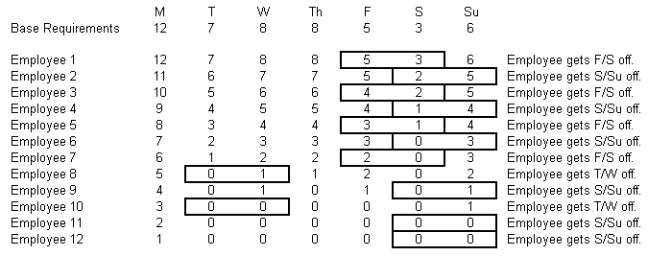
- We used Workforce Scheduler Solver in OM Explorer to arrive at the minimum number of collectors. For each employee, the sentences on the right show his or her two off-days.
The minimum number of employees is 12. However, many schedules (particular assignments of on-duty periods) are possible.
- The work schedule for the analysis in part (a) is to assign employees the stipulated days off.

On-duty | 12 | 10 | 10 | 10 | 7 | 4 | 7
Requirements | 12 | 7 | 9 | 9 | 5 | 3 | 6
Slack | 0 | 3 | 1 | 1 | 2 | 1 | 1
- We can use the heuristic method again to find whether we can get by with fewer employees. One solution follows.
- Only 11 employees would be needed now. Total slack generated from this work schedule is:
M | T | W | Th | F | S | Su | Employee
8 | 7 | 7 | 7 | 7 | 7 | 7 | 1
7 | 6 | 6 | 6 | 6 | 7 | 7 | 2
6 | 5 | 5 | 6 | 6 | 6 | 6 | 3
5 | 5 | 5 | 5 | 5 | 5 | 5 | 4
4 | 4 | 4 | 4 | 4 | 5 | 5 | 5
3 | 3 | 3 | 4 | 4 | 4 | 4 | 6
2 | 3 | 3 | 3 | 3 | 3 | 3 | 7
2 | 3 | 2 | 2 | 2 | 2 | 2 | 8
1 | 2 | 1 | 1 | 1 | 2 | 2 | 9
0 | 1 | 0 | 1 | 1 | 1 | 1 | 10
0 | 1 | 0 | 0 | 0 | 0 | 0 | 11

 | M | T | W | Th | F | S | Su
On-duty | 9 | 7 | 9 | 8 | 8 | 7 | 7
Requirements | 8 | 7 | 7 | 7 | 7 | 7 | 7
Slack | 1 | 0 | 2 | 1 | 1 | 0 | 0

- With preference to S-Su pairs.

M | T | W | Th | F | S | Su | Employee
8 | 7 | 7 | 7 | 7 | 7 | 7 | 1
7 | 6 | 6 | 6 | 6 | 7 | 7 | 2
6 | 5 | 5 | 6 | 6 | 6 | 6 | 3
5 | 5 | 5 | 5 | 5 | 5 | 5 | 4
4 | 4 | 4 | 4 | 4 | 5 | 5 | 5
3 | 3 | 3 | 4 | 4 | 4 | 4 | 6
2 | 3 | 3 | 3 | 3 | 3 | 3 | 7
2 | 2 | 2 | 2 | 2 | 2 | 3 | 8
1 | 1 | 1 | 1 | 2 | 2 | 2 | 9
0 | 0 | 1 | 1 | 1 | 1 | 1 | 10

The number of employees needed is reduced to 10, and no slack is generated from this solution.

 | M | T | W | Th | F | S | Su
On-duty | 8 | 7 | 7 | 7 | 7 | 7 | 7
Requirements | 8 | 7 | 7 | 7 | 7 | 7 | 7
Slack | 0 | 0 | 0 | 0 | 0 | 0 | 0

iii. Because each employee requires a truck, the number of trucks needed would be 8 to cover Monday, even though the actual number of employees available would be 9 in the solution (i). Assuming that extra employees are put to work doing some support activities, the smoothing of the workload will result in a reduction of 4 trucks over the requirements schedule in part (a).

- Little 6, Inc.
As shown in the following table, the number of accountants required each day is a function of the number of each type of return to be prepared. For example, on Tuesday the demand for an accountant’s time is (14x1.5 hrs)+(10x4.0 hrs) = 61 hrs. Since each accountant can work no more than 10 hours per day, 7 accountants are needed.
 |  | Time | M | T | W | Th | F | S | Su
 | Personal tax returns | 1.5 | 24 | 14 | 18 | 18 | 10 | 28 | 16
 | Corporate tax returns | 4.0 | 16 | 10 | 12 | 15 | 224 | 12 | 4
 | Total hours required |  | 100 | 61 | 75 | 87 | 111 | 90 | 40
 | Accountants | 10.0 | 10 | 7 | 8 | 9 | 12 | 9 | 4

  - The following table provides definitions for the Linear Programming decision variables (“W” indicates a work day). Thus, accountants assigned to schedule X1 will work Monday – Friday

Decision Variable | Monday | Tuesday | Wednesday | Thursday | Friday | Saturday | Sunday
X₁  X₂  X₃  X₄  X₅  X₆  X₇ | W  W  W  W  W | W  W  W  W  W | W  W  W  W  W | W  W  W  W  W | W  W  W  W  W | W  W  W  W  W | W  W  W  W  W
Demand | 10 | 7 | 8 | 9 | 12 | 9 | 4

One optimal solution is provided in the following table

Decision Variable | Monday | Tuesday | Wednesday | Thursday | Friday | Saturday | Sunday | Number of Accountants Scheduled
X₁  X₂  X₃  X₄  X₅  X₆  X₇ | W  W  W  W  W | W  W  W  W  W | W  W  W  W  W | W  W  W  W  W | W  W  W  W  W | W  W  W  W  W | W  W  W  W  W | 4  3  0  2  3  1  0
Demand | 10 | 7 | 8 | 9 | 12 | 9 | 4 | 59
Supply | 10 | 11 | 8 | 9 | 12 | 9 | 6 | 65
Surplus |  | 4 |  |  |  |  | 2 | 6

In this accountant-minimizing solution of 13 accountants, 4 accountants work Monday-Friday, 3 accountants work Tuesday – Saturday, 2 accountants work Thursday – Monday, 3 accountants work Friday – Tuesday, and 1 accountant works Saturday – Wednesday.

The POM for Windows Linear Programming formulation for part a:

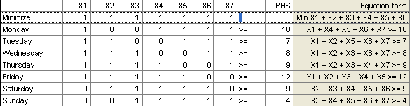

The POM for Windows Linear Programming solution for part a:

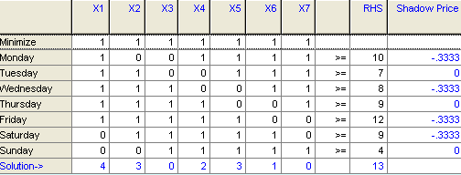
POMS for Windows finds the same optimal solution with 13 accountants.

  - Linear Programming decision variable definitions (“W” indicates a work day) and objective function coefficients.
Decision Variable | Monday | Tuesday | Wednesday | Thursday | Friday | Saturday | Sunday | Payrate
X₁  X₂  X₃  X₄  X₅  X₆  X₇ | W  W  W  W  W | W  W  W  W  W | W  W  W  W  W | W  W  W  W  W | W  W  W  W  W | W  W  W  W  W | W  W  W  W  W | $1,200  $1,300  $1,450  $1,450  $1,450  $1,450  $1,350

The solution is provided in the following table
Decision Variable | Monday | Tuesday | Wednesday | Thursday | Friday | Saturday | Sunday | Number of Accountants Scheduled | Weekly  Payroll  Cost
X₁  X₂  X₃  X₄  X₅  X₆  X₇ | W  W  W  W  W | W  W  W  W  W | W  W  W  W  W | W  W  W  W  W | W  W  W  W  W | W  W  W  W  W | W  W  W  W  W | 4  3  0  2  3  1  0 | $4,800  $3,900  $0  $2,900  $4,350  $1,450  $0
Demand | 10 | 7 | 8 | 9 | 12 | 9 | 4 | 59 | $17,400
Supply | 10 | 11 | 8 | 9 | 12 | 9 | 6 | 65
Surplus |  | 4 |  |  |  |  | 2 | 6
In this payroll-minimizing solution, 4 accountants work Monday-Friday, 3 accountants work Tuesday – Saturday, 2 accountants work Thursday – Monday, 3 accountants work Friday – Tuesday, and 1 accountant works Saturday – Wednesday. The total payroll cost is $17,400

The POM for Windows Linear Programming formulation and solution for part b:
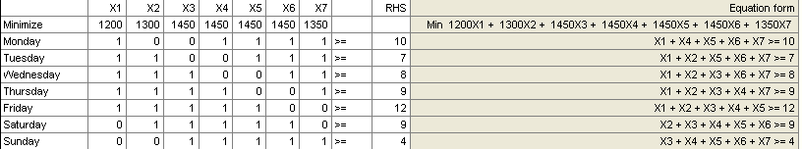

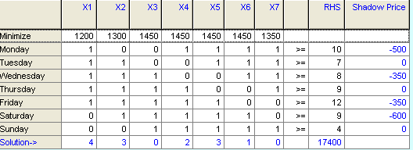

POMS for Windows finds the same optimal solution with 13 accountants and a total payroll cost of $17,400.

  - Linear Programming decision variable definitions (“W” indicates a work day) and objective function coefficients. Variable X₈ has been included to represent the part-time employees available to work Friday – Sunday.

Decision Variable | Monday | Tuesday | Wednesday | Thursday | Friday | Saturday | Sunday | Payrate
X₁  X₂  X₃  X₄  X₅  X₆  X₇  X₈ | W  W  W  W  W | W  W  W  W  W | W  W  W  W  W | W  W  W  W  W | W  W  W  W  W  W | W  W  W  W  W  W | W  W  W  W  W  W | $1200  $1300  $1450  $1450  $1450  $1450  $1350  $800

The solution is provided in the following table

Decision Variable | Monday | Tuesday | Wednesday | Thursday | Friday | Saturday | Sunday | Number of Accountants Scheduled | Weekly  Payroll  Cost
X₁  X₂  X₃  X₄  X₅  X₆  X₇  X₈ | W  W  W  W  W | W  W  W  W  W | W  W  W  W  W | W  W  W  W  W | W  W  W  W  W  W | W  W  W  W  W  W | W  W  W  W  W  W | 5  1  0  3  0  2  0  3 | $6,000  $1,300  $0  $4,350  $0  $2,900  $0  $2,400
Demand | 10 | 7 | 8 | 9 | 12 | 9 | 4 | 59 | $16,950
Supply | 10 | 8 | 8 | 9 | 12 | 9 | 8 | 64
Surplus |  | 1 |  |  |  |  | 4 | 5
In this payroll-minimizing solution, 5 accountants work Monday-Friday, 1 accountant work Tuesday – Saturday, 3 accountants work Thursday – Monday, 2 accountants work Saturday to Wednesday, and 3 temp accountant work Friday Sunday. The total payroll cost is $16,950. a savings of $450. over the optimal solution in part b.

The POM for Windows Linear Programming formulation and solution for part c:

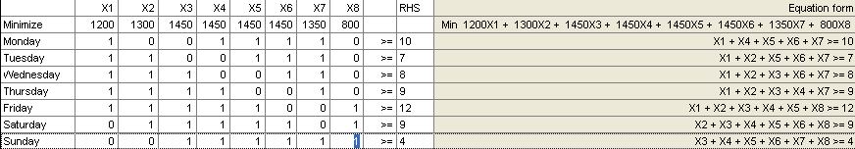

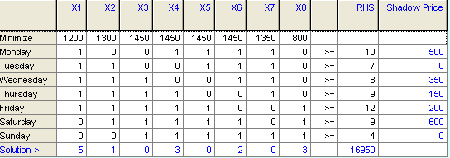

POMS for Windows finds the same optimal solution with a total payroll cost of $16,950.

- Return to Problem 11.
The following table provides definitions for the Linear Programming decision variables (“W” indicates a work day). Thus, loading dock workers assigned to schedule X1 will work Monday – Wednesday.

Decision Variable | Monday | Tuesday | Wednesday | Thursday | Friday | Saturday | Sunday
X₁  X₂  X₃  X₄  X₅  X₆  X₇ | W  W  W | W  W  W | W  W  W | W  W  W | W  W  W | W  W  W | W  W  W
Demand | 6 | 3 | 5 | 3 | 7 | 2 | 3

The solution is provided in the following table. 13 workers are required.

Decision Variable | Monday | Tuesday | Wednesday | Thursday | Friday | Saturday | Sunday | Number of Loaders Scheduled
X₁  X₂  X₃  X₄  X₅  X₆  X₇ | W  W  W | W  W  W | W  W  W | W  W  W | W  W  W | W  W  W | W  W  W | 5  0  5  0  2  0  1
Demand | 6 | 3 | 5 | 3 | 7 | 2 | 3 | 29
Supply | 6 | 6 | 10 | 5 | 7 | 2 | 3 | 39
Surplus |  | 3 | 5 | 2 |  |  |  | 10
The POM for Windows Linear Programming model formulation and solution:
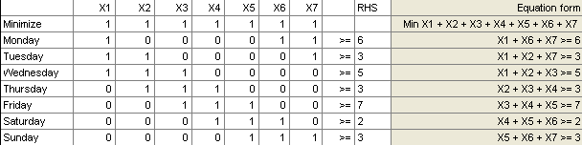

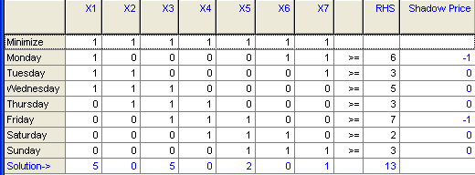

POMS for Windows finds the same optimal solution with 13 workers required.

- Hickory Company
  - Schedules for two rules
FCFS rule:
Customer Sequence | Hr Since Order Arrived | Start Time (hr) |  | Machine Time (hr) |  | Finish Time (hr) | Due Date(hr) | Past Due (hr) | Flow Time (hr)
1 | 6 | 0 | + | 10 | = | 10 | 12 | 0 | 16
2 | 5 | 10 | + | 3 | = | 13 | 8 | 5 | 18
3 | 3 | 13 | + | 15 | = | 28 | 18 | 10 | 31
4 | 1 | 28 | + | 9 | = | 37 | 20 | 17 | 38
5 | 0 | 37 | + | 7 | = | 44 | 21 | 23 | 44
Average flow time = $\frac{\text{16}+\text{18}+\text{31}+\text{38}+\text{44}}{5}$ = 29.4 hours
Average hours past due = $\frac{0+5+\text{10}+\text{17}+\text{23}}{5}$ = 11.0 hours
EDD rule:
Customer Sequence | Hr Since Order Arrived | Start Time (hr) |  | Machine Time (hr) |  | Finish Time (hr) | Due Date(hr) | Hr Past Date | Flow Time (hr)
2 | 5 | 0 | + | 3 | = | 3 | 8 | 0 | 8
1 | 6 | 3 | + | 10 | = | 13 | 12 | 1 | 19
3 | 3 | 13 | + | 15 | = | 28 | 18 | 10 | 31
4 | 1 | 28 | + | 9 | = | 37 | 20 | 17 | 38
5 | 0 | 37 | + | 7 | = | 44 | 21 | 23 | 44
Average flow time = $\frac{8+\text{19}+\text{31}+\text{38}+\text{44}}{5}$ = 28.0 hours
Average hours past due = $\frac{0+1+\text{10}+\text{17}+\text{23}}{5}$ = 10.2 hours
The EDD rule is better than FCFS on both average flow time (28.0 vs. 29.4) and average hours past due (10.2 vs. 11.0). It gives the better schedule, although this is not always true.

- Website designer
  - Schedules for two rules
FCFS rule:
Customer Sequence | Day Order Arrived | Start Time (days) |  | Processing Time (days) |  | Finish Time (days) | Due Date | Days Past Date | Flow Time (days)
A | 180 | 190 | + | 20 | = | 210 | 216 | 0 | 30
B | 182 | 210 | + | 12 | = | 222 | 240 | 0 | 40
C | 184 | 222 | + | 28 | = | 250 | 256 | 0 | 66
D | 187 | 250 | + | 24 | = | 274 | 248 | 26 | 87
E | 188 | 274 | + | 32 | = | 306 | 290 | 16 | 118
 |  |  |  |  |  |  | Average | 8.4 | 68.2
Average flow time = $\frac{\text{30}+\text{40}+\text{66}+\text{87}+\text{118}}{5}$ = 68.2 days
Average days past due = = 8.4 days
EDD RULE:
Customer Sequence | Day Order Arrived | Start Time (days) |  | Processing Time (days) |  | Finish Time (days) | Due Date | Days Past Date | Flow Time (days)
A | 180 | 190 | + | 20 | = | 210 | 216 | 0 | 30
B | 182 | 210 | + | 12 | = | 222 | 240 | 0 | 40
D | 187 | 222 | + | 24 | = | 246 | 248 | 0 | 59
C | 184 | 246 | + | 28 | = | 274 | 256 | 18 | 90
E | 188 | 274 | + | 32 | = | 306 | 290 | 16 | 118
 |  |  |  |  |  |  | Average | 6.8 | 67.4
Average flow time = $\frac{\text{30}+\text{40}+\text{59}+\text{90}+\text{118}}{5}$ = 67.4 days
Average days past due = = 6.8 days

  - The EDD rule is better than FCFS on both average flow time (67.4 vs. 68.2) and average days past due (6.8 vs. 8.4). It gives the better schedule, although this is not always true.

- Mowry Machine Shop
- Schedules for two rules
FCFS rule:
Customer Sequence | Day Order Arrived | Start Time (days) |  | Processing Time (days) |  | Finish Time (days) | Due Date | Days Past Date | Flow Time (days)
A | 12 | 23 | + | 10 | = | 33 | 45 | 0 | 21
B | 13 | 33 | + | 8 | = | 41 | 36 | 5 | 28
C | 15 | 41 | + | 4 | = | 45 | 42 | 3 | 30
 | 17 | 45 | + | 4 | = | 49 | 39 | 10 | 32
 | 22 | 49 | + | 3 | = | 52 | 53 | 0 | 30
Average flow time = $\frac{\text{21}+\text{28}+\text{30}+\text{32}+\text{30}}{5}$ = 28.2 days
Average days past due = $\frac{0+5+3+\text{10}+0}{5}$ = 3.6 days
EDD rule:
Customer Sequence | Day Order Arrived | Start Time (days) |  | Processing Time (days) |  | Finish Time (days) | Due Date | Days Past Date | Flow Time (days)
B | 13 | 23 | + | 8 | = | 31 | 36 | 0 | 18
 | 17 | 31 | + | 4 | = | 35 | 39 | 0 | 18
C | 15 | 35 | + | 4 | = | 39 | 42 | 0 | 24
A | 12 | 39 | + | 10 | = | 49 | 45 | 4 | 37
 | 22 | 49 | + | 3 | = | 52 | 53 | 0 | 30
Average flow time = $\frac{\text{18}+\text{18}+\text{24}+\text{37}+\text{30}}{5}$ = 25.4 days
Average days past due = $\frac{0+0+0+4+0}{5}$ = 0.8 days
- The EDD rule is better than FCFS on both average flow time (25.4 vs. 28.2) and average days past due (0.8 vs. 3.6). It gives the better schedule, although this is not always true.

CASE: MEMORIAL HOSPITAL *

A. Synopsis
Memorial Hospital is a 265-bed regional hospital serving western North Carolina. The hospital is segmented into eight major care areas for the purpose of allocating nursing staff. Darlene Fry, Director of Nursing, is facing the annual problem of planning the nurse staffing levels for the upcoming year. Information pertaining to average patient census across the eight care areas as well as target patient-to-nurse ratios is presented. Students are also provided with sufficient cost data to help Darlene develop for next year a staffing plan that conforms to the mission and objectives of the hospital.
B. Purpose
The primary objective of the case is to have students develop a nurse staffing plan for Memorial Hospital next year. Parameters and data to allow students to use both demand and supply options to developing a feasible staffing plan are provided in the case. Available options that you should expect students to use and discuss in their plan include:
q Hiring and firing/layoff
q Overtime and undertime
q Use of temporary nurses (i.e., subcontracting)
q Use of vacations
q Cross training to be able to assign nurses across different care areas
q Offering new services such as HMOs for preventive medical care to keep skilled nurses employed
Students should be expected to address the trade-offs presented by the hospital’s stated objectives, the costs of different options, and the projected demands for nursing services.
Students should also be able to begin to see the issues that are faced in the more detailed scheduling of personnel.
C. Analysis
Darlene faces several trade-offs to meet her three key objectives: maximizing customer service, minimizing costs, and minimizing workforce fluctuations. In general, maximizing customer service requires, on average, a larger nursing staff, which may possibly cause a direct trade-off with cost minimization. Minimizing workforce fluctuations requires some combination of overstaffing during slow months and using overtime or temp workers during heavy months.
Darlene can follow one of the three general staffing strategies—chase, modified level, or mixed.
q The chase strategy doesn’t seem to be a desirable strategy based on both minimizing the workforce fluctuation and maximizing customer service objectives. In addition, the strategy has little advantage over a mixed strategy that can reduce the overstaffing/ understaffing and hiring/layoff costs.
q A modified level strategy means establishing a constant workforce level and then using a combination of temp workers and overtime during peak periods and undertime and vacations during slow periods. We call it “modified” because the use of temp workers is not level. This strategy would best meet the workforce fluctuation objective.
q A mixed strategy would use near level staffing with a minimal amount of hiring and/or layoffs during the peak and slow seasons. This strategy would require the trade-offs between the level workforce objective and the customer service and minimal cost objectives.
Students must first establish some guidelines for their analysis along with any simplifying assumptions. Some reasonable assumptions would be:
q The nurses in the seven care areas (ignoring surgery in this analysis) are interchangeable due to cross training. This level of aggregation may be too much of a simplification assumption for some students, who instead break them down into clusters of wards. For example, one way to disaggregate would be to have three subgroups. Subgroup 1 would consist of Intensive Care, Cardiac, Emergency, and Post Op; Subgroup 2 would have Maternity and Pediatric; and Subgroup 3 would be General. Transfers are allowed within the subgroups, but not between them. With this more disaggregate approach, students must make an assumption on how the current workforce of 110 nurses (excluding the 20 surgical nurses) is allocated to the three subgroups. Factors to consider if nurses are not aggregated into one workforce are: (1) similarity of skill requirements between wards, (2) differences in seasonal patient census patterns, and (3) translating nurse requirements into integers.
q The average daily patient census given in Table 15.4 indicates the patients needing care over the entire 24-hour period, seven days per week, and each week of the year. The daily data are assumed to be an average for the entire day; therefore differences between night and day shifts are accounted for in the data.
q Nurse requirements will be rounded up to the nearest full-time equivalent (FTE). A different approach is rounding to the nearest integer, either up or down. Students will differ as to how and when they convert to integer numbers. The rounding assumption, coupled by the level of aggregation of the workforce, can significantly affect their final determination of the number of FTE nurses required per month, and therefore total costs. A more detailed analysis can even allow partial FTEs and assign overtime to cover these requirements.
q Some assumption or decision must be made as to what constitutes a full week of regular time, so that nurse requirements can be expressed in terms of this number of hours. A common choice is a 40-hour week, because the case states current practice is four 10-hour days. Some hospitals are also moving to 12-hour days, which also could be considered. For our purposes here, we assume a nurse works 40 hours of regular time each week and can work another 20 hours on overtime each week (as long as not used excessively).
q Some allowance needs to be made for paid vacations. A plausible assumption is that vacation periods of four weeks (1/13 of a year) per full-time nurse can be assigned as needed across the year. The amount currently on the staff at the beginning of the planning horizon might be the ones entitled to a vacation, or perhaps the new ones hired are not entitled to vacations during their first year. A common tactic is to assign more vacation time for slow months and less vacation time for peak months, while not being so extreme in the assignments as to create excessive nurse dissatisfaction.
q Nurses can be given up to 10 hours per week of unpaid undertime, working only 30 hours per week. However, most students pass up this possible cost savings in favor of paying undertime, with each nurse working a minimum of 40 hours per week. This assumption is based on qualitative considerations, such as minimizing the amount of attrition from nurses seeking better jobs elsewhere.
Given these assumptions, some preliminary analysis can be done on the relative attractiveness of the reactive alternatives. Three comparisons are given following:
1. Hire/layoff versus temps
$400 hire temp = $3/hr premium
$150 layoff
$550 total
$550 ÷ $3/hr = 183 hours or 4–5 weeks
It is less expensive to hire a new nurse than to use a temporary nurse for over five weeks.
2. Overtime versus temps
It is less expensive to use temporary nurses than to use an FTE nurse on overtime.
Temporary nurse $15/hour
Overtime $18/hour
3. Hire/layoff versus overtime
$550 ÷ $6/hour premium = 92 hours or 2–3 weeks
It is less expensive to hire a new nurse than to pay an FTE overtime for more than three weeks. (Maximum overtime for any one nurse is 20 hours per week.)

These three comparisons suggest that a low-cost solution would avoid excessive overtime, giving preference to temps, undertime, and vacation timing. Hiring and layoffs also appear attractive on a cost basis, except that the CEO lists aims to minimize fluctuations in workforce levels. Thus a near-level workforce, coupled with a liberal use of temps and judicious use of vacations, might lead to a good solution.
There are several ways to get the requirements row. Here are two approaches, illustrated for the Intensive Care (ICU) ward in the month of January:
1. Divide the average daily patient census per month in Table 15.5 by the patients per nurse required in Table 15.4, getting the number of nurses needed round the clock, 7 days per week. For ICU, it is 13/2 = 6.5. Multiply this number by 168 hours per week (7 days × 24 hours/day) and divide the product by the regular time capacity per week of one nurse. For the ICU ward, we get (6.5 × 168)/ 40 = 27.3 nurses. The equivalent of 27.3 nurses working 40 hours a week is required. Some students might inflate this number to account for lost vacation time, which is acceptable as long as they do not double count the vacations with their spreadsheets. The final number would be pooled with like numbers for the other wards in the workforce (or subgroup), and then rounded to an integer.
2. Another approach is to determine the total number of nurse hours needed each month, and then dividing by the regular time capacity made available over a month’s time. The result should be comparable, depending on how many weeks (or days) are assumed in each month. For the ICU in January, the total demand in ICU nursing hours in January would be (13/2) × 24 hours/day × 31 days, or 4836 nurse hours. There are 4.43 weeks in January, so the typical nurse provides a month capacity of 177 hours. Dividing 4836 by this number gives 27.3 nurses required as before.
Using such logic, students will develop a projection of nurse requirements over the planning horizon, and then generate a number of feasible staffing plans using different strategies. One such plan is given in Appendix A. This plan holds that the nurse requirements in January for the whole workforce are 153 FTEs (with 40-hour weeks) and provides a level workforce throughout the year. The requirements show that Memorial Hospital has been understaffed, and proposes the workforce be increased to 148 full-time nurses. It uses no planned undertime and overtime, but depends instead on the temps and vacation schedules to handle the peaks and valleys of demand.
D. Recommendations
Obviously, the recommendations from the students will vary widely depending on the assumptions made and importance attributed to various qualitative factors. As the assumptions are relaxed, the staffing plan becomes more complex and difficult to develop.
E. Teaching Suggestions: As an Experiential Exercise
This case makes for an excellent team-based experiential exercise, spread over two days. It might take 45 minutes in the first day, and 30 minutes in the second day.

Day 1
Before the first day, have the class read over the case and ask each team to bring at least one laptop to class. When the session begins, get the teams to puzzle over the requirements and costs, with the goal to get them into using OM Explorer’s Sales and Operations Planning With Spreadsheets Solver. They can talk about likely strategies and perhaps try out several ones before the end of the class. In getting agreement on the requirements, make sure that they understand the need for 24-hour care (must provide for round-the-clock staffing). They must also decide how much to aggregate in dealing with the seven care areas (interchangeable or not), decide how to handle noninteger requirements (round or leave fractional), what to make a full-time week, how to handle paid vacations, whether to allow some unpaid undertime, and the like.

Day 2
For the second day, each team is to prepare a three-page report (maximum) describing their basic approach, strategy selected, spreadsheet (maybe sent by e-mail), and reasons why it is best (including qualitative factors). The instructor can make a transparency of the team results and lead the discussion of their results, seeing who (1) had low cost (open up their spreadsheet) and (2) had best for qualitative reasons (open up their spreadsheets). Maybe also bring out some basic analysis of:
q Hire/layoff versus temps
q Overtime versus temps
q Hire/layoff versus overtime
F. Teaching Suggestions: Out-of-Class Exercise
A more traditional approach is to assign it as an out-of-class exercise. Tell the students that they are to analyze the situation and can make some reasonable simplifying assumptions, but their assignment is to bring to class a staffing plan that they can share. They should be required to explain any assumptions made and to defend how their plan meets the three objectives of the hospital.
In class it is best to start with a general discussion of the alternative approaches that can be used to develop a staffing plan and how different approaches (level, chase, and mixed) may impact the hospital’s objectives differently. Then have the students present their plans and explain their analysis and rationale. You may have to be prepared to show one of the plans provided to get the ball rolling.
After a few plans have been discussed, note that the differences are generally accounted for by the differing assumptions that were made or the differing priorities that were given the three objectives. Be sure that the students understand the impact assumptions such as the following have on staffing plans:
q Using FTE nurses versus partial nurses—overtime would be more appropriate when partial nurses are used.
q Interchangeability of nurses—the staffing plan would be more modularized by department without this assumption.
q Use of vacation periods as needed—loss of flexibility here would probably increase the requirements and costs.
The case can take as much time as you wish depending on the number of staffing plans you have students present. You should allow at least 30 to 45 minutes to discuss the issues and alternatives thoroughly.
APPENDIX A
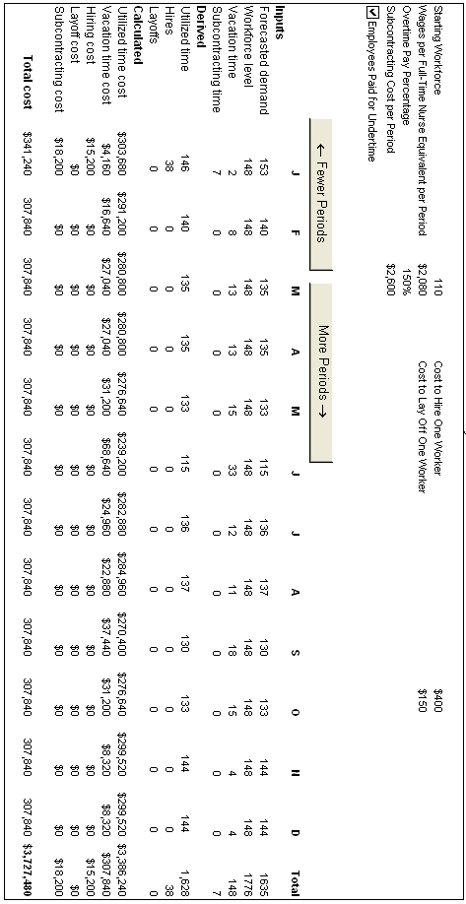

ADDITIONAL CASE

CASE: FOOD KING *

A. Synopsis
The Food King case is set in the grocery supermarket industry where competition is severe and profit margins are a very small percentage of revenues. The principal in the case, Marty Moyer, has recently been promoted to the position of store manager at a large, flagship store in Columbia, South Carolina. Competitive positioning of the supermarket chain’s service package has just been revised, and the store has recently adopted a 24-hour-a-day, 7-days-a-week open-door policy. The problem facing Marty is to develop a work schedule for the stocking/bagging employees that will satisfy competitive priorities and, at the same time, control costs.

B. Purpose
This case is designed to expose students to issues pertaining to scheduling workers in a service environment where demand typically exhibits large fluctuations over very short periods of time within a day or even within a shift.
Specific issues the case is meant to illustrate include:
q Adjusting capacity to meet demand, given workforce scheduling constraints concerning:
—Organizational policies
—Legal restrictions
—Behavioral/psychological factors
—Minimizing cost
q Seeing how the scheduling of workers impacts the ability of organizations to meet competitive priorities.
q Receiving enough information concerning demand, work policies, and costs to enable students to develop a work schedule.
q Rotating versus fixed work schedules within the context of meeting behavioral needs of the younger workers specifically.
q Appropriate measures for determining the effectiveness of the resulting schedule with respect to meeting the competitive priorities of Food King.

C. Analysis
The analysis should begin with a discussion of the target market and the accompanying shopper priorities. The issue here is translating customer requirements into organizational competitive priorities. Customer requirements given in the case were:
q Cleanliness
q Availability
q Timely service
q Reasonable prices

These requirements can be associated with the following competitive priorities:

1. Quality: Food King must maintain the quality of the service delivery package, which includes both high-performance design and service delivery process factors. Facilities that are easy to keep clean, don’t look messy and cluttered, and are flexible with respect to changing displays and stocking locations should be designed. Stockers/baggers are the primary labor input in the housekeeping service process.

2. Flexibility: The many aspects of flexibility will impact virtually all of the customer requirements listed. The facilities must be designed to adapt to changing customer grocery item mixes. The store must keep the shelves stocked with what the customers want. Shelf space allocations, in-store displays, and the grocery item mix will be constantly changing.

3. Fast and convenient delivery: Perhaps on par with flexibility, the ability to provide fast, convenient service is important. The store recently established a 7-day, 24-hour open policy in response to customer and competitive requirements. Other aspects of fast delivery service include not having to wait at service counters (i.e., meat, deli, or bakery) or at the checkout counters.

4. Low Cost: The grocery store industry traditionally operates on very low profit margins. Customers may be willing to pay some premium for higher quality and faster service, but the issue is how much? This is one of the key trade-offs facing Food King. Stockers and baggers can be added to help meet each of the other competitive priorities, but then overall costs would rise.

Following a discussion of the trade-offs present in establishing the competitive priorities for Food King, students’ attention should be directed to the development of a work schedule for stockers/baggers. This note contains one possible solution in Exhibits TN.1 through TN.7. Also attached is Appendix A, a student solution that contains two methods of approaching the schedule.
The solution in the teaching note is based on the following assumptions:

1. Full-time employees were assigned shifts of eight consecutive hours, each with two consecutive days off.

2. Part-time workers were scheduled in four-hour blocks of time.

3. The number of part-time hours worked could not exceed 50 percent of that of the full-time staff.

4. Standard full-time shifts began at 8 a.m., 4 p.m., and 12 a.m.

5. Maximize the use of full-time employees without creating a large amount of excess capacity.

6. Utilize part-time employees to avoid excess capacity and to lower labor costs.

The solution presented in the exhibits was developed using a modified version of the “minimize total slack capacity” approach outlined in Chapter 14, “Operations Planning and Scheduling.” The differences are that two consecutive four-hour blocks were used to identify the minimum requirement pairs. The work schedule for full-time employees is provided in Exhibit TN.1 with the procedure for the traditional shift schedules of 8:00 a.m., 4:00 p.m., and 12:00 a.m. given in Exhibits TN.2, TN.3, and TN.4. Twenty-two full-time stockers/baggers are utilized in this schedule. Eight will work from 8:00 a.m. to 4:00 p.m. with four having Sunday and Monday off and four having Wednesday and Thursday off. Six employees will work from 4:00 p.m. to 12:00 a.m. Two will have Wednesday and Thursday off, two will have Sunday and Monday off, and one will have Tuesday and Wednesday off.
Six employees will work the 12:00 a.m. to 8:00 a.m. shift with three having Saturday and Sunday off. Two employees will have Tuesday and Wednesday off and one will have Thursday and Friday off. The 21st and 22nd full-time employees were determined by creating a special 12:00 p.m. to 8:00 p.m. shift, as seen in Exhibit TN.5.
Exhibit TN.6 represents the remaining requirements after the 22 full-time employees had been scheduled. In order to cover these requirements, 12 part-time employees were scheduled. These workers represent 9.4 20-hour per week part-time employee equivalents. The part-time schedule is provided in Exhibit TN.7. The total costs of this schedule in labor cost dollars is:
22 FT × 40 hrs/wk × $5.25/hr = $4,620
9.4 PT × 20 hrs/wk × $4.50hr = 846
$5,466

Of course there are many other combinations of part-time workers available. The configuration of part-time workers will change depending on the rules of thumb used to assign workers. However, if 22 full-time workers are employed, you need the equivalent of 9.4 part-time workers, each working 20 hours per week. General rules for the configuration in Exhibit TN.7 were to allocate 20 hours per worker when possible; do not allocate more than 8 hours in any one day, and try to spread like time slots across multiple days.

D. Recommendations
Once a schedule similar to the one provided in this note is developed, you can readily test its ability to cover expected demand and calculate the labor costs involved. There are no specified legal restrictions presented in this case. For example, most states have restrictions against high school students working after certain evening hours. In addition, there are organizational policies to consider with respect to limiting part-time employees to 50 percent of the hours of full-time employees and keeping part-time hours to 20 or fewer per employee. The solution presented has 22 full-time and 12 part-time employees scheduled, but some part-time employees work fewer than 20 hours per week. The effective full-time equivalent number of part-time employees is actually 9.4, well below the 50 percent target.
When students are convinced that the schedule meets demand, costs, and organizational guidelines, attention usually shifts toward the behavioral and psychological factors associated with the schedule. Therefore, additional recommendations will usually focus on the following issues:

q Should employees be rotated through the schedule in some manner to provide more fairness in days off and shifts?
q Are there other ways to assign individual employees to work schedules? Seniority? Performance ratings?

q Can employees swap days and shift times on a limited basis?
q What would be the impact of utilizing extended shift times, such as 10 hours?
q Having weekends off is usually a consideration brought up by the students. In the schedule provided, only three full-time employees have the whole weekend off, and they work the 12:00 a.m. to 8:00 a.m. shifts.

E. Teaching Suggestions
This is a pretty straightforward case that should be assigned as an overnight exercise. The primary focus, of course, is to challenge the student to adapt scheduling methodologies presented in the text in order to develop an acceptable schedule. The discussion should be sectioned into three stages. First, discuss the requirements being placed on the operating system, and make sure the students see how these customer requirements translate into competitive priorities. Second, go right into the development of a work schedule. Ask students to share their schedules and explain the assumptions and rules of thumb they used to arrive at their schedule. It is helpful if you can have at least two schedules presented so comparisons can be made and students can discuss the trade-offs made.
Finally, focus the students’ attention on evaluating the schedule with respect to organizational policies and the behavioral implications of the schedule. It is easy to use an hour to discuss the case issues completely. I try to allocate 15 minutes to discuss the requirements and competitive priorities; 30 minutes to go over at least two different schedules; and 15 minutes to evaluate the schedules and discuss recommendations beyond the specific worker configuration. It is usually a good idea to have the solutions in this Teaching Note ready if students are reluctant to offer their solutions. However, make sure that they understand that this is not necessarily “the best” solution, just a feasible one. The best depends on the interpretation and prioritization of the trade-offs that are present.

 | EXHIBIT TN.1 | Full-Time Work Schedule

Shift Time | Employee | M | T | W | Th | F | S | Su
8A–4P | 1 | off | X | X | X | X | X | Off
8A–4P | 2 | X | X | off | off | X | X | X
8A–4P | 3 | off | X | X | X | X | X | Off
8A–4P | 4 | X | X | off | off | X | X | X
8A–4P | 5 | off | X | X | X | X | X | Off
8A–4P | 6 | X | X | off | off | X | X | X
8A–4P | 7 | off | X | X | X | X | X | Off
8A–4P | 8 | X | X | off | off | X | X | X
4P–12A | 9 | X | X | off | off | X | X | X
4P–12A | 10 | off | X | X | X | X | X | Off
4P–12A | 11 | off | off | X | X | X | X | X
4P–12A | 12 | X | X | off | off | X | X | X
4P–12A | 13 | off | X | X | X | X | X | Off
4P–12A | 14 | X | off | off | X | X | X | X
12A–8A | 15 | X | X | X | X | X | off | Off
12A–8A | 16 | X | off | off | X | X | X | X
12A–8A | 17 | X | X | X | X | X | off | Off
12A–8A | 18 | X | off | off | X | X | X | X
12A–8A | 19 | X | X | X | off | off | X | X
12A–8A | 20 | X | X | X | X | X | off | Off
12P–8p | 21 | X | off | off | X | X | X | X
12P–8p | 22 | X | X | off | off | X | X | X

 | EXHIBIT TN.2 | Full-Time 8:00 a.m.–4:00 p.m. Requirements

 | M | T | W | TH | F | S | Su
8A–12P | 6 | 8 | 5 | 5 | 8 | 15 | 4
12P–4P | 6 | 8 | 5 | 5 | 10 | 15 | 6
8A–12P | 6 | 7 | 4 | 4 | 7 | 14 | 4
12P–4P | 6 | 7 | 4 | 4 | 9 | 14 | 6
8A–12P | 5 | 6 | 4 | 4 | 6 | 13 | 3
12P–4P | 5 | 6 | 4 | 4 | 8 | 13 | 5
8A–12P | 5 | 5 | 3 | 3 | 5 | 12 | 3
12P–4P | 5 | 5 | 3 | 3 | 7 | 12 | 5
8A–12P | 4 | 4 | 3 | 3 | 4 | 11 | 2
12P–4P | 4 | 4 | 3 | 3 | 6 | 11 | 4
8A–12P | 4 | 3 | 2 | 2 | 3 | 10 | 2
12P–4P | 4 | 3 | 2 | 2 | 5 | 10 | 4
8A–12P | 3 | 2 | 2 | 2 | 2 | 9 | 1
12P–4P | 3 | 2 | 2 | 2 | 4 | 9 | 3
8A–12P | 3 | 1 | 1 | 1 | 1 | 8 | 1
12P–4P | 3 | 1 | 1 | 1 | 3 | 8 | 3
8A–12P | 2 | 0 | 1 | 1 | 0 | 7 | 0
12P–4P | 2 | 0 | 1 | 1 | 2 | 7 | 2

Note: Bold pairs indicate chosen minimum requirements for each allocation. Pairs represent 8-hour shifts with consecutive days off.

 | EXHIBIT TN.3 | Full-Time 4:00 p.m.–12:00 a.m. Requirements

 | M | T | W | Th | F | S | Su
4P–8P | 5 | 6 | 5 | 5 | 15 | 15 | 6
8P–12A | 4 | 4 | 4 | 4 | 8 | 6 | 4
4P–8P | 4 | 5 | 5 | 5 | 14 | 14 | 5
8P–12A | 3 | 3 | 4 | 4 | 7 | 5 | 3
4P–8P | 4 | 4 | 4 | 4 | 13 | 13 | 5
8P–12A | 3 | 2 | 3 | 3 | 6 | 4 | 3
4P–8P | 4 | 4 | 3 | 3 | 12 | 12 | 4
8P–12A | 3 | 2 | 2 | 2 | 5 | 3 | 2
4P–8P | 3 | 3 | 3 | 3 | 11 | 11 | 3
8P–12A | 2 | 1 | 2 | 2 | 4 | 2 | 1
4P–8P | 3 | 2 | 2 | 2 | 10 | 10 | 3
8P–12A | 2 | 0 | 1 | 1 | 3 | 1 | 1
4P–8P | 2 | 2 | 2 | 1 | 9 | 9 | 2
8P–12A | 1 | 0 | 1 | 0 | 2 | 0 | 0

Note: Bold pairs indicate chosen minimum requirements for each allocation. Pairs represent 8-hour shifts with consecutive days off.

 | EXHIBIT TN.4 | Full-Time 12:00 a.m.–8:00 a.m. Requirements

 | M | T | W | Th | F | S | Su
12A–4A | 4 | 4 | 4 | 4 | 5 | 4 | 4
4A–8A | 8 | 4 | 4 | 8 | 5 | 4 | 4
12A–4A | 3 | 3 | 3 | 3 | 4 | 4 | 4
4A–8A | 7 | 3 | 3 | 7 | 4 | 4 | 4
12A–4A | 2 | 3 | 3 | 2 | 3 | 3 | 3
4A–8A | 6 | 3 | 3 | 6 | 3 | 3 | 3
12A–4A | 1 | 2 | 2 | 1 | 2 | 3 | 3
4A–8A | 5 | 2 | 2 | 5 | 2 | 3 | 3
12A–4A | 0 | 2 | 2 | 0 | 1 | 2 | 2
4A–8A | 4 | 2 | 2 | 4 | 1 | 2 | 2
12A–4A | 0 | 1 | 1 | 0 | 1 | 1 | 1
4A–8A | 3 | 1 | 1 | 4 | 1 | 1 | 1
12A–4A | 0 | 0 | 0 | 0 | 0 | 1 | 1
4A–8A | 2 | 0 | 0 | 3 | 0 | 1 | 1

Note: Bold pairs indicate chosen minimum requirements for each allocation. Pairs represent 8-hour shifts with consecutive days off.

 | EXHIBIT TN.5 | Full-Time 12:00 a.m.–8:00 a.m. Requirements

 | M | T | W |  | Th | F | S | Su
12P–4P* | 2 | 0 | 1 |  | 1 | 2 | 7 | 2
4P–8P** | 2 | 2 | 2 |  | 1 | 9 | 9 | 2
12P–4P | 1 | 0 | 1 |  | 0 | 1 | 6 | 1
4P–8P | 1 | 2 | 2 |  | 0 | 8 | 8 | 1
12P–4P | 0 | 0 | 1 |  | 0 | 0 | 5 | 0
4P–8P | 0 | 1 | 2 |  | 0 | 7 | 7 | 0

* From Exhibit TN.2 last row of 12 p.m.–4 p.m.
** From Exhibit TN.3 last row of 4 p.m.–8 p.m.

 | EXHIBIT TN.6 | Remaining Part-Time Employee Requirements

 | M | T | W |  | Th | F | S | Su
8A–12P | 2 | 0 | 1 |  | 1 | 0 | 7 | 0
12P–4P | 0 | 0 | 1 |  | 0 | 0 | 5 | 0
4P–8P | 0 | 1 | 2 |  | 0 | 7 | 7 | 0
8P–12A | 1 | 0 | 1 |  | 0 | 2 | 0 | 0
12A–4A | 0 | 0 | 0 |  | 0 | 0 | 1 | 1
4A–8A | 2 | 0 | 0 |  | 3 | 0 | 1 | 1

Note: This matrix represents the requirements that remain after the full-time employees were scheduled. They are transcribed from the last row of requirements from Exhibits TN.2, TN.3, TN.4, and TN.5.

 | EXHIBIT TN.7 | Part-Time Employee Work Schedule

 | M | T | W | Th | F | S | Su
PT–1 (20 hr) | 8A–12P |  | 8A–12P | 8A–12P |  | 8A–4p
PT–2 (20 hr) |  | 4P–8p | 4P–8p |  | 4p–12A | 4P–8p
PT–3 (20 hr) | 8p–12A |  | 8p–12A |  | 4p–12A | 4P–8p
PT–4 (20 hr) |  |  |  | 4A–8A |  | 12A–8A | 12A–8A
PT–5 (20 hr) | 4A–12P |  |  |  | 4P–8p | 8A–4p
PT–6 (20 hr) | 4A–8A |  |  | 4A–8A | 4P–8A | 8A–4p
PT–7 (20 hr) |  |  | 12P–4p | 4A–8A | 4P–8p | 12P–8p
PT–8 (16 hrs) |  |  | 4P–8p |  | 4P–8p | 8A–4p
PT–9 (12 hrs) |  |  |  |  | 4P–8p | 8A–12P
 |  |  |  |  |  | 4P–8p
PT–10 (8 hrs) |  |  |  |  |  | 8A–12P
 |  |  |  |  |  | 4P–8p
PT–11 (8 hrs) |  |  |  |  |  | 8A–12P
 |  |  |  |  |  | 4P–8p
PT–12 (4 hrs) | _____ | _____ | _____ | _____ | _____ | 4P–8p | _____
Total  number of  four-hour  shifts | 5 | 1 | 5 | 4 | 9 | 21 | 2

APPENDIX A Student Solutions

A. Food King—Scheduling
Two methods were used to determine the schedule. Both methods required the full-time employees to be given two consecutive days off. In addition, standard start times with 8-hour shifts were used whenever possible.
q Method 1 results are provided as Attachment 1. For this method, workers were assigned in a way that emphasized three standard shifts: (Tue-Sat at 8 a.m., 4 p.m., and 12 a.m.). Other shifts were used as required to balance workers.
q Method 2 results are provided as Attachment 2. For this method, workers were assigned in a way that minimized slack, as defined in the text. Days off were selected one worker at a time, based on the minimum capacity (employee) requirements. The pair of 4-hour blocks selected was based on the maximum number of workers required for two consecutive blocks. These rules were modified as required to balance the number of workers.

Additional information concerning trade-offs and priorities:
q Excess full-time workers were not used with either method. With this restriction, the fraction of part-time employees slightly exceeded 50 percent for Method 1.
q Food King likely requires additional full-time workers because the part-time worker head count was based on 20-hour workweeks.
q Method 2 does a better job of minimizing part-time workers during peak stocking hours. For both methods, the use of part-time workers is maximized during peak bagging hours as much as possible.

Options to allow more fairness in the schedule:
q Food King should cycle individual worker schedules once a month or so. Workers should be allowed to swap 4-hour schedule blocks.
q A method should be developed to allow weekends off on a rotating basis.
q Extended shifts of up to 12 hours or four 10-hour days could be considered.

ATTACHMENT 1: FOOD KING Method 1

Stocking/bagging personnel required
 | Mon | Tue | Wed | Thur | Fri | Sat | Sun | Total
8:00 a.m. | 6 | 8 | 5 | 5 | 8 | 15 | 4 | 51
12:00 p.m. | 6 | 8 | 5 | 5 | 10 | 15 | 6 | 55
4:00 p.m. | 5 | 6 | 5 | 5 | 15 | 15 | 6 | 57
8:00 p.m. | 4 | 4 | 4 | 4 | 8 | 6 | 4 | 34
12:00 a.m. | 4 | 4 | 4 | 4 | 5 | 4 | 4 | 29
4:00 a.m. | 8 | 4 | 4 | 8 | 5 | 4 | 4 | 37
 | 33 | 34 | 27 | 31 | 51 | 59 | 28 | 263

Full-time personnel
 | Mon | Tue | Wed | Thur | Fri | Sat | Sun | Total
8:00 a.m. | 4 | 5 | 4 | 5 | 6 | 7 | 4 | 35
12:00 p.m. | 5 | 7 | 4 | 5 | 9 | 9 | 6 | 45
4:00 p.m. | 4 | 6 | 4 | 5 | 8 | 8 | 5 | 40
8:00 p.m. | 3 | 4 | 3 | 4 | 6 | 6 | 3 | 29
12:00 a.m. | 3 | 4 | 3 | 4 | 4 | 4 | 3 | 25 | FT
4:00 a.m. | 3 | 4 | 4 | 5 | 3 | 4 | 3 | 26 | emps
 | 22 | 30 | 22 | 28 | 36 | 38 | 24 | 200 | 20

Part-time personnel
 | Mon | Tue | Wed | Thur | Fri | Sat | Sun | Total
8:00 a.m. | 2 | 3 | 1 | 0 | 2 | 8 | 0 | 16
12:00 p.m. | 1 | 1 | 1 | 0 | 1 | 6 | 0 | 10
4:00 p.m. | 1 | 0 | 1 | 0 | 7 | 7 | 1 | 17
8:00 p.m. | 1 | 0 | 1 | 0 | 2 | 0 | 1 | 5
12:00 a.m. | 1 | 0 | 1 | 0 | 1 | 0 | 1 | 4 | PT
4:00 a.m. | 5 | 0 | 0 | 3 | 2 | 0 | 1 | 11 | emps
 | 11 | 4 | 5 | 3 | 15 | 21 | 4 | 63 | 12.6

Hours\Days | Tu–Sa | We–Su | Th–Mo | Fr–Tu | Sa–We | Su–Th
8:00 a.m.–4:00 p.m. | 3 |  | 1 | 1
12:00 p.m.–8:00 p.m. |  | 1 |  | 3
4:00 p.m.–12:00 a.m. | 3 |  | 1
8:00 p.m.–4:00 a.m. |  |  | 1 | 1 |  |  | Full–time
12:00 a.m.–8:00 a.m. | 2 |  |  |  |  | 1 | employees
4:00 a.m.–12:00 a.m. |  |  | 1 |  | 1 |  | 20

ATTACHMENT 2: FOOD KING Method 2

Stocking/bagging personnel required
 | Mon | Tue | Wed | Thur | Fri | Sat | Sun | Total
8:00 a.m. | 6 | 8 | 5 | 5 | 8 | 15 | 4 | 51
12:00 p.m. | 6 | 8 | 5 | 5 | 10 | 15 | 6 | 55
4:00 p.m. | 5 | 6 | 5 | 5 | 15 | 15 | 6 | 57
8:00 p.m. | 4 | 4 | 4 | 4 | 8 | 6 | 4 | 34
12:00 a.m. | 4 | 4 | 4 | 4 | 5 | 4 | 4 | 29
4:00 a.m. | 8 | 4 | 4 | 8 | 5 | 4 | 4 | 37
 | 33 | 34 | 27 | 31 | 51 | 59 | 28 | 263

Full-time personnel
Mon | Tue | Wed | Thur | Fri | Sat | Sun |  | Total
8:00 a.m. | 4 | 8 | 4 | 5 | 8 | 8 | 4 | 41
12:00 p.m. | 5 | 8 | 4 | 5 | 9 | 10 | 5 | 46
4:00 p.m. | 5 | 6 | 3 | 5 | 8 | 8 | 5 | 40
8:00 p.m. | 4 | 4 | 2 | 4 | 6 | 6 | 4 | 30
12:00 a.m. | 4 | 4 | 2 | 3 | 4 | 4 | 4 | 25 | FT
4:00 a.m. | 4 | 4 | 3 | 4 | 5 | 4 | 4 | 28 | emps
 | 26 | 34 | 18 | 26 | 40 | 40 | 26 | 210 | 21

Part-time personnel
 | Mon | Tue | Wed | Thur | Fri | Sat | Sun | Total
8:00 a.m. | 2 | 0 | 1 | 0 | 0 | 7 | 0 | 10
12:00 p.m. | 1 | 0 | 1 | 0 | 1 | 5 | 1 | 9
4:00 p.m. | 0 | 0 | 2 | 0 | 7 | 7 | 1 | 17
8:00 p.m. | 0 | 0 | 2 | 0 | 2 | 0 | 0 | 4
12:00 a.m. | 0 | 0 | 2 | 1 | 1 | 0 | 0 | 4 | PT
4:00 a.m. | 4 | 0 | 1 | 4 | 0 | 0 | 0 | 9 | emps
 | 7 | 0 | 9 | 5 | 11 | 19 | 2 | 53 | 10.6

Hours/Days | Mo–Fr | Tu–Sa | We–Su | Th–Mo | Fr–Tu | Sa–We | Su–Th
8:00 a.m.–4:00 p.m. |  | 2 |  |  | 1
12:00 p.m.–8:00 P.M |  | 2 |  | 1 | 3
4:00 p.m.–12:00 a.m. |  | 1 |  | 1
8:00 p.m.–4:00 a.m. |  | 1 |  | 1 | 2 |  |  | Full-time  employees
12:00 a.m.–8:00 a.m. |  |  |  |  |  |  | 1 | 21
4:00 a.m.–12:00 a.m. |  | 2 |  | 1 | 2

* This case was prepared by Dr. Brooke Saladin, Wake Forest University, as a basis for classroom discussion.
* This case was prepared by Dr. Brooke Saladin, Wake Forest University, as a basis for classroom discussion.

