Operations Management: Processes and Supply Chains, 10e (Krajewski et al.)
Chapter 14 Forecasting

1) The repeated observations of demand for a product or service in their order of occurrence form a pattern known as a time series.
Answer: TRUE
Reference: Demand Patterns
Difficulty: Easy
Keywords: time series, repeated observations

2) One of the basic time series patterns is random.
Answer: TRUE
Reference: Demand Patterns
Difficulty: Easy
Keywords: time series, pattern, random

3) Random variation is an aspect of demand that increases the accuracy of the forecast.
Answer: FALSE
Reference: Demand Patterns
Difficulty: Easy
Keywords: random variation, forecast accuracy

4) Aggregation is the act of clustering several similar products or services.
Answer: TRUE
Reference: Key Decisions on Making Forecasts
Difficulty: Moderate
Keywords: aggregation, clustering

5) Aggregating products or services together generally decreases the forecast accuracy.
Answer: FALSE
Reference: Key Decisions on Making Forecasts
Difficulty: Moderate
Keywords: aggregation, forecast accuracy

6) Judgment methods of forecasting are quantitative methods that use historical data on independent variables to predict demand.
Answer: FALSE
Reference: Key Decisions on Making Forecasts
Difficulty: Moderate
Keywords: judgment method, forecast, historical data, qualitative methods
Learning Outcome: Describe major approaches to forecasting

7) Time-series analysis is a statistical approach that relies heavily on historical demand data to project the future size of demand.
Answer: TRUE
Reference: Key Decisions on Making Forecasts
Difficulty: Moderate
Keywords: time series, forecast, historical demand data
Learning Outcome: Describe major approaches to forecasting
8) The causal method of forecasting uses historical data on independent variables (such as promotional campaigns and economic conditions) to predict the demand of dependent variables (such as sales volume).
Answer: TRUE
Reference: Key Decisions on Making Forecasts
Difficulty: Moderate
Keywords: causal method, independent variable, dependent variable
Learning Outcome: Describe major approaches to forecasting

9) Salesforce estimates are extremely useful for technological forecasting.
Answer: FALSE
Reference: Judgment Methods
Difficulty: Moderate
Keywords: sales force, technological forecasting
Learning Outcome: Describe major approaches to forecasting

10) Technological forecasting is an application of executive opinion in light of the difficulties in keeping abreast of the latest advances in technology.
Answer: TRUE
Reference: Judgment Methods
Difficulty: Moderate
Keywords: technological forecasting, executive opinion
Learning Outcome: Describe major approaches to forecasting

11) Market research is a systematic approach to determine consumer interest by gaining consensus from a group of experts while maintaining their anonymity.
Answer: FALSE
Reference: Judgment Methods
Difficulty: Moderate
Keywords: market research, Delphi
Learning Outcome: Describe major approaches to forecasting

12) Judgment methods of forecasting should never be used with quantitative forecasting methods.
Answer: FALSE
Reference: Judgment Methods
Difficulty: Moderate
Keywords: judgment, quantitative method
Learning Outcome: Describe major approaches to forecasting

13) The Delphi method is a process of gaining consensus from a group of experts by debate and voting throughout several rounds of group discussion led by a moderator.
Answer: FALSE
Reference: Judgment Methods
Difficulty: Moderate
Keywords: judgment, Delphi method
Learning Outcome: Describe major approaches to forecasting
14) Regression equations with a coefficient of determination close to zero are extremely accurate because they have little forecast error.
Answer: FALSE
Reference: Causal Methods: Linear Regression
Difficulty: Moderate
Keywords: regression, coefficient of determination

15) The closer the value of the sample correlation coefficient is to -1.00, the worse the predictive ability of the independent variable for the dependent variable.
Answer: FALSE
Reference: Causal Methods: Linear Regression
Difficulty: Moderate
Keywords: regression, correlation coefficient

16) The larger the slope of the regression line, the more accurate the regression forecast.
Answer: FALSE
Reference: Causal Methods: Linear Regression
Difficulty: Easy
Keywords: regression line, correlation coefficient, slope

17) A linear regression model results in the equation Y = 15 - 23X. If the coefficient of determination is a perfect 1.0, the correlation coefficient must be -1.
Answer: TRUE
Reference: Causal Methods: Linear Regression
Difficulty: Moderate
Keywords: regression, correlation coefficient, slope, coefficient of determination
AACSB: Analytic skills

18) The standard error of the estimate measures how closely the data on the independent variable cluster around the regression line.
Answer: FALSE
Reference: Causal Methods: Linear Regression
Difficulty: Moderate
Keywords: standard error, regression

19) Time-series forecasts require information about only the dependent variable.
Answer: TRUE
Reference: Time-Series Methods
Difficulty: Moderate
Keywords: time-series method, dependent variable
Learning Outcome: Describe major approaches to forecasting

20) A naive forecast is a time-series method whereby the forecast for the next period equals the demand for the current period.
Answer: TRUE
Reference: Time-Series Methods
Difficulty: Moderate
Keywords: naive method
Learning Outcome: Describe major approaches to forecasting
21) A simple moving average of one period will yield identical results to a naive forecast.
Answer: TRUE
Reference: Time-Series Methods
Difficulty: Moderate
Keywords: simple moving average forecast, naive forecast
Learning Outcome: Describe major approaches to forecasting

22) An exponential smoothing model with an alpha equal to 1.00 is the same as a naive forecasting model.
Answer: TRUE
Reference: Time-Series Methods
Difficulty: Moderate
Keywords: exponential smoothing, alpha, naïve forecast
Learning Outcome: Describe major approaches to forecasting

23) When a significant trend is present, exponential smoothing forecasts can be below or above the actual demand, and must therefore be modified.
Answer: TRUE
Reference: Time-Series Methods
Difficulty: Moderate
Keywords: exponential smoothing, trend
Learning Outcome: Describe major approaches to forecasting

24) The trend projection with regression model can forecast demand well into the future.
Answer: TRUE
Reference: Time-Series Methods
Difficulty: Moderate
Keywords: trend projection regression
Learning Outcome: Describe major approaches to forecasting

25) The trend projection with regression model is highly adaptive.
Answer: FALSE
Reference: Time-Series Methods
Difficulty: Moderate
Keywords: trend projection regression
Learning Outcome: Describe major approaches to forecasting

26) Forecasts almost always contain errors.
Answer: TRUE
Reference: Key Decisions on Making Forecasts
Difficulty: Moderate
Keywords: forecast, error

27) Forecast error is found by subtracting the forecast from the actual demand for a given period.
Answer: TRUE
Reference: Key Decisions on Making Forecasts
Difficulty: Moderate
Keywords: forecast error, forecast, demand
28) A bias error results from unpredictable factors that cause the forecast to deviate from actual demand.
Answer: FALSE
Reference: Key Decisions on Making Forecasts
Difficulty: Moderate
Keywords: bias error

29) Some analysts prefer to use a holdout set as the final test of a forecasting procedure.
Answer: TRUE
Reference: Choosing a Quantitative Forecasting Method
Difficulty: Moderate
Keywords: holdout set, accuracy

30) Combination forecasting is a method of forecasting that selects the best from a group of forecasts generated by simple techniques.
Answer: FALSE
Reference: Using Multiple Techniques
Difficulty: Moderate
Keywords: combination forecast
Learning Outcome: Describe major approaches to forecasting

31) Combination forecasting is most effective when the techniques being combined contribute different kinds of information to the forecasting process.
Answer: TRUE
Reference: Using Multiple Techniques
Difficulty: Moderate
Keywords: combination forecast
Learning Outcome: Describe major approaches to forecasting

32) Focus forecasting selects the best forecast from a group of forecasts generated by individual techniques.
Answer: TRUE
Reference: Using Multiple Techniques
Difficulty: Moderate
Keywords: focus forecasting
Learning Outcome: Describe major approaches to forecasting

33) Bias is the worst kind of forecasting error.
Answer: TRUE
Reference: Putting It All Together: Forecasting as a Process
Difficulty: Moderate
Keywords: forecasting process, bias, error
Learning Outcome: Describe major approaches to forecasting

34) Better forecasting processes yield better forecasts.
Answer: TRUE
Reference: Putting It All Together: Forecasting as a Process
Difficulty: Moderate
Keywords: forecasting process, process
Learning Outcome: Describe major approaches to forecasting
35) Which one of the following basic patterns of demand is difficult to predict because it is affected by national or international events or because of a lack of demand history reflecting the stages of demand from product development to decline?
A) horizontal
B) seasonal
C) random
D) cyclical
Answer: D
Reference: Demand Patterns
Difficulty: Moderate
Keywords: cyclical demand pattern

36) The electricity bill at Padco was driven solely by the lights throughout the office; everything else was driven by alternative energy sources. The office was open roughly 8 hours a day, five days a week and the cleaning crew spent about the same amount of time in the offices each week night. The kilowatt hour usage for the office was best described as a:
A) horizontal demand pattern.
B) random demand pattern.
C) seasonal demand pattern.
D) cyclical demand pattern.
Answer: A
Reference: Demand Patterns
Difficulty: Easy
Keywords: horizontal demand pattern

37) A regression equation with a coefficient of determination near one would be most likely to occur when the data demonstrated a:
A) seasonal demand pattern.
B) trend demand pattern.
C) cyclical demand pattern.
D) random demand pattern.
Answer: B
Reference: Demand Patterns
Difficulty: Easy
Keywords: trend demand pattern, coefficient of determination, regression equation

38) Professor Willis noted that the popularity of his office hours mysteriously rose in the middle and the end of each semester, falling off to virtually no visitors throughout the rest of the year. The demand pattern at work is:
A) cyclical.
B) random.
C) seasonal.
D) trend.
Answer: C
Reference: Demand Patterns
Difficulty: Easy
Keywords: seasonal demand pattern
39) There are historically three 32-month periods of generally rising prices in the stock market for every one 9-month period of falling prices. This observation leads you to conclude that the stock market exhibits a:
A) random pattern.
B) trend pattern
C) seasonal pattern.
D) cyclical pattern.
Answer: D
Reference: Demand Patterns
Difficulty: Easy
Keywords: cyclical demand pattern

40) Polly Prognosticator was the greatest quantitative forecaster in recorded history. A skillful user of all techniques in your chapter on forecasting, she knew better than to try and develop a forecast for data that exhibited a:
A) random pattern.
B) horizontal pattern.
C) seasonal pattern.
D) cyclical pattern.
Answer: A
Reference: Demand Patterns
Difficulty: Easy
Keywords: random demand pattern

41) Which one of the following statements about the patterns of a demand series is FALSE?
A) The five basic patterns of most business demand series are the horizontal, trend, seasonal, cyclical, and random patterns.
B) Estimating cyclical movement is difficult. Forecasters do not know the duration of the cycle because they cannot predict the events that cause it.
C) The trend, over an extended period of time, always increases the average level of the series.
D) Every demand series has at least two components: horizontal and random.
Answer: C
Reference: Demand Patterns
Difficulty: Moderate
Keywords: demand pattern, trend

42) One aspect of demand that makes every forecast inaccurate is:
A) trend variation.
B) random variation.
C) cyclical variation.
D) seasonal variation.
Answer: B
Reference: Demand Patterns
Difficulty: Moderate
Keywords: random variation
43) Which one of the following statements about forecasting is FALSE?
A) Causal methods of forecasting use historical data on independent variables (promotional campaigns, competitors' actions, etc.) to predict demand.
B) Three general types of forecasting techniques are used for demand forecasting: time-series analysis, causal methods, and judgment methods.
C) Time series express the relationship between the factor to be forecast and related factors such as promotional campaigns, economic conditions, and competitor actions.
D) A time series is a list of repeated observations of a phenomenon, such as demand, arranged in the order in which they actually occurred.
Answer: C
Reference: Key Decisions on Making Forecasts
Difficulty: Moderate
Keywords: time series, causal factor
Learning Outcome: Describe major approaches to forecasting

44) When forecasting total demand for all their services or products, few companies err by more than:
A) one to four percent.
B) five to eight percent.
C) nine to twelve percent.
D) thirteen to sixteen percent.
Answer: B
Reference: Key Decisions on Making Forecasts
Difficulty: Moderate
Keywords: aggregation, forecast accuracy

45) Which one of the following statements about forecasting is TRUE?
A) The five basic patterns of demand are the horizontal, trend, seasonal, cyclical, and the subjective judgment of forecasters.
B) Judgment methods are particularly appropriate for situations in which historical data are lacking.
C) Casual methods are used when historical data are available and the relationship between the factor to be forecast and other external and internal factors cannot be identified.
D) Focused forecasting is a technique that focuses on one particular component of demand and develops a forecast from it.
Answer: B
Reference: Multiple Sections
Difficulty: Moderate
Keywords: judgment, data, forecast
Learning Outcome: Describe major approaches to forecasting

46) A forecasting system that brings the manufacturer and its customers together to provide input for forecasting is a(n):
A) nested system.
B) harmonically balanced supply chain.
C) iterative Delphi method system for the supply chain.
D) collaborative planning, forecasting, and replenishment system.
Answer: D
Reference: Key Decisions on Making Forecasts
Difficulty: Moderate
Keywords: forecast, collaborative planning, forecasting, and replenishment, CPFR
47) Using salesforce estimates for forecasting has the advantage that:
A) no biases exist in the forecasts.
B) statistical estimates of seasonal factors are more precise than any other approach.
C) forecasts of individual sales force members can be easily combined to get regional or national sales totals.
D) confusion between customer "wants" (wish list) and customer "needs" (necessary purchases) is eliminated.
Answer: C
Reference: Judgment Methods
Difficulty: Moderate
Keywords: salesforce estimates, forecast, aggregation
Learning Outcome: Describe major approaches to forecasting

48) The judgment methods of forecasting are to be used for purposes of:
A) making adjustments to quantitative forecasts due to unusual circumstances
B) forecasting seasonal demands in lieu of time-series approaches
C) avoiding the calculations necessary for quantitative forecasts
D) making forecasts more variable
Answer: A
Reference: Judgment Methods
Difficulty: Moderate
Keywords: judgment, adjustments, quantitative forecasts
Learning Outcome: Describe major approaches to forecasting

49) The Delphi method of forecasting is useful when:
A) judgment and opinion are the only bases for making informed projections
B) a systematic approach to creating and testing hypotheses is needed and the data are usually gathered by sending a questionnaire to consumers
C) historical data are available and the relationship between the factor to be forecast and other external or internal factors can be identified
D) historical data is available and the best basis for making projections is to use past demand patterns
Answer: A
Reference: Judgment Methods
Difficulty: Moderate
Keywords: Delphi method, judgment, opinion
Learning Outcome: Describe major approaches to forecasting

50) The manufacturer developed and tested a questionnaire, designed to assist them in gauging the level of acceptance for their new product, and identified a representative sample as part of their:
A) salesforce estimate.
B) market research.
C) executive opinion.
D) Delphi method.
Answer: B
Reference: Judgment Methods
Difficulty: Easy
Keywords: market research, judgment
51) It would be most appropriate to combine a judgment approach to forecasting with a quantitative approach by:
A) having a group of experts examine each historical data point to determine whether it should be included in the model.
B) combining opinions about the quantitative models to form one forecasting approach.
C) adjusting a forecast up or down to compensate for specific events not included in the quantitative technique.
D) developing a trend model to predict the outcomes of judgmental techniques in order to avoid the cost of employing the experts.
Answer: C
Reference: Judgment Methods
Difficulty: Moderate
Keywords: market research, judgment, quantitative
Learning Outcome: Describe major approaches to forecasting

52) A linear regression model is developed that has a slope of -2.5 and an intercept of 10. The sample coefficient of determination is 0.50. Which of the following statements is TRUE?
A) The sample correlation coefficient must be 0.250.
B) The sample correlation coefficient must be -0.707.
C) The sample correlation coefficient must be -0.250.
D) The sample correlation coefficient must be 1.00.
Answer: B
Reference: Causal Methods: Linear Regression
Difficulty: Moderate
Keywords: linear regression, sample correlation coefficient, sample coefficient of determination
AACSB: Analytic skills

53) The number of #2 pencils the bookstore sells appears to be highly correlated with the number of student credit hours each semester. The bookstore manager wants to create a linear regression model to assist her in placing an appropriate order. In this scenario:
A) the dependent variable is student credit hours
B) there are two independent variables
C) there are two dependent variables
D) the independent variable is student credit hours
Answer: D
Reference: Causal Methods: Linear Regression
Difficulty: Easy
Keywords: linear regression, sample correlation coefficient
Table 14.1
The Agricultural Extension Agent's Office has tracked fertilizer application and crop yields for a variety of chickpea and has recorded the data shown in the following table. Their staff statistician developed the regression model and computed the performance statistics displayed below the data.

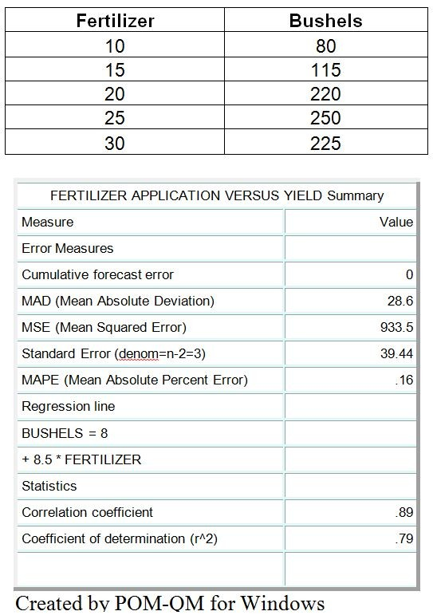

54) Use the information provided in Table 14.1. What percent in the variation of the variable Bushels is explained by the value of the variable Fertilizer?
A) 89%
B) 79%
C) 71%
D) 50%
Answer: B
Reference: Causal Methods: Linear Regression
Difficulty: Moderate
Keywords: regression, coefficient of determination, variance
AACSB: Analytic skills
55) Use the information provided in Table 14.1. For every unit of fertilizer applied, the crop yield increases by:
A) 8.0 bushels.
B) 8.5 bushels.
C) 8.9 bushels.
D) 7.9 bushels.
Answer: B
Reference: Causal Methods: Linear Regression
Difficulty: Moderate
Keywords: regression, slope
AACSB: Analytic skills

56) Use the information provided in Table 14.1. The value of Bushels when Fertilizer is 60 is:
A) 2520.
B) 490.
C) 390.
D) 518.
Answer: D
Reference: Causal Methods: Linear Regression
Difficulty: Moderate
Keywords: regression, forecast
AACSB: Analytic skills

57) Use the information provided in Table 14.1. The value of Fertilizer required to generate 100 bushels yield must be:
A) 10.82.
B) 12.25.
C) 10.26.
D) 9.07.
Answer: A
Reference: Causal Methods: Linear Regression
Difficulty: Moderate
Keywords: regression, forecast
AACSB: Analytic skills

58) Use the information in Table 14.1. If the correlation coefficient were negative, what would also be true?
A) The coefficient of determination would also be negative.
B) An increase in fertilizer would result in a decrease in crop yield.
C) Applying no fertilizer would mean a negative crop yield.
D) The standard error would also be negative.
Answer: B
Reference: Causal Methods: Linear Regression
Difficulty: Moderate
Keywords: regression, slope, coefficient of correlation
AACSB: Analytic skills
Table 14.2
A textbook publisher for books used in business schools believes that the number of books sold is related to the number of campus visits to decision makers made by their sales force. A sampling of the number of sales calls made and the number of books sold is shown in the following table.

NUMBER OF SALES CALLS MADE | NUMBER OF BOOKS SOLD
25 | 375
15 | 250
25 | 525
45 | 825
35 | 550
25 | 575
25 | 550
35 | 575
25 | 400
15 | 400

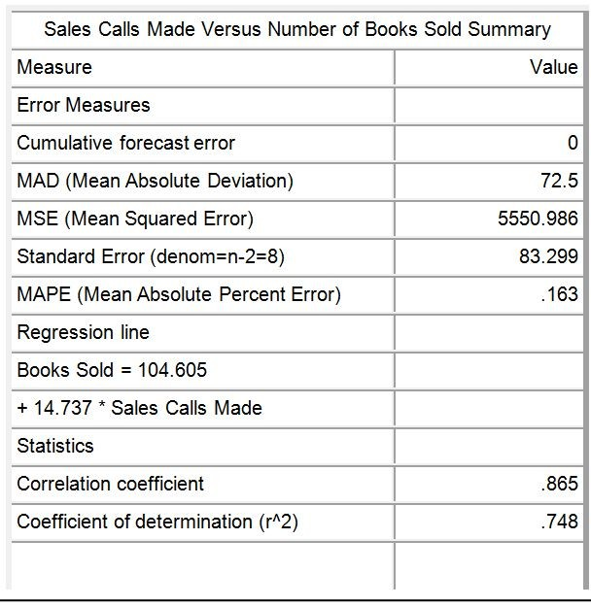

59) Use the information provided in Table 14.2. What percent in the variation of the variable Books Sold is explained by the value of the variable Sales Calls Made?
A) 86.5%
B) 83.3%
C) 74.8%
D) 72.5%
Answer: C
Reference: Causal Methods: Linear Regression
Difficulty: Moderate
Keywords: regression, coefficient of determination, variance
AACSB: Analytic skills
60) Use the information provided in Table 14.2. For every sale call made, the number of books sold increases by:
A) 14.74 books.
B) 104.6 books.
C) 83.30 books.
D) 7.25 books.
Answer: A
Reference: Causal Methods: Linear Regression
Difficulty: Moderate
Keywords: regression, slope
AACSB: Analytic skills

61) Use the information provided in Table 14.2. If a sales representative makes 55 sales calls, the number of book sales the publisher should expect is:
A) 105.
B) 4,581.
C) 114.
D) 915.
Answer: D
Reference: Causal Methods: Linear Regression
Difficulty: Moderate
Keywords: regression, forecast
AACSB: Analytic skills

62) Use the information provided in Table 14.2. In order to realize the sale of 700 books, how many sales calls will the sales representative have to make?
A) 40.4
B) 45.9
C) 32.7
D) 37.6
Answer: A
Reference: Causal Methods: Linear Regression
Difficulty: Moderate
Keywords: regression, forecast
AACSB: Analytic skills

Table 14.3
Columbia Appliance sells and delivers appliances in the Columbia, South Carolina area. The Operations and Supply Chain Manager wants to be able to predict the delivery crew's hours for easier scheduling. The delivery crew, consisting of a truck and two workers, must load the truck each day and then drive the truck to various locations to deliver appliances. Variables each day include miles driven and the number of deliveries made. The manager has collected data for the past five weeks, and has recorded the following average daily crew hours worked, miles driven and deliveries made:

WEEK | AVERAGE HOURS WORKED PER DAY | AVERAGE MILES DRIVEN PER DAY | AVERAGE NUMBER OF DELIVERIES PER DAY
1 | 8.1 | 75 | 5
2 | 9.3 | 80 | 6
3 | 8.5 | 100 | 4
4 | 8.5 | 75 | 5
5 | 8.9 | 110 | 4

The manager uses the multiple regression model in POM for Windows and obtains the following results:

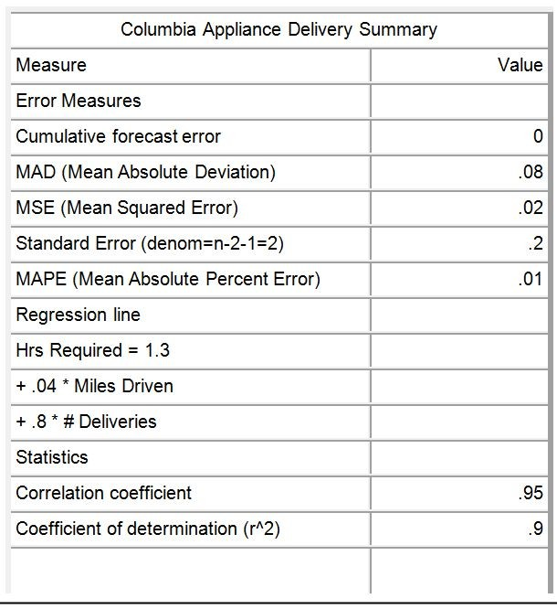

63) Use the information provided in Table 14.3. If one delivery is added to the crew's daily work, how much time is added to their work schedule for that day? (Assume all other variables are held constant.)
A) 30 minutes
B) 2.4 minutes
C) 24 minutes
D) 48 minutes
Answer: D
Reference: Causal Methods: Linear Regression
Difficulty: Moderate
Keywords: multiple regression, variables
AACSB: Analytic skills

64) Use the information provided in Table 14.3. If 10 extra miles of driving is added to the crew's daily work, how much time is added to their work schedule for that day? (Assume all other variables are held constant.)
A) 30 minutes
B) 2.4 minutes
C) 24 minutes
D) 48 minutes
Answer: C
Reference: Causal Methods: Linear Regression
Difficulty: Moderate
Keywords: multiple regression, variables
AACSB: Analytic skills
65) Use the information provided in Table 14.3. What is the estimated work time for the crew if the schedule that day calls for 90 driving miles and 4 deliveries?
A) 8.1 hours
B) 9.2 hours
C) 8.9 hours
D) 8.5 hours
Answer: A
Reference: Causal Methods: Linear Regression
Difficulty: Moderate
Keywords: multiple regression, variables
AACSB: Analytic skills

66) Use the information provided in Table 14.3. What is the estimated work time for the crew if the schedule that day calls for 85 driving miles and 6 deliveries?
A) 8.1 hours
B) 9.2 hours
C) 8.9 hours
D) 9.5 hours
Answer: D
Reference: Causal Methods: Linear Regression
Difficulty: Moderate
Keywords: multiple regression, variables
AACSB: Analytic skills

Table 14.4
The Furniture Super Mart is a furniture retailer in Evansville, Indiana. The Marketing Manager wants to prepare a media budget based on the next quarter's business plan. The manager wants to decide the mix of radio advertising and newspaper advertising needed to generate varying levels of Weekly Gross Revenue. The manager has collected data for the past five weeks, and has recorded the following average Weekly Gross Revenues and expenditures for Weekly Radio (X1) and Newspaper (X2) advertising:

WEEK | AVERAGE WEEKLY GROSS REVENUE ($000) | AVERAGE WEEKLY RADIO ADVERTISING ($000) | AVERAGE WEEKLY NEWSPAPER ADVERTISING ($000)
1 | 60 | 6 | 1
2 | 45 | 3 | 3
3 | 55 | 4 | 2
4 | 70 | 5 | 3
5 | 40 | 2 | 1

The Manager uses the multiple regression model in OM Explorer and obtains the following results:

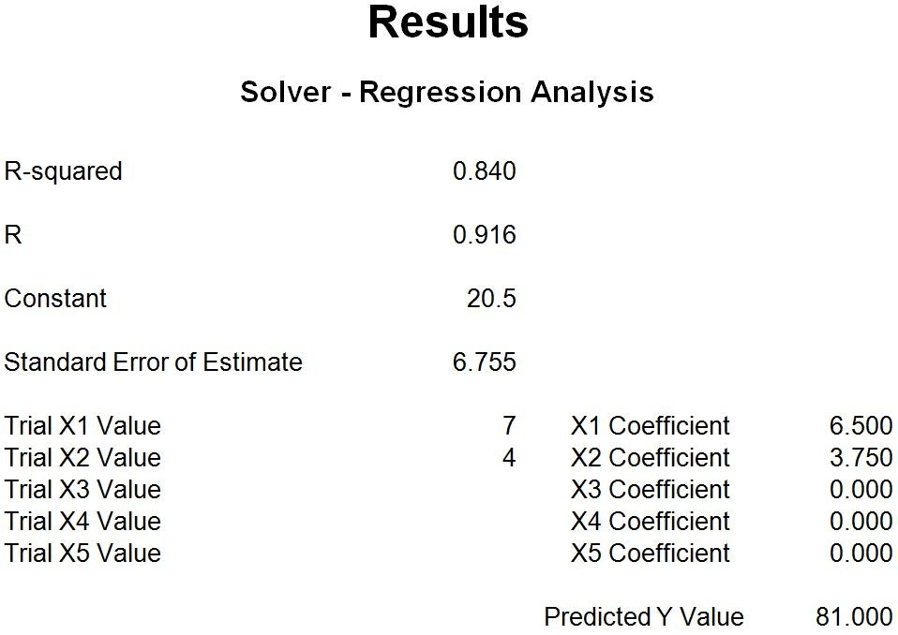

67) Use the information provided in Table 14.4. Adding $1,000 of Weekly Radio Advertising (X1) can be expected to increase Weekly Gross Revenues by what amount? (Assume all other variables are held constant.)
A) $20,500
B) $3,750
C) $6,500
D) $10,250
Answer: C
Reference: Causal Methods: Linear Regression
Difficulty: Moderate
Keywords: multiple regression, variables
AACSB: Analytic skills

68) Use the information provided in Table 14.4. Adding $1,000 of Weekly Newspaper Advertising (X2) can be expected to increase Weekly Gross Revenues by what amount? (Assume all other variables are held constant.)
A) $20,500
B) $3,750
C) $6,500
D) $10,250
Answer: B
Reference: Causal Methods: Linear Regression
Difficulty: Moderate
Keywords: multiple regression, variables
AACSB: Analytic skills
69) Use the information provided in Table 14.4. What amount of Weekly Gross Revenue can be expected for a week in which no radio or newspaper advertising is purchased? (Assume all other variables are held constant.)
A) $20,500
B) $3,750
C) $6,500
D) $10,250
Answer: A
Reference: Causal Methods: Linear Regression
Difficulty: Moderate
Keywords: multiple regression, variables
AACSB: Analytic skills

70) Use the information provided in Table 14.4. What is the estimated Weekly Gross Revenue if $7,000 is spent on Radio Advertising (X1) and $4,000 is spent on Newspaper Advertising (X2)?
A) $45,500
B) $15,000
C) $60,500
D) $81,000
Answer: D
Reference: Causal Methods: Linear Regression
Difficulty: Moderate
Keywords: multiple regression, variables
AACSB: Analytic skills

71) Use the information provided in Table 14.4. What is the estimated Weekly Gross Revenue if $4,000 is spent on Radio Advertising (X1) and $7,000 is spent on Newspaper Advertising (X2)?
A) $52,250
B) $26,250
C) $72,750
D) $20,500
Answer: C
Reference: Causal Methods: Linear Regression
Difficulty: Moderate
Keywords: multiple regression, variables
AACSB: Analytic skills
72) Which one of the following statements about forecasting is FALSE?
A) You should use the simple moving-average method to estimate the mean demand of a time series that has a pronounced trend and seasonal influences.
B) The weighted moving-average method allows forecasters to emphasize recent demand over earlier demand. The forecast will be more responsive to change in the underlying average of the demand series.
C) The most frequently used time-series forecasting method is exponential smoothing because of its simplicity and the small amount of data needed to support it.
D) In exponential smoothing, higher values of alpha place greater weight on recent demands in computing the average.
Answer: A
Reference: Time-Series Methods
Difficulty: Moderate
Keywords: forecasting, moving average, trend, seasonal demand patterns
Learning Outcome: Describe major approaches to forecasting

73) Which of the following statements regarding time-series methods is FALSE?
A) A naive forecast is identical to a simple moving average of one period.
B) Exponential smoothing with an alpha equal to 1.00 is identical to a naive forecast.
C) A weighted moving average with weights of 0.5 and 0.5 is identical to a simple moving average of two periods.
D) A simple moving average of three periods is identical to exponential smoothing with an alpha equal to 0.33.
Answer: D
Reference: Time-Series Methods
Difficulty: Hard
Keywords: time series, exponential smoothing, simple moving average, weighted moving average, naive forecast
Learning Outcome: Describe major approaches to forecasting
AACSB: Analytic skills

74) When the underlying mean of a time series is very stable and there are no trend, cyclical, or seasonal influences:
A) a simple moving-average forecast with n = 20 should outperform a simple moving-average forecast with n = 3.
B) a simple moving-average forecast with n = 3 should outperform a simple moving-average forecast with n = 15.
C) a simple moving-average forecast with n = 20 should perform about the same as a simple moving-average forecast with n = 3.
D) an exponential smoothing forecast with a = 0.30 should outperform a simple moving-average forecast with α = 0.01.
Answer: A
Reference: Time-Series Methods
Difficulty: Moderate
Keywords: time series, exponential smoothing, simple moving average, stable
Learning Outcome: Describe major approaches to forecasting
AACSB: Analytic skills
75) With the multiplicative seasonal method of forecasting:
A) the times series cannot exhibit a trend.
B) seasonal factors are multiplied by an estimate of average demand to arrive at a seasonal forecast.
C) the seasonal amplitude is a constant, regardless of the magnitude of average demand.
D) there can be only four seasons in the time-series data.
Answer: B
Reference: Time-Series Methods
Difficulty: Moderate
Keywords: multiplicative seasonal forecasting
Learning Outcome: Describe major approaches to forecasting

76) Which one of the following statements about forecasting is FALSE?
A) The method for incorporating a trend into an exponentially smoothed forecast requires the estimation of three smoothing constants: one for the mean, one for the trend, and one for the error.
B) The cumulative sum of forecast errors (CFE) is useful in measuring the bias in a forecast.
C) The standard deviation and the mean absolute deviation measure the dispersion of forecast errors.
D) A tracking signal is a measure that indicates whether a method of forecasting has any built-in biases over a period of time.
Answer: A
Reference: Multiple Sections
Difficulty: Moderate
Keywords: trend, exponential smoothing
Learning Outcome: Describe major approaches to forecasting

77) Which one of the following is most useful for measuring the bias in a forecast?
A) cumulative sum of forecast errors
B) standard deviation of forecast errors
C) mean absolute deviation of forecast errors
D) percentage forecast error in period t
Answer: A
Reference: Choosing a Quantitative Forecasting Method
Difficulty: Moderate
Keywords: bias, cumulative sum of forecast errors

78) A tracking signal greater than zero and a mean absolute deviation greater than zero imply that the forecast has:
A) no bias and no variability of forecast error.
B) a nonzero amount of bias and a nonzero amount of forecast error variability.
C) no bias and a nonzero amount of forecast error variability.
D) a nonzero amount of bias and no variability of forecast error.
Answer: B
Reference: Choosing a Quantitative Forecasting Method
Difficulty: Hard
Keywords: tracking signal, error
AACSB: Analytic skills
79) Assume that a time-series forecast is generated for future demand and subsequently it is observed that the forecast method did not accurately predict the actual demand. Specifically, the forecast errors were found to be:
Mean absolute percent error = 10%
Cumulative sum of forecast errors = 0
Which one of the statements concerning this forecast is TRUE?
A) The forecast has no bias but has a positive standard deviation of errors.
B) The forecast has a positive bias and a standard deviation of errors equal to zero.
C) The forecast has no bias and has a standard deviation of errors equal to zero.
D) The forecast has a positive bias and a positive standard deviation of errors.
Answer: A
Reference: Choosing a Quantitative Forecasting Method
Difficulty: Moderate
Keywords: bias, standard deviation
AACSB: Analytic skills

80) Which one of the following statements is TRUE?
A) The ideal of zero bias and zero MAD can be accomplished by systematically searching for the best values of the smoothing constants.
B) Bias is always less than MAD.
C) For projections of more stable demand patterns without trends, seasonal influences, or cyclical influences, use larger values of n in the simple moving-average approach.
D) One disadvantage of a weighted moving average forecast is that it does not allow you to emphasize recent demand over earlier demand.
Answer: C
Reference: Choosing a Quantitative Forecasting Method
Difficulty: Moderate
Keywords: simple moving average, trend

81) Which one of the following is an example of causal forecasting technique?
A) weighted moving average
B) linear regression
C) exponential smoothing
D) Delphi method
Answer: B
Reference: Multiple Sections
Difficulty: Moderate
Keywords: causal, linear regression
Learning Outcome: Describe major approaches to forecasting
Table 14.5
The manager of a pizza shop must forecast weekly demand for special pizzas so that he can order pizza shells weekly. Recent demand has been:

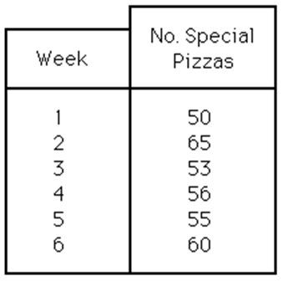

82) Use the information from Table 14.5. Using a three-week moving average, what is the forecast for week 7?
A) 55
B) 56
C) 57
D) 58
Answer: C
Reference: Time-Series Methods
Difficulty: Moderate
Keywords: simple moving average
AACSB: Analytic skills

83) Use the information from Table 14.5. If a naive forecast were constructed, the forecast for week 7 would be:
A) 53 pizzas.
B) 55 pizzas.
C) 56 pizzas.
D) 60 pizzas.
Answer: D
Reference: Time-Series Methods
Difficulty: Moderate
Keywords: naive forecast, time series
AACSB: Analytic skills

84) Use the information from Table 14.5. If a four-week weighted moving average were used, what would be the forecast for week 7? (The weights are 0.60, 0.30, 0.07, and 0.03 with 0.60 applied to the most recent period and 0.03 applied to the oldest period.)
A) 58 pizzas
B) 60 pizzas
C) 62 pizzas
D) 64 pizzas
Answer: A
Reference: Time-Series Methods
Difficulty: Moderate
Keywords: weighted moving average
AACSB: Analytic skills
85) Demand for a new five-inch color TV during the last six periods has been as follows:

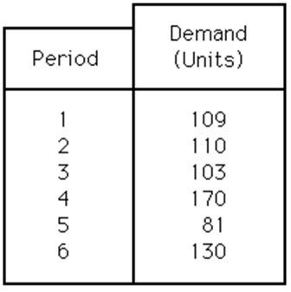

What is the forecast for period 7 if the company uses the simple moving-average method with n = 4?
A) fewer than or equal to 115
B) greater than 115 but fewer than or equal to 120
C) greater than 120 but fewer than or equal to 125
D) greater than 125
Answer: C
Reference: Time-Series Methods
Difficulty: Moderate
Keywords: simple moving average
AACSB: Analytic skills

86) Demands for a newly developed salad bar at the Great Professional restaurant for the first six months of this year are shown in the following table. What is the forecast for July if the 3-month weighted moving-average method is used? (Use weights of 0.5 for the most recent demand, 0.3, and 0.2 for the oldest demand.)

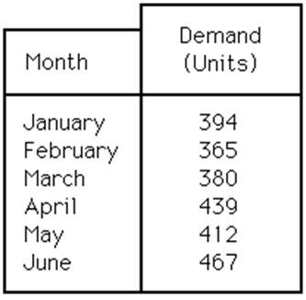

A) fewer than or equal to 432 units
B) greater than 432 units but fewer than or equal to 442 units
C) greater than 442 units but fewer than or equal to 452 units
D) greater than 452
Answer: C
Reference: Time-Series Methods
Difficulty: Moderate
Keywords: weighted moving average
AACSB: Analytic skills
87) It is now near the end of May and you must prepare a forecast for June for a certain product. The forecast for May was 900 units. The actual demand for May was 1000 units. You are using the exponential smoothing method with = 0.20. The forecast for June is:
A) fewer than 925 units.
B) greater than or equal to 925 units but fewer than 950 units.
C) greater than or equal to 950 units but fewer than 1000 units.
D) greater than or equal to 1000 units.
Answer: A
Reference: Time-Series Methods
Difficulty: Moderate
Keywords: exponential smoothing, alpha
AACSB: Analytic skills

88) The Classical Consultant Company provides forecasting research for clients such as a group of five doctors associated with a new hospital health-maintenance program. The company has been asked to forecast the number of patients requesting blood analysis per week. The past weekly average is 38 and, for the trend, is 2 per week. This week's demand was 42 blood tests. How many patients will come next week? (Suppose = 0.10 and = 0.30.)
A) fewer than or equal to 39
B) greater than 39 but fewer than or equal to 41
C) greater than 41 but fewer than or equal to 43
D) greater than 43
Answer: C
Reference: Time-Series Methods
Difficulty: Moderate
Keywords: trend adjusted exponential smoothing
AACSB: Analytic skills

89) The Acme Computer Company has recorded sales of one of its products for a six-week period:

Week | Sales
1 | 25
2 | 23
3 | 20
4 | 22
5 | 23
6 | 24

Using the three-week moving-average method, forecast sales for week 7.
A) 20
B) 21
C) 22
D) 23
Answer: D
Reference: Time-Series Methods
Difficulty: Moderate
Keywords: simple moving average forecast
AACSB: Analytic skills
Table 14.6
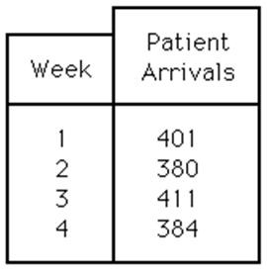

90) Use the information in Table 14.6. Compute a three-week moving-average forecast for the arrival of medical clinic patients in week 5.
A) fewer than or equal to 382
B) greater than 382 but fewer than or equal to 389
C) greater than 389 but fewer than or equal to 396
D) greater than 396
Answer: C
Reference: Time-Series Methods
Difficulty: Moderate
Keywords: simple moving average forecast
AACSB: Analytic skills

91) Use the information in Table 14.6. If the actual number of patients is 415 in week 5, what is the forecast for week 6, using a three-week moving-average forecast?
A) fewer than or equal to 390
B) greater than 390 but fewer than or equal to 398
C) greater than 398 but fewer than or equal to 406
D) greater than 406
Answer: C
Reference: Time-Series Methods
Difficulty: Moderate
Keywords: simple moving average forecast
AACSB: Analytic skills

92) Use the information in Table 14.6. Calculate the exponential smoothing forecast for week 5 using α= 0.10 and F4 = 410.
A) fewer than or equal to 400
B) greater than 400 but fewer than or equal to 408
C) greater than 408 but fewer than or equal to 416
D) greater than 416
Answer: B
Reference: Time-Series Methods
Difficulty: Moderate
Keywords: exponential smoothing forecast
AACSB: Analytic skills
Table 14.7
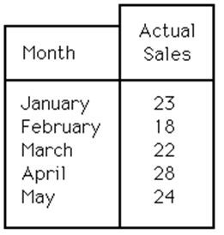

93) Use the information in Table 14.7. Use the three-month moving-average method to forecast sales for June.
A) fewer than or equal to 20 units
B) greater than 20 but fewer than or equal to 22 units
C) greater than 22 but fewer than or equal to 24 units
D) greater than 24 units
Answer: D
Reference: Time-Series Methods
Difficulty: Moderate
Keywords: simple moving average forecast
AACSB: Analytic skills

94) Use the information in Table 14.7. Suppose actual sales in June turn out to be 40 units. Use the three-month moving-average method to forecast the sales in July.
A) fewer than or equal to 27
B) greater than 27 but fewer than or equal to 29 units
C) greater than 29 but fewer than or equal to 31 units
D) greater than 31 units
Answer: C
Reference: Time-Series Methods
Difficulty: Moderate
Keywords: simple moving average forecast
AACSB: Analytic skills

95) Use the information in Table 14.7. What is the forecast for July with the two-month moving-average method and June sales of 40 units?
A) fewer than or equal to 25 units
B) greater than 25 but fewer than or equal to 30 units
C) greater than 30 but fewer than or equal to 35 units
D) greater than 35 units
Answer: C
Reference: Time-Series Methods
Difficulty: Moderate
Keywords: simple moving average forecast
AACSB: Analytic skills
96) Use the information in Table 14.7. The forecasting equation for a three-month weighted moving average is:
Ft = W1Dt + W2Dt - 1 + W3Dt - 2
If the sales for June were 40 units and the weights are W1= 1/2, W2 = 1/3, and W3 = 1/6, what is the forecast for July?
A) fewer than or equal to 30 units
B) greater than 30 but fewer than or equal to 33 units
C) greater than 33 but fewer than or equal to 36 units
D) greater than 36 units
Answer: B
Reference: Time-Series Methods
Difficulty: Moderate
Keywords: weighted moving average forecast
AACSB: Analytic skills

Table 14.8
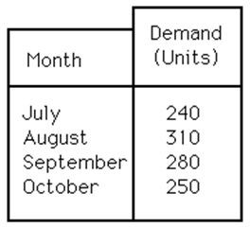

97) Use the information in Table 14.8. Using the simple moving-average technique for the most recent three months, what will be the forecasted demand for November?
A) fewer than or equal to 260 units
B) greater than 260, but fewer than or equal to 275 units
C) greater than 275, but fewer than or equal to 290 units
D) more than 290 units
Answer: C
Reference: Time-Series Methods
Difficulty: Moderate
Keywords: simple moving average forecast
AACSB: Analytic skills
98) Use the information in Table 14.8. Using the 4-month weighted moving-average technique and the following weights, what is the forecasted demand for November?

Time Period | Weight
Most recent month | 50%
One month ago | 20%
Two months ago | 20%
Three months ago | 10%

A) fewer than or equal to 250 units
B) greater than 250 but fewer than or equal to 265 units
C) greater than 265 but fewer than or equal to 280 units
D) more than 280 units
Answer: C
Reference: Time-Series Methods
Difficulty: Moderate
Keywords: weighted moving average forecast
AACSB: Analytic skills

99) Use the information in Table 14.8. Using the exponential smoothing method, with alpha equal to 0.2, what is the forecasted demand for November? Use an initial value for the forecast equal to 277 units.
A) fewer than or equal to 260 units
B) greater than 260 but fewer than or equal to 275 units
C) greater than 275 but fewer than or equal to 285 units
D) more than 285 units
Answer: B
Reference: Time-Series Methods
Difficulty: Moderate
Keywords: exponential smoothing forecast
AACSB: Analytic skills
Table 14.9
Month | Demand
January | 480
February | 520
March | 535
April | 550
May | 590
June | 630

100) Use the information in Table 14.9. Use an exponential smoothing model with a smoothing parameter of 0.30 and an April forecast of 525 to determine what the forecast sales would have been for June.
A) fewer than or equal to 535
B) greater than 535 but fewer than or equal to 545
C) greater than 545 but fewer than or equal to 555
D) greater than 555
Answer: C
Reference: Time-Series Methods
Difficulty: Hard
Keywords: exponential smoothing forecast
AACSB: Analytic skills

101) Use the information in Table 14.9. Use the exponential smoothing method with = 0.5 and a February forecast of 500 to forecast the sales for May.
A) fewer than or equal to 530
B) greater than 530 but fewer than or equal to 540
C) greater than 540 but fewer than or equal to 550
D) greater than 550
Answer: B
Reference: Time-Series Methods
Difficulty: Moderate
Keywords: exponential smoothing forecast
AACSB: Analytic skills
Table 14.10
TOMBOW is a small manufacturer of pencils and has had the following sales record for the most recent five months:

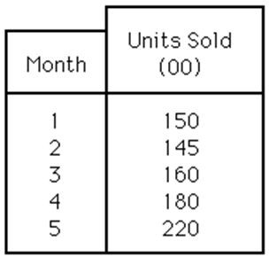

Use an exponential smoothing model to forecast sales in months 2, 3, 4, and 5. Let the smoothing parameter equal 0.6; select F1 = 150 to get the forecast started.

102) Use the information in Table 14.10. The forecast for month 2 is:
A) fewer than or equal to 120 units.
B) greater than 120 but fewer than or equal to 140 units.
C) greater than 140 but fewer than or equal to 160 units.
D) greater than 160 units.
Answer: C
Reference: Time-Series Methods
Difficulty: Moderate
Keywords: exponential smoothing forecast
AACSB: Analytic skills

103) Use the information in Table 14.10. The forecast for month 3 is:
A) fewer than or equal to 140 units.
B) greater than 140 but fewer than or equal to 160 units.
C) greater than 160 but fewer than or equal to 180 units.
D) greater than 180 units.
Answer: B
Reference: Time-Series Methods
Difficulty: Moderate
Keywords: exponential smoothing forecast
AACSB: Analytic skills

104) Use the information in Table 14.10. The forecast for month 4 is:
A) fewer than or equal to 140 units.
B) greater than 140 but fewer than or equal to 150.
C) greater than 150 but fewer than or equal to 160 units.
D) greater than 160 units.
Answer: C
Reference: Time-Series Methods
Difficulty: Moderate
Keywords: exponential smoothing forecast
AACSB: Analytic skills
105) Use the information in Table 14.10. The forecast for month 5 is:
A) fewer than or equal to 150 units.
B) greater than 150 but fewer than or equal to 160 units.
C) greater than 160 but fewer than or equal to 170 units.
D) greater than 170 units.
Answer: C
Reference: Time-Series Methods
Difficulty: Moderate
Keywords: exponential smoothing forecast
AACSB: Analytic skills

106) Use the information in Table 14.10. The cumulative sum of errors (CFE) from months 2 through 5 is:
A) fewer than or equal to 80.
B) greater than 80 but fewer than or equal to 85.
C) greater than 87 but fewer than or equal to 90.
D) greater than 90.
Answer: B
Reference: Choosing a Quantitative Forecasting Method
Difficulty: Moderate
Keywords: CFE, cumulative sum of errors
AACSB: Analytic skills

107) Use the information in Table 14.10. What is the MAD for months 2 through 5?
A) less than or equal to 20
B) greater than 20 but less than or equal to 25
C) greater than 25 but less than or equal to 30
D) greater than 30
Answer: B
Reference: Choosing a Quantitative Forecasting Method
Difficulty: Moderate
Keywords: MAD, mean absolute deviation
AACSB: Analytic skills
Table 14.11
A sales manager wants to forecast monthly sales of the machines the company makes using the following monthly sales data.

Month | Balance
1 | $3,803
2 | $2,558
3 | $3,469
4 | $3,442
5 | $2,682
6 | $3,469
7 | $4,442
8 | $3,728

108) Use the information in Table 14.11. Forecast the monthly sales of the machine for month 9, using the three-month moving-average method.
A) $3,728
B) $4,085
C) $3,880
D) $3,277
Answer: C
Reference: Time-Series Methods
Difficulty: Moderate
Keywords: simple moving average forecast
AACSB: Analytic skills

109) Use the information in Table 14.11. Use the 3-month weighted moving-average method to calculate the forecast for month 9. The weights are 0.60, 0.30, and 0.10, where 0.60 refers to the most recent demand.
A) $3,916
B) $3,880
C) $3,396
D) $3,229
Answer: A
Reference: Time-Series Methods
Difficulty: Moderate
Keywords: weighted moving average forecast
AACSB: Analytic skills

110) Use the information in Table 14.11. If the forecast for period 7 is $4,300, what is the forecast for period 9 using exponential smoothing with an alpha equal to 0.30?
A) $4,300
B) $4,342
C) $4,158
D) $3,957
Answer: C
Reference: Time-Series Methods
Difficulty: Hard
Keywords: exponential smoothing forecast
AACSB: Analytic skills
111) Use the information in Table 14.11. What is the forecast for period 9 using a naive forecast.
A) $3,728
B) $3,803
C) $4,442
D) $4,085
Answer: A
Reference: Time-Series Methods
Difficulty: Easy
Keywords: naive forecast
AACSB: Analytic skills

Table 14.12
The management of an insurance company monitors the number of mistakes made by telephone service representatives for a company they have subcontracted with. The number of mistakes for the past several months appears in this table along with forecasts for errors made with three different forecasting techniques. The column labeled Exponential was created using exponential smoothing with an alpha of 0.30. The column labeled MA is forecast using a moving average of three periods. The column labeled WMA uses a 3-month weighted moving average with weights of 0.65, 0.25, and 0.10 for the most-to-least recent months.

Month | Mistakes | Exponential | MA | WMA
1 | 55
2 | 61
3 | 71
4 | 77 | 71 | 62 | 67
5 | 88 | 73 | 70 | 74
6 | 100 | 77 | 79 | 84
7 | 109 | 84 | 88 | 95
8 | 122 | 92 | 99 | 105
9 | 126 | 101 | 110 | 117
10 | 126 | 108 | 119 | 123

112) Using Table 14.12, what is the CFE for months 6-10 for the exponential smoothing technique?
A) less than or equal to 120
B) greater than 120 but less than or equal to 123
C) greater than 123 but less than or equal to 126
D) greater than 126
Answer: B
Reference: Choosing a Quantitative Forecasting Method
Difficulty: Moderate
Keywords: CFE, forecast error, cumulative forecast error
AACSB: Analytic skills
113) Using Table 14.12, what is the MSE for months 6-10 for the exponential smoothing technique?
A) less than 591
B) greater than or equal to 591 but less than 595
C) greater than or equal to 595 but less than 599
D) Greater than 599
Answer: D
Reference: Choosing a Quantitative Forecasting Method
Difficulty: Moderate
Keywords: MSE, forecast error, mean squared error
AACSB: Analytic skills

114) Using Table 14.12, what is the MAD for months 6-10 for the exponential smoothing technique?
A) less than 23
B) greater than or equal to 23 but less than 25
C) greater than or equal to 25 but less than 27
D) greater than or equal to 27
Answer: B
Reference: Choosing a Quantitative Forecasting Method
Difficulty: Moderate
Keywords: MAD, forecast error, mean absolute deviation
AACSB: Analytic skills

115) Using Table 14.12, what is the order of the forecasting techniques from most accurate to least accurate based on their errors for months 6-10?
A) exponential smoothing, weighted moving average, moving average
B) exponential smoothing, moving average, weighted moving average
C) moving average, exponential smoothing, weighted moving average
D) weighted moving average, moving average, exponential smoothing
Answer: D
Reference: Choosing a Quantitative Forecasting Method
Difficulty: Moderate
Keywords: forecast error
AACSB: Analytic skills

116) Using Table 14.12, what is the mean absolute percent error for months 6-10 using the exponential smoothing forecasts?
A) less than 22%
B) greater than or equal to 22% but less than 24%
C) greater than or equal to 24% but less than 26%
D) greater than 26%
Answer: A
Reference: Choosing a Quantitative Forecasting Method
Difficulty: Moderate
Keywords: MAPE, mean absolute percent error
AACSB: Analytic skills
117) Using Table 14.12, what is the tracking signal for months 6-10 using the exponential smoothing forecasts?
A) 0.5
B) -0.5
C) 5.0
D) -5.0
Answer: C
Reference: Choosing a Quantitative Forecasting Method
Difficulty: Moderate
Keywords: tracking signal, CFE, MAD
AACSB: Analytic skills

118) Consider the following data concerning the performance of a forecasting method.

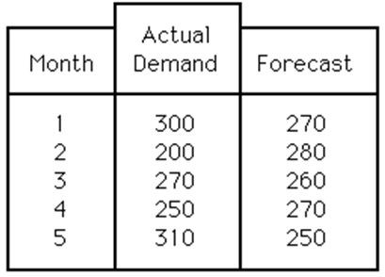

A) The CFE is greater than 100, and the MAD is less than 50.
B) The CFE is less than 100, and the MAD is less than 50.
C) The CFE is less than 100, and the MAD is greater than 50.
D) The CFE is greater than 100, and the MAD is greater than 50.
Answer: B
Reference: Choosing a Quantitative Forecasting Method
Difficulty: Moderate
Keywords: CFE, MAD, cumulative forecast error, mean absolute deviation
AACSB: Analytic skills

119) Which statement about forecast accuracy is TRUE?
A) A manager must be careful not to "overfit" past data.
B) The ultimate test of forecasting power is how well a model fits past data.
C) The ultimate test of forecasting power is how a model fits holdout samples.
D) The best technique in explaining past data is the best technique to predict the future.
Answer: A
Reference: Choosing a Quantitative Forecasting Method
Difficulty: Moderate
Keywords: forecast accuracy
120) A forecaster that uses a holdout set approach as a final test for forecast accuracy typically uses:
A) the entire data set available to develop the forecast.
B) the older observations in the data set to develop the forecast and more recent to check accuracy.
C) the newer observations in the data set to develop the forecast and older observations to check accuracy.
D) every other observation to develop the forecast and the remaining observations to check the accuracy.
Answer: B
Reference: Choosing a Quantitative Forecasting Method
Difficulty: Moderate
Keywords: holdout set, final test, forecast accuracy

121) Barney took what he liked to call "the shotgun approach" to forecasting. Every period he tried a number of different forecasting approaches and at the end of the period he reviewed all of the forecasts to see which was the most accurate. The winner would be used for next period's forecast (but he still made forecasts all possible ways so he could use the system again for the following period). The more formal name for this technique is:
A) combination forecasting.
B) post-hoc forecasting.
C) focus forecasting.
D) shotgun forecasting. He is using the correct terminology.
Answer: C
Reference: Using Multiple Techniques
Difficulty: Moderate
Keywords: focus forecasting
Learning Outcome: Describe major approaches to forecasting

122) Andy took what he liked to call "the sheriff without a gun" approach to forecasting. Every period he tried a number of different forecasting approaches and simply averaged the predictions for all of the techniques. This overall average was the official forecast for the period. The more formal name for this technique is:
A) grand averaging.
B) focus forecasting.
C) simple average.
D) combination forecasting.
Answer: D
Reference: Using Multiple Techniques
Difficulty: Moderate
Keywords: combination forecasting
Learning Outcome: Describe major approaches to forecasting
Table 14.13
The manager of a pizza shop must forecast weekly demand for special pizzas so that he can order pizza shells weekly. Recent demand has been:

WEEK | No. Special Pizzas
1 | 30
2 | 45
3 | 33
4 | 36
5 | 35
6 | 40

123) Use the information from Table 14.13. Using a three-week simple moving average, what is the forecast for week 7?
A) 35.0
B) 36.0
C) 37.0
D) 38.0
Answer: C
Reference: Time-Series Methods
Difficulty: Moderate
Keywords: simple moving average
AACSB: Analytic skills

124) Use the information from Table 14.13. If a three-week weighted moving average were used, what would be the forecast for week 7? (The weights are 0.60, 0.30, and 0.10 with 0.60 applied to the most recent period and 0.10 applied to the oldest period.)
A) 38.1 pizzas
B) 40.1 pizzas
C) 42.0 pizzas
D) 44.0 pizzas
Answer: A
Reference: Time-Series Methods
Difficulty: Moderate
Keywords: weighted moving average
AACSB: Analytic skills

125) Use the information from Table 14.13. What is the exponentially smoothed forecast for week #7 if α = 0.9 is used, and the forecast for week #6 was 34?
A) 36.0 pizzas
B) 39.4 pizzas
C) 42.4 pizzas
D) 45.6 pizzas
Answer: B
Reference: Time-Series Methods
Difficulty: Moderate
Keywords: weighted moving average
AACSB: Analytic skills
126) Use the information from Table 14.13. The pizza shop manager believes that a combination forecast might improve her ability to predict future demand, and thus improve keeping fresh ingredients on hand. She decides to use the 3-week simple moving average and 3-week weighted moving average (problems # 125 and 126), giving them equal weight. What is her forecast for week #7?
A) 38.05 pizzas
B) 39.5 pizzas
C) 38.5 pizzas
D) 37.55 pizzas
Answer: D
Reference: Using Multiple Techniques
Difficulty: Moderate
Keywords: combination forecasting
AACSB: Analytic skills

127) Use the information from Table 14.13. The pizza shop manager believes that a combination forecast might improve her ability to predict future demand, and thus improve keeping fresh ingredients on hand. She decides to use the 3-week weighted moving average and exponentially smoothed average forecast (problems # 126 and 127), giving them equal weight. What is her forecast for week #7?
A) 38.75 pizzas
B) 40.8 pizzas
C) 42.25 pizzas
D) 44.8 pizzas
Answer: A
Reference: Using Multiple Techniques
Difficulty: Moderate
Keywords: combination forecasting
AACSB: Analytic skills

128) Use the information from Table 14.13. The pizza shop manager believes that a combination forecast might improve her ability to predict future demand, and thus improve keeping fresh ingredients on hand. She decides to use the 3-week simple moving average and exponentially smoothed average forecast (problems # 125 and 127), giving them equal weight. What is her forecast for week #7?
A) 35.5 pizzas
B) 37.4 pizzas
C) 38.2 pizzas
D) 40.2 pizzas
Answer: C
Reference: Using Multiple Techniques
Difficulty: Moderate
Keywords: combination forecasting
AACSB: Analytic skills
129) Use the information from Table 14.13. The pizza shop manager is looking for a forecasting approach that will forecast her demand within 0.5 pizzas. If the actual demand for week #7 was 39 pizzas, which of the combination forecasts came closest to predicting this demand?
A) simple moving average and weighted moving average forecast
B) simple moving average and exponentially smoothed forecast
C) weighted moving average and exponentially smoothed forecast pizzas
D) week #7 demand of 39 is within 0.5 pizzas for all three of these combination forecasts, and thus all of them are appropriate.
Answer: C
Reference: Using Multiple Techniques
Difficulty: Moderate
Keywords: combination forecasting
AACSB: Analytic skills

Use the data and graph shown below for the following questions.
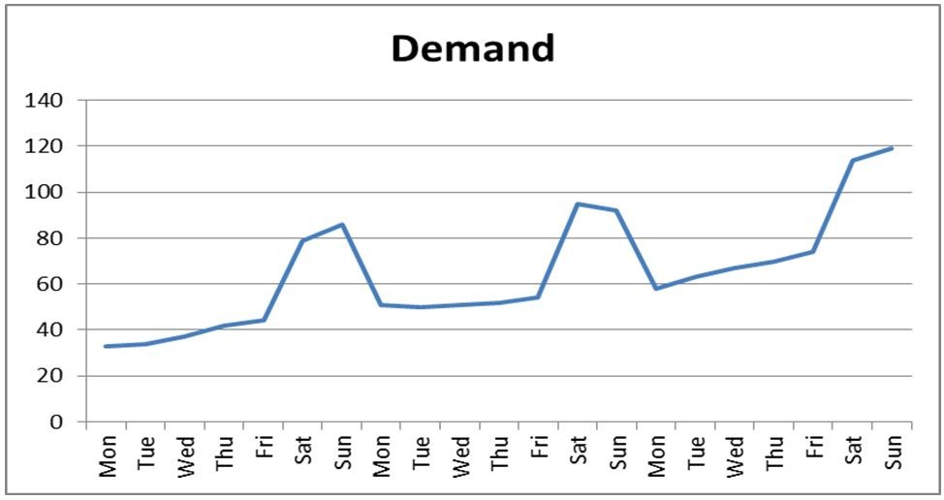

Obs # | Day | Demand |  | Obs # | Day | Demand
1 | Mon | 33 |  | 12 | Fri | 54
2 | Tue | 34 |  | 13 | Sat | 95
3 | Wed | 37 |  | 14 | Sun | 92
4 | Thu | 42 |  | 15 | Mon | 58
5 | Fri | 44 |  | 16 | Tue | 63
6 | Sat | 79 |  | 17 | Wed | 67
7 | Sun | 86 |  | 18 | Thu | 70
8 | Mon | 51 |  | 19 | Fri | 74
9 | Tue | 50 |  | 20 | Sat | 114
10 | Wed | 51 |  | 21 | Sun | 119
11 | Thu | 52

130) Refer to the instruction above. Which term most accurately describes the data points associated with Saturdays and Sundays?
A) nonbase data
B) outliers
C) seasons
D) erroneous
Answer: C
Reference: Time-Series Methods
Difficulty: Moderate
Keywords: seasonal, multiplicative seasonal model

131) Refer to the instruction above. What is the average demand for the second period?
A) 63.57
B) 50.71
C) 82.5
D) 93.5
Answer: A
Reference: Time-Series Methods
Difficulty: Easy
Keywords: seasonal, multiplicative seasonal model, season

132) Refer to the instruction above. What is the seasonal index for the first Saturday in the data set?
A) 1.69
B) 1.56
C) 0.64
D) 0.58
Answer: B
Reference: Time-Series Methods
Difficulty: Moderate
Keywords: seasonal, multiplicative seasonal model, seasonal index

133) Refer to the instruction above. What is the average seasonal index for the Sundays in the data set?
A) 0.65
B) 0.67
C) 1.49
D) 1.54
Answer: D
Reference: Time-Series Methods
Difficulty: Moderate
Keywords: seasonal, multiplicative seasonal model, seasonal index

134) Refer to the instruction above. Use a trend projection to forecast the next week's demand. Then apply seasonal indices to determine the demand on Saturday of the fourth week. What is the demand projected to be?
A) 141.4
B) 146.2
C) 151.3
D) 158.9
Answer: A
Reference: Time-Series Methods
Difficulty: Moderate
Keywords: seasonal, multiplicative seasonal model, seasonal index
135) The local building supply store experienced what they considered to be irregular demands for lumber after the devastating hurricane season. These unusual data points were considered:
A) nonbase data.
B) outliers.
C) residuals.
D) erroneous.
Answer: A
Reference: Putting It All Together: Forecasting as a Process
Difficulty: Moderate
Keywords: nonbase data

136) Which word best describes forecasting?
A) quantitative
B) process
C) resource
D) managerial
Answer: B
Reference: Putting It All Together: Forecasting as a Process
Difficulty: Moderate
Keywords: process, forecasting

137) ________ is the prediction of future events used for planning purposes.
Answer: Forecasting
Reference: Introduction
Difficulty: Easy
Keywords: forecast, predict

138) A systematic increase or decrease in the mean of the series over time is a(n) ________.
Answer: trend
Reference: Demand Patterns
Difficulty: Easy
Keywords: time series, trend

139) Variations in demand that cannot be predicted are said to be a(n) ________ pattern.
Answer: random
Reference: Demand Patterns
Difficulty: Easy
Keywords: time series, random

140) Cyclical patterns arise from ________ and ________.
Answer: the business cycle, the product (or service) life cycle
Reference: Demand Patterns
Difficulty: Hard
Keywords: time series, cycle, cyclical
141) ________ methods of forecasting translate the opinions of management, experts, consumers, or salesforce into quantitative estimates.
Answer: Judgment
Reference: Key Decisions on Making Forecasts
Difficulty: Moderate
Keywords: forecasting, judgment method
Learning Outcome: Describe major approaches to forecasting

142) ________ methods use historical data on independent variables to predict demand.
Answer: Causal
Reference: Key Decisions on Making Forecasts
Difficulty: Moderate
Keywords: forecasting, causal method
Learning Outcome: Describe major approaches to forecasting

143) ________ analysis is a statistical approach that relies heavily on historical demand data to project the future size of demand, and it recognizes trends and seasonal patterns.
Answer: Time-series
Reference: Key Decisions on Making Forecasts
Difficulty: Moderate
Keywords: time-series analysis
Learning Outcome: Describe major approaches to forecasting

144) The ________ is a process of gaining consensus from a group of experts while maintaining their anonymity.
Answer: Delphi method
Reference: Key Decisions on Making Forecasts
Difficulty: Moderate
Keywords: judgment method, Delphi method
Learning Outcome: Describe major approaches to forecasting

145) ________ is a systematic approach to determine consumer interest in a product or service by creating and testing hypotheses through data-gathering surveys.
Answer: Market research
Reference: Judgment Methods
Difficulty: Easy
Keywords: judgment method, market research
Learning Outcome: Describe major approaches to forecasting

146) ________ is a causal method of forecasting in which one variable is related to one or more variables by a linear equation.
Answer: Linear regression
Reference: Causal Methods: Linear Regression
Difficulty: Moderate
Keywords: causal method, linear regression
Learning Outcome: Describe major approaches to forecasting
147) In an exponential smoothing model a ________ value for alpha results in greater emphasis being placed on more recent periods.
Answer: larger
Reference: Time-Series Methods
Difficulty: Moderate
Keywords: time series, exponential smoothing, alpha
Learning Outcome: Describe major approaches to forecasting

148) The ________ variable is the variable that one wants to forecast.
Answer: dependent
Reference: Causal Methods: Linear Regression
Difficulty: Moderate
Keywords: dependent variable, causal method
Learning Outcome: Describe major approaches to forecasting

149) ________ are assumed to "cause" the results that a forecaster wishes to predict.
Answer: Independent variables
Reference: Causal Methods: Linear Regression
Difficulty: Moderate
Keywords: independent variable, cause, causal method

150) A(n) ________ measures the direction and strength between the independent variable and the dependent variable.
Answer: sample correlation coefficient, r
Reference: Causal Methods: Linear Regression
Difficulty: Moderate
Keywords: sample correlation coefficient, r, independent variable, dependent variable

151) The ________ measures the amount of variation in the dependent variable about its mean that is explained by the regression line.
Answer: sample coefficient of determination, r-squared
Reference: Causal Methods: Linear Regression
Difficulty: Moderate
Keywords: sample coefficient of determination, r-squared

152) A(n) ________ forecast is a time-series method whereby the forecast for the next period equals the demand for the current period.
Answer: naive
Reference: Time-Series Methods
Difficulty: Moderate
Keywords: naive forecast, time-series forecasting
Learning Outcome: Describe major approaches to forecasting

153) ________ is a time-series method used to estimate the average of a demand time series by averaging the demand for the n most recent time periods.
Answer: Simple moving average
Reference: Time-Series Methods
Difficulty: Moderate
Keywords: simple moving average, time-series forecasting
Learning Outcome: Describe major approaches to forecasting
154) ________ is the difference found by subtracting the forecast from actual demand for a given period.
Answer: Forecast error
Reference: Key Decisions on Making Forecasts
Difficulty: Moderate
Keywords: forecast error

155) The dispersion of forecast errors is measured by both MAD and MSE, which behave differently in the way they emphasize errors. ________ gives larger weight to errors and ________ gives smaller weight to errors.
Answer: MSE, MAD
Reference: Key Decisions on Making Forecasts
Difficulty: Easy
Keywords: forecast error, MAD, MSE, mean absolute deviation, mean squared error

156) The ________ measure of forecast errors puts the size of the error in appropriate context by forming the ratio of the average forecast error to the average ________.
Answer: MAPE, demand
Reference: Key Decisions on Making Forecasts
Difficulty: Moderate
Keywords: forecast error, MAPE

157) ________ are often the result of neglecting or not accurately estimating patterns of demand such as a trend, seasonal, or cyclical pattern.
Answer: Bias errors
Reference: Key Decisions on Making Forecasts
Difficulty: Moderate
Keywords: bias error

158) A(n) ________ is a measure that indicates whether a method of forecasting is accurately predicting actual changes in demand.
Answer: tracking signal
Reference: Choosing a Quantitative Forecasting Method
Difficulty: Moderate
Keywords: tracking signal

159) A(n) ________ is a portion of data from more recent time periods that is used to test different models developed from earlier time period data.
Answer: holdout set
Reference: Choosing a Quantitative Forecasting Method
Difficulty: Moderate
Keywords: holdout set

160) ________ are produced by averaging independent forecasts based on different methods or different data, or both.
Answer: Combination forecasts
Reference: Using Multiple Techniques
Difficulty: Moderate
Keywords: combination forecast
Learning Outcome: Describe major approaches to forecasting
161) ________ selects the best forecast from a group of forecasts generated by individual techniques.
Answer: Focus forecasting
Reference: Using Multiple Techniques
Difficulty: Moderate
Keywords: focus forecasting
Learning Outcome: Describe major approaches to forecasting

162) A history file of past demand will often be separated into two parts; the ________ part will reflect irregular demands.
Answer: nonbase (data)
Reference: Putting It All Together: Forecasting as a Process
Difficulty: Moderate
Keywords: forecasting process, nonbase data

163) Forecasting is a(n) ________ that should continually be reviewed for improvements.
Answer: (nested) process
Reference: Putting It All Together: Forecasting as a Process
Difficulty: Moderate
Keywords: forecasting process

164) Why are forecasts for product families typically more accurate than forecasts for the individual items within a product family?
Answer: More accurate forecasts are obtained for a group of items because the individual forecast errors for each item tend to cancel each other.
Reference: Key Decisions on Making Forecasts
Difficulty: Moderate
Keywords: aggregate forecast accuracy

165) Which forecasting technique would you consider for technological forecasts?
Answer: I would consider the Delphi method because technological change takes place at a rapid pace and often the only way to make forecasts is to get the opinion of experts who devote their attention to those issues.
Reference: Judgment Methods
Difficulty: Moderate
Keywords: technological forecasts, Delphi method
Learning Outcome: Describe major approaches to forecasting
166) Pho Bulous, a Vietnamese restaurant in the bustling metropolis of Edmond, has had great success using forecasting techniques to predict demand for their main menu items ever since they opened their doors. Their forecast for last month was grossly inaccurate and so far this month, their forecast appears to be just as bad as last month's. It's already time to prepare the forecast for next month, what should they do about their model?
Answer: The answer depends on whether Pho Bulous believes that last month's and this month's results are aberrations or the start of something new. Both causal and time-series techniques assume that there has been no change in how the world works, that is, independent factors of time or other variables will permit the forecaster to make accurate predictions about the future. If Pho Bulous believes that there is a significant change in the system, for example, a new competitor in the Edmond restaurant scene, a significant change in population or in their disposable income, then they might try multiple regression to include these factors or weight more recent data more heavily in a time-series model (the scenario isn't specific about which technique they have used thus far). Pho Bulous might also try a combination approach if they feel their situation has changed significantly. On the other hand, if Pho Bulous feels that these two months are not reflective of any major paradigm shift for the restaurant crowd in Edmond, they could continue to use the model(s) they have had success with in the past.
Reference: Multiple Sections
Difficulty: Moderate
Keywords: forecast accuracy
Learning Outcome: Describe major approaches to forecasting

167) Explain how the value of alpha affects forecasts produced by exponential smoothing.
Answer: The smoothing constant alpha allows recent demand values to be emphasized or deemphasized depending on how the forecaster wishes to incorporate previous values. Larger alpha values emphasize recent levels of demand and result in forecasts more responsive to changes in the underlying average. Smaller alpha values treat past demand more uniformly and result in more stable forecasts.
Reference: Time-Series Methods
Difficulty: Moderate
Keywords: alpha value, exponential smoothing
Learning Outcome: Describe major approaches to forecasting

168) Your team has been asked to develop a forecast for the need for storage in the company's communication devices ten years from now. What method would develop the best forecast? Why? How would you execute this method?
Answer: Since you are tasked with developing a technological forecast ten years into the future, and for a product that has evolved significantly over the last ten years, it is doubtful that a quantitative approach is suitable. Among the judgment methods discussed in the text; salesforce estimates, market research, executive opinion, technological forecasting and the Delphi method, the latter three would hold the most potential for a forecast. Answers will vary as to implementation depending on the approach chosen.
Reference: Judgment Methods
Difficulty: Moderate
Keywords: judgment, salesforce estimates, executive opinion, technological forecasting
Learning Outcome: Describe major approaches to forecasting
169) Draw a curve that represents four out of the five demand patterns for time series as discussed in this chapter. Clearly label both dependent and independent axes and the salient features of your graph that demonstrate your chosen patterns. Select a product or service and discuss what influences might cause it to exhibit each of these patterns.
Answer: Answers will vary depending on which patterns among horizontal, trend, seasonal, cyclical, and random patterns have been chosen.
Reference: Demand Patterns
Difficulty: Moderate
Keywords: demand patterns, horizontal, trend, seasonal, cyclical, random patterns

170) What is the difference between mean absolute deviation (MAD) and mean squared error (MSE)?
Answer: Both MAD and MSE are measurements of the amount of forecast error, and smaller values of both metrics reflect superior forecasting methods. The difference between the two is that MAD places less emphasis on an outlier while MSE is more sensitive to one. A forecast technique that seeks to minimize MSE will have overall forecast accuracy hurt by one extreme outlier more than a forecast developed using a MAD-minimizing technique.
Reference: Key Decisions on Making Forecasts
Difficulty: Moderate
Keywords: MAD, MSE, mean absolute deviation, mean squared error

171) What are reasonable criteria for selecting one time-series method over another?
Answer: Forecast error measures provide important information for choosing the best forecasting method for a service or product. They also guide managers in selecting the best values for the parameters needed for the method: n for the moving average method, the weights for the weighted moving average method, alpha for the exponential smoothing method, and when regression data begins for the trend projection with regression method. The criteria to use in making forecast method and parameter choices include (1) minimizing bias (CFE); (2) minimizing MAPE, MAD, or MSE; (3) maximizing r2; (4) meeting managerial expectations of changes in the components of demand; and (5) minimizing the forecast errors in recent periods. The first three criteria relate to statistical measures based on historical performance, the fourth reflects expectations of the future that may not be rooted in the past, and the fifth is a way to use whatever method seems to be working best at the time a forecast must be made.
Reference: Choosing a Quantitative Forecasting Method
Difficulty: Moderate
Keywords: MAD, MSE, time series, MAPE, statistical method
172) How is a typical forecasting process similar to the Plan-Do-Study-Act (PDSA) cycle? (See Chapter 5 for more information on PDSA)
Answer: The authors indicate that forecasting is a process that should be continually reviewed for improvements; the PDSA cycle provides one vehicle for continuous improvement. The authors present a six step cycle for forecasting: 1) adjust the history file, 2) prepare initial forecasts, 3) consensus meetings and collaboration, 4) revise forecasts, 5) review by the operating committee, and 6) finalize and communicate the forecasts. The history file adjustment in step 1 provides a check of forecast accuracy; if results have been less than stellar, then planners and forecasters will explore different techniques and/or independent variables to prepare future forecasts. This approach closely parallels the PDSA cycle of methodically trying a new approach and checking results before acting system-wide.
Reference: Putting It All Together: Forecasting as a Process
Difficulty: Moderate
Keywords: forecasting process, Plan-Do-Study-Act, PDSA

173) Describe the combination forecast techniques and discuss how they have been shown to perform in recent studies.
Answer: Combination forecasts are forecasts that are produced by averaging independent forecasts based on different methods, different sources, or different data. Research during the last two decades suggests that combining forecasts from multiple sources often produces more accurate forecasts. It is intriguing that combination forecasts often perform better over time than even the best single forecasting procedure. Combining is most effective when the individual forecasts bring different kinds of information into the forecasting process. Forecasters have achieved excellent results by weighting forecasts equally, and this is a good starting point. However, unequal weights may provide better results under some conditions.
Reference: Using Multiple Techniques
Difficulty: Moderate
Keywords: combination forecast

174) What are the steps of the forecasting process as described in the text?
Answer: The authors describe a six-step forecasting process.
Step 1. Update the history file and review forecast accuracy. Enter the actual demand and review forecast accuracy.
Step 2. Prepare initial forecasts using some forecasting software package and judgment. Adjust the parameters of the software to find models that fit the past demand well and yet reflect the demand manager's judgment on irregular events and information about future sales pulled from various sources and business units.
Step 3. Hold consensus meetings with the stakeholders, such as marketing, sales, supply chain planners, and finance. Arrive at consensus forecasts from all of the important players.
Step 4. Revise the forecasts using judgment, considering the inputs from the consensus meetings and collaborative sources.
Step 5. Present the forecasts to the operating committee for review and to reach a final set of forecasts.
Step 6. Finalize the forecasts based on the decisions of the operating committee and communicate them to the important stakeholders.
Reference: Putting It All Together: Forecasting as a Process
Difficulty: Moderate
Keywords: forecasting process, principles
175) What are some of the principles organizations can observe to improve their forecasting process?
Answer: (See Table 14.2 in the text.) Some principles organizations can observe to improve their forecasting process include:
1. Better processes yield better forecasts
2. Demand forecasting is being done in virtually every company, either formally or informally. The challenge is to do it well–better than the competition.
3. Better forecasts result in better customer service and lower costs, as well as better relationships with suppliers and customers.
4. The forecast can and must make sense based on the big picture, economic outlook, market share, and so on.
5. The best way to improve forecast accuracy is to focus on reducing forecast error.
6. Bias is the worst kind of forecast error–strive for zero bias.
7. Whenever possible, forecast at more aggregate levels. Forecast in detail only where necessary.
8. Far more can be gained by people collaborating and communicating well than by using the most advanced forecasting technique or model.
Reference: Putting It All Together: Forecasting as a Process
Difficulty: Moderate
Keywords: forecasting process, principles
Learning Outcome: Describe major approaches to forecasting

176) Calculate three forecasts using the following data. First, for periods 4 through 10, develop the exponentially smoothed forecasts using a forecast for period 3 (F3) of 45.0 and an alpha of 0.4. Second, calculate the three-period moving-average forecast for periods 4 through 10. Third, calculate the weighted moving average for periods 4 through 10, using weights of .70, .20, and .10, with 0.70 applied to the most recent data. Calculate the mean absolute deviation (MAD) and the cumulative sum of forecast error (CFE) for each forecasting procedure. Which forecasting procedure would you select? Why?

Month | Demand
1 | 45
2 | 48
3 | 43
4 | 48
5 | 49
6 | 54
7 | 47
8 | 50
9 | 46
10 | 47

Answer:
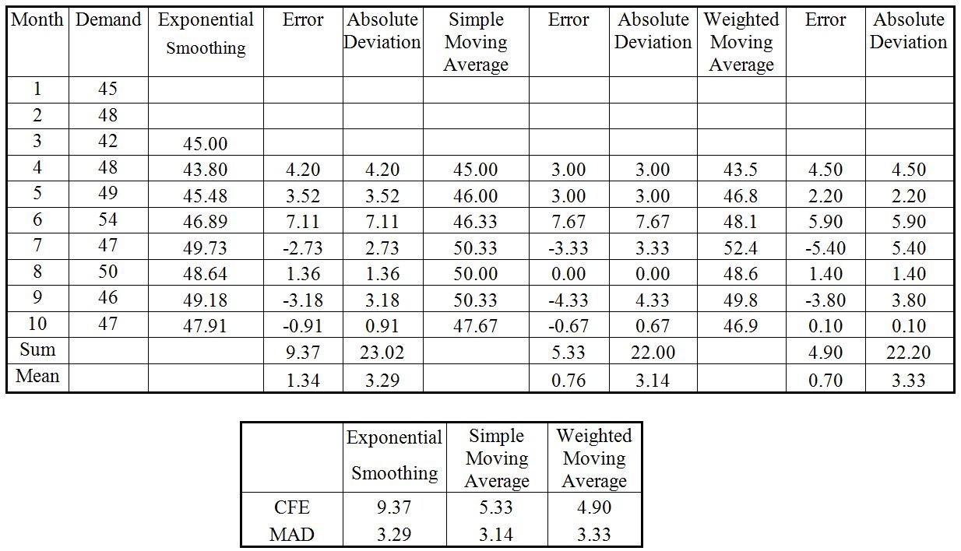

 | Exponential Smoothing | Simple Moving Average | Weighted Moving Average
CFE | 9.37 | 5.33 | 4.90
MAD | 3.29 | 3.14 | 3.33

Using MAD, the simple moving average is best. However, the weighted moving average does better on CFE.
Reference: Multiple Sections
Difficulty: Moderate
Keywords: time-series forecast, exponential smoothing forecast, simple moving average forecast, weighted moving average forecast, MAD, mean absolute deviation, CFE, cumulative forecast error
Learning Outcome: Describe major approaches to forecasting
AACSB: Analytic skills

177) Calculate three forecasts using the following data. First, for periods 4 through 10, develop the exponentially smoothed forecasts using a forecast for period 3 (F3) of 120.0 and an alpha of 0.3. Second, calculate the three-period moving-average forecast for periods 4 through 10. Third, calculate the weighted moving average for periods 4 through 10, using weights of .60, .30, and .10. Calculate the mean absolute deviation (MAD) and the cumulative sum of forecast error (CFE) for each forecasting procedure. Which forecasting procedure would you select? Why?

Month | Demand
1 | 120
2 | 115
3 | 125
4 | 119
5 | 127
6 | 114
7 | 120
8 | 124
9 | 116
10 | 137

Answer:
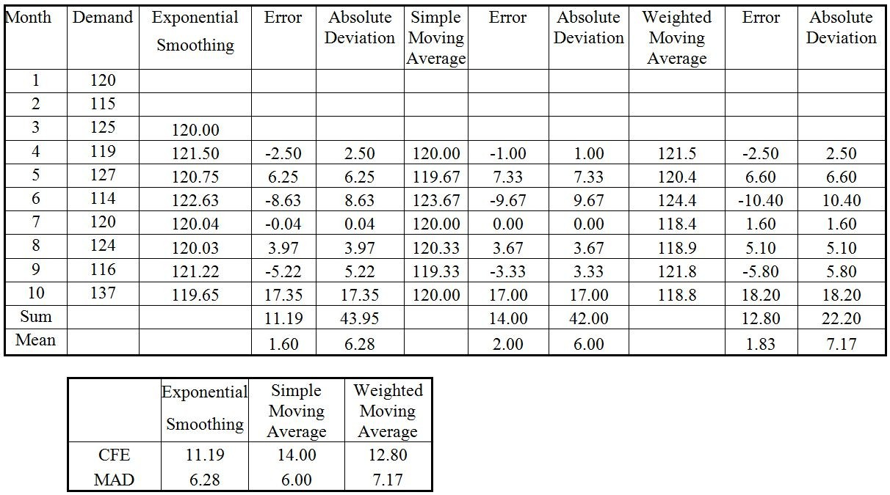

 | Exponential Smoothing | Simple Moving Average | Weighted Moving Average
CFE | 11.19 | 14.00 | 12.80
MAD | 6.28 | 6.00 | 7.17

Using MAD, the simple moving average is best. However, the exponential smoothing does better on CFE.
Reference: Multiple Sections
Difficulty: Moderate
Keywords: time-series forecast, exponential smoothing forecast, simple moving average forecast, weighted moving average forecast, MAD, mean absolute deviation, CFE, cumulative forecast error
Learning Outcome: Describe major approaches to forecasting
AACSB: Analytic skills

178) The marketing department for a major manufacturer tracks sales and advertising expenditures each month. Data from the past nine months and regression output appear in the following table. Interpret the equation coefficients and the values for the coefficient of determination and the correlation coefficient.

Month | Sales (units) | Advertising ($1,000)
1 | 86,010 | 25
2 | 134,697 | 40
3 | 202,025 | 65
4 | 141,180 | 45
5 | 217,086 | 70
6 | 178,399 | 55
7 | 156,975 | 50
8 | 113,155 | 35
9 | 191,901 | 60

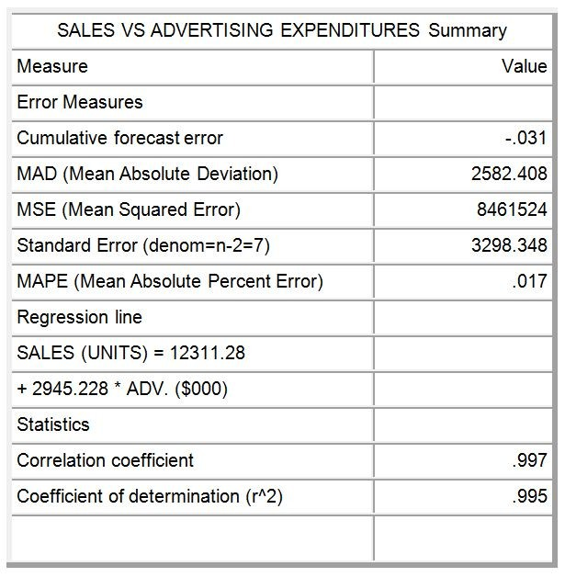
Created by POM-QM for Windows
Answer: The regression equation is:
Y = a + bX
Sales (units) = 12,311.28 + 2,945.23 x Advertising ($ in 000s)

The intercept of 12,311 suggests that if no money were spent on advertising, sales would be 12,311 units for that month. The slope may be interpreted as for every $1,000 spent on advertising, sales increase by a little over 2,945 units.
The correlation coefficient of 0.997 shows a very strong positive relationship between the independent and dependent variables. The sample coefficient of determination is 0.995, so the level of advertising expenditure explains 99.5% of the variation in sales.
Reference: Causal Methods: Linear Regression
Difficulty: Moderate
Keywords: regression, correlation coefficient, coefficient of determination
AACSB: Analytic skills
179) A local moving company has collected data on the number of moves they have been asked to perform over the past three years. Moving is highly seasonal, so the owner/operator, who is both burly and highly educated, decides to apply the multiplicative seasonal method (based on a linear regression for total demand) to forecast the number of customers for the coming year. What is his forecast for each quarter?

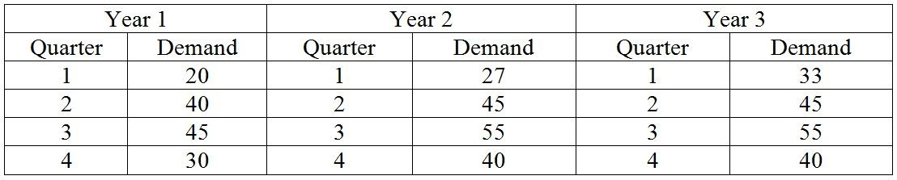
Answer: The seasonal factor calculations for each year show:

Year 1 | Year 1 | Year 1 | Year 2 | Year 2 | Year 2 | Year 3 | Year 3 | Year 3 | Year 3
Quarter | Demand | Seas Fact | Quarter | Demand | Seas Fact | Quarter | Demand | Seas Fact | Avg SF
1 | 20 | 0.592 | 1 | 27 | 0.647 | 1 | 33 | 0.763 | 0.667
2 | 40 | 1.185 | 2 | 45 | 1.078 | 2 | 45 | 1.040 | 1.1014
3 | 45 | 1.333 | 3 | 55 | 1.317 | 3 | 55 | 1.272 | 1.307
4 | 30 | 0.889 | 4 | 40 | 0.958 | 4 | 40 | 0.925 | 0.924

The regression equation for total demand is y = 120.33 + 19*year; for the fourth year y=196.33. (This is assuming the regression is done in year sequence, i.e. year 1, year 2, year 3. If a regression is run using the actual year dates, the equation of the line is y=-37936.7+19*year.) Both equations result in a forecast for Year 4 of 196.33. Dividing this total demand by 4 yields 49.08333.

Forecasts for the next four quarters are:
Quarter 1: (49.083) × 0.67 = 32.74
Quarter 2: (49.083) × 1.10 = 54.06
Quarter 3: (49.083) × 1.31 = 64.15
Quarter 4: (49.083) × 0.92 = 45.35
Reference: Time-Series Methods
Difficulty: Hard
Keywords: multiplicative seasonal forecast
AACSB: Analytic skills
180) The Bahouth Company wants to develop a sales forecast for a fast-selling new product line it has introduced, in order to help plan future production. The following information has been gathered by the Marketing Department. The past weekly average is 4,200 and the trend has been 250 additional units per week. This week's demand was 4,600 units. Using trend adjusted exponential smoothing, calculate the forecasted sales for next week? (Suppose α = 0.20 and β= 0.40.)
Answer:
At-1 = 4,200 α = 0.2
Tt-1 = 250 β = 0.4
Dt = 4,600

At = (.2)(4,600) + (.8)(4,200 + 250) = 920 + 3,560 = 4,480
Tt = (.4)(4,480 — 4,200) + (.6)(250) = 112 + 150 = 262
Ft+1 = 4,480 + 262 = 4,742
Reference: Time-Series Methods
Difficulty: Moderate
Keywords: trend adjusted exponential smoothing
AACSB: Analytic skills

181) The demand for an item over the last year is plotted below. Develop a forecast and explain why your approach is reasonable.

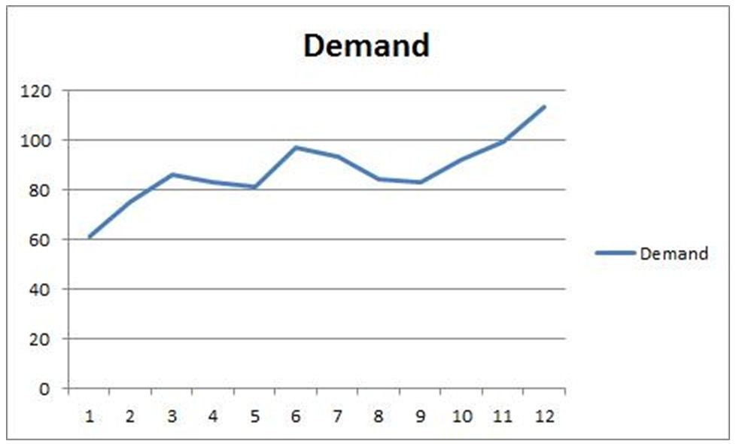
Answer: The data were generated using the function 25*rand()-15*rand() added to the previous value with the value 61 seeded in the first month. As such, the data show an upward trend with some random variation. There is some temptation to model a seasonality, but this is truly random variation. A technique with a short memory would be most appropriate.
Reference: Time-Series Methods
Difficulty: Moderate
Keywords: trend, random variation, short memory, time series
AACSB: Analytic skills
182) Three weeks of data are available from a restaurant. Develop a forecast and explain why your approach is reasonable.

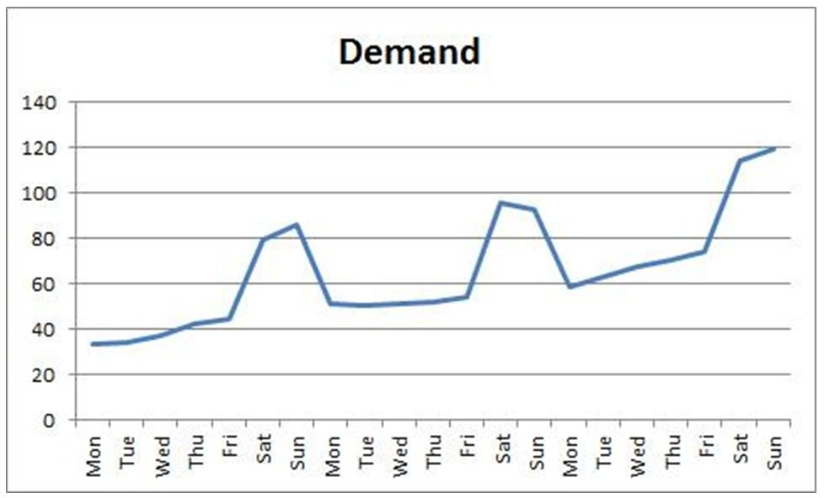
Answer: The data were generated using the function ROUND(10*RAND()+C28-5*RAND(),0) added to the previous value with the value 33 seeded in the first day. For Saturday and Sunday observations, and additional RAND()*40 is added and then the series reverts to additive from the previous Friday's observation. As such, the data show an upward trend with some random variation and a strong seasonality. A technique with a short memory and an ability to capture the spike in Saturday and Sunday demand would be most appropriate. Of the techniques covered in the text, the multiplicative seasonal method would be most suitable.
Reference: Time-Series Methods
Difficulty: Moderate
Keywords: trend, random variation, short memory, time series
AACSB: Analytic skills

183) Ten months of data and the forecasts for those same periods are in the table below. Use mean bias, MAD, and MAPE to analyze the accuracy of the forecasts.

Month | Actual | Forecast
January | 42 | 37
February | 58 | 50
March | 58 | 58
April | 77 | 67.5
May | 91 | 84
June | 102 | 96.5
July | 124 | 113
August | 148 | 136
September | 171 | 159.5
October | 177 | 174

Answer:
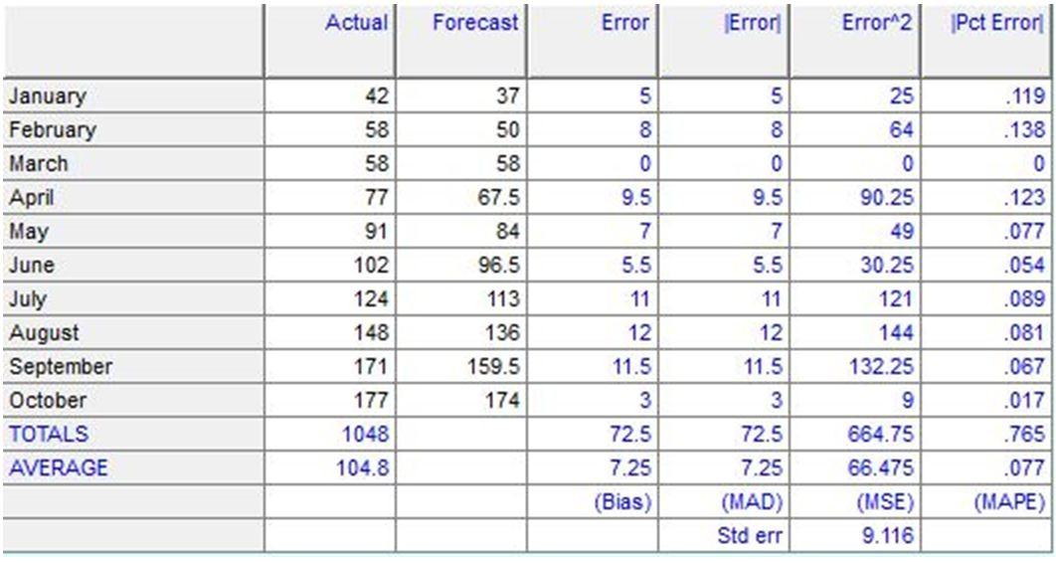

Bias = 7.25
Mad = 7.25
MAPE = 0.077
Reference: Key Decisions on Making Forecasts
Difficulty: Moderate
Keywords: error, MAPE, bias, MAD
AACSB: Analytic skills

184) Two mercenary forecasters dueled for the lucrative Surreal Farms egg production forecasting job. The farmer provided them with output levels from ten day's production and had them forecast the next ten days. The combatant's forecasts and the actual egg production are shown in the table. Which forecaster was more accurate and should be hired as a result of his performance on this trial?

 | Actual | Forecast A | Forecast B
Day 1 | 102 | 97 | 107
Day 2 | 108 | 105 | 113
Day 3 | 118 | 113 | 109
Day 4 | 130 | 124 | 119
Day 5 | 142 | 136 | 130
Day 6 | 154 | 148 | 142
Day 7 | 166 | 160 | 154
Day 8 | 181 | 174 | 167
Day 9 | 198 | 190 | 182
Day 10 | 206 | 202 | 195

Answer: Based on mean absolute deviation and mean absolute percent error; Forecaster A is more accurate than Forecaster B.

Period | Error A | Error B | Absolute Error A | Absolute Error B | Abs % Error A | Abs % Error B
Day 1 | 5 | -5 | 5 | 5 | 4.9% | 4.9%
Day 2 | 3 | -5 | 3 | 5 | 2.8% | 4.63%
Day 3 | 5 | 9 | 5 | 9 | 4.2% | 7.63%
Day 4 | 6 | 11 | 6 | 11 | 4.6% | 8.46%
Day 5 | 6 | 12 | 6 | 12 | 4.2% | 8.45%
Day 6 | 6 | 12 | 6 | 12 | 3.9% | 7.79%
Day 7 | 6 | 12 | 6 | 12 | 3.6% | 7.23%
Day 8 | 7 | 14 | 7 | 14 | 4.1% | 7.73%
Day 9 | 8 | 16 | 8 | 16 | 4.3% | 8.08%
Day 10 | 4 | 11 | 4 | 11 | 1.9% | 5.34%
Sum | 56 | 107 | 56 | 107 | 39% | 70.25%
Avg | 5.6 | 10.7 | 5.6 | 10.7 | 4% | 7%
 |  |  | MADa | MADb | MAPEa | MAPEb

Reference: Key Decisions on Making Forecasts
Difficulty: Moderate
Keywords: error, MAPE, bias, MAD
AACSB: Analytic skills

